Odsek Visoka ICT škola,  
Akademija tehničko-umetničkih strukovnih studija,  
Beograd

SWIFTMARKET

<http://swiftmarket.infinityfreeapp.com/>

Smer: Internet tehnologije

Modul: Web programiranje

Predmet: Praktikum iz Web Programiranja PHP

Mihailo Ilić 41/19

Sadržaj

1. Uvod 3

1.1 Korišćeni programski jezici/tehnologije 3

1.2 Opis funkcionalnosti 3

1.2 Template 4

2. Organizacija 4

2.1 Dizajn baze podataka 4

2.2 Struktura projekta 5

2.3 Slike stranica i opisi funkcionalnosti 6

2.3.1 home 6

2.3.2 buy 7

2.3.3 products 8

2.3.4 product 9

2.3.5 sell 10

2.3.4 login 11

2.3.5 register 12

2.3.6 wish-list 13

2.3.7 profile 14

2.3.8 contact 15

2.3.9 author 16

2.3.10 user-products 17

2.3.11 user-offers 18

2.3.12 c-h-a-t 19

2.3.13 admin 20

2.3.14 admin-see-offers 23

2.3.15 admin-see-chat 24

3. Kodovi 25

3.1 PHP 25

3.1.1 index.php 25

3.1.2 views/fixed/head.php 26

3.1.3 views/fixed/nav.php 26

3.1.4 views/fixed/footer.php 29

3.1.5 views/pages/admin-see-chat.php 30

3.1.6 views/pages/admin-see-offers.php 31

3.1.7 views/pages/admin.php 33

3.1.8 views/pages/author.php 39

3.1.9 views/pages/buy.php 39

3.1.10 views/pages/c-h-a-t.php 40

3.1.11 views/pages/contact.php 41

3.1.12 views/pages/home.php 42

3.1.13 views/pages/login.php 42

3.1.14 views/pages/product.php 43

3.1.15 views/pages/products.php 47

3.1.16 views/pages/profile.php 52

3.1.17 views/pages/register.php 53

3.1.18 views/pages/sell.php 54

3.1.19 views/pages/user-offers.php 58

3.1.20 views/pages/user-products.php 60

3.1.21 views/pages/wish-list.php 63

3.1.22 models/admin/add-category.php 65

3.1.23 models/admin/change-cover-image.php 66

3.1.24 models/admin/change-user-ban-status.php 67

3.1.25 models/admin/change-user-password.php 69

3.1.26 models/admin/export-offers-to-excel.php 70

3.1.27 models/admin/functions.php 71

3.1.28 models/admin/get-users.php 74

3.1.29 models/admin/make-product-inactive.php 75

3.1.30 models/admin/remove-category.php 76

3.1.31 models/admin/unlock-user.php 77

3.1.32 models/mail/functions.php 78

3.1.33 models/mail/send-mail.php 79

3.1.34 models/offers/functions.php 80

3.1.35 models/offers/rate-seller.php 83

3.1.36 models/offers/seller-accept.php 84

3.1.37 models/offers/send-m-e-s-s-a-g-e.php 85

3.1.38 models/offers/show-m-e-s-s-a-g-e-s.php 86

3.1.39 models/offers/user-remove-offer.php 88

3.1.40 models/offers/user-submit-offer.php 89

3.1.41 models/products/functions.php 90

3.1.42 models/products/get-categories.php 94

3.1.43 models/products/get-products.php 94

3.1.44 models/products/get-wish-list-status.php 97

3.1.45 models/products/set-wish-list-status.php 98

3.1.46 models/products/user-submit-new-product.php 99

3.1.47 models/users/functions.php 102

3.1.48 models/users/login.php 104

3.1.49 models/users/logout.php 106

3.1.50 models/users/register.php 106

3.1.51 models/users/user-change-pw.php 109

3.1.52 models/users/user-unlock-account.php 110

3.1.53 models/export-author-to-word.php 111

3.1.54 models/functions.php 111

3.1.55 config/config.php 115

3.1.56 config/connection.php 115

3.2 JS 117

3.2.1 assets/js/main.js 117

3.3 CSS 134

3.3.1 assets/css/style.scss 134

# 1. Uvod

## 1.1 Korišćeni programski jezici/tehnologije

Za potrebe sajta korišćene su sledeće tehnologije:

* HTML
* CSS, SASS
* Bootstrap (samo CSS), Font Awesome
* JavaScript, jQuery
* PHP
* PHPMailer
* Xampp (Apache, MySQL)
* Visual Studio Code

## 1.2 Opis funkcionalnosti

Funkcionalnosti sajta se mogu svrstati u sledeće kategorije:

* Dinamičko učitavanje navigacije, cover slika i naslova stranica iz baze
* Prodavnica sa robom koju postavljaju korisnici, svrstanom u glavne kategorije, a zatim u potkategorije
* Prikaz proizvoda glavne kategorije preko AJAX-a, uz filtriranje, sortiranje, pretragu i paginaciju (sve ovo se obavlja na serverskom delu)
* Mogućnost dodavanja proizvoda na listu želja korisnika
* Dve varijante slika za proizvode i kategorije: puna veličina (maks. 1920px širine) i thumbnail
* Forma za postavljanje novih proizvoda od strane korisnika, moguće je uploadovati više slika, i sav unos se proverava na oba kraja
* Davanje ponuda od strane kupaca, i prihvatanje istih od strane prodavca
* Čet namenjen za razgovor prodavca i kupca (osvežavanje 3-5s zbog limitacija servera)
* Slanje mejlova uz pomoć PHPMailera predefinisanoj mejl adresi administratora kroz kontakt formu
* Zaključavanje naloga ukoliko se za isti ukuca pogrešna lozinka 3 puta u roku od 5min i slanje mejla vlasniku naloga
* Admin panel sa osnovnim statističkim podacima o sajtu i opcijama za upravljanje korisnicima, izmenu/brisanje kategorija, promenu cover slika
* Mogućnost administratora da deaktivira proizvode i vidi ponude za isti zajedno sa četom
* Eksportovanje ponuda u formi Excel fajla, dostupno administratoru na stranici za pregled svih ponuda za određeni proizvod (See Offers)
* Eksportovanje informacija o autoru u formi Word fajla
* Log fajl u kom se beleži pristup svih posetilaca sajta, kao i error log fajl u kom se beleže greške

## 1.2 Template

Za izradu sajta nije korišćeno gotovo rešenje. Sve funkcionalnosti i kod su napisani ispočetka.

# 2. Organizacija

## 2.1 Dizajn baze podataka

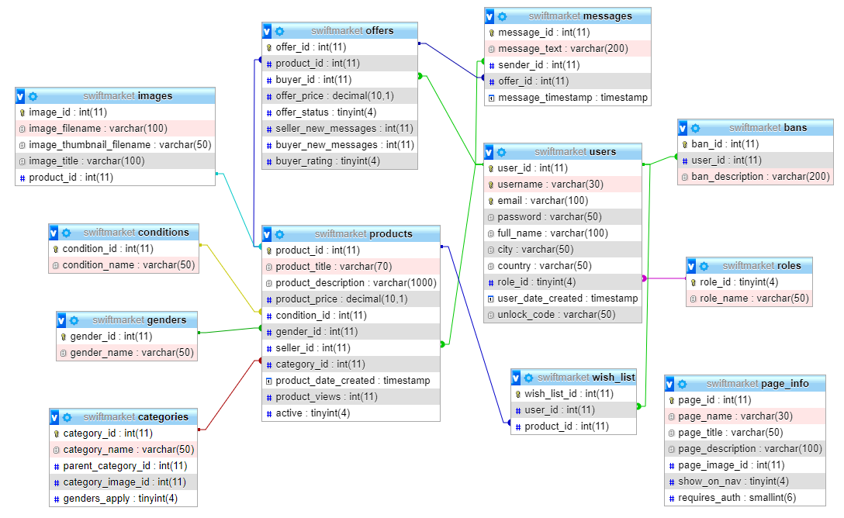

## 2.2 Struktura projekta

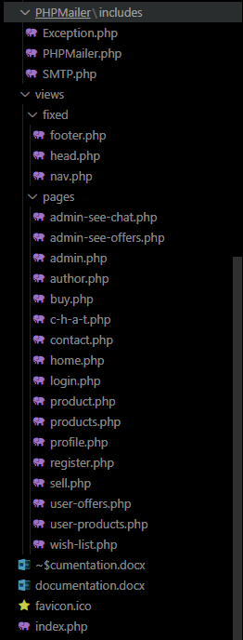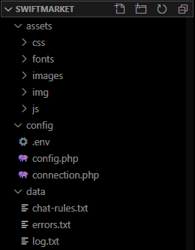

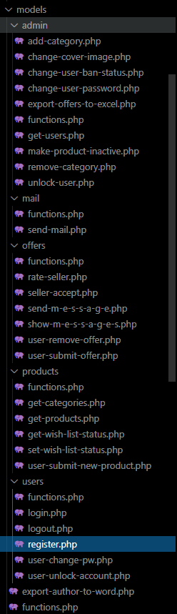

## 2.3 Slike stranica i opisi funkcionalnosti

### 2.3.1 home

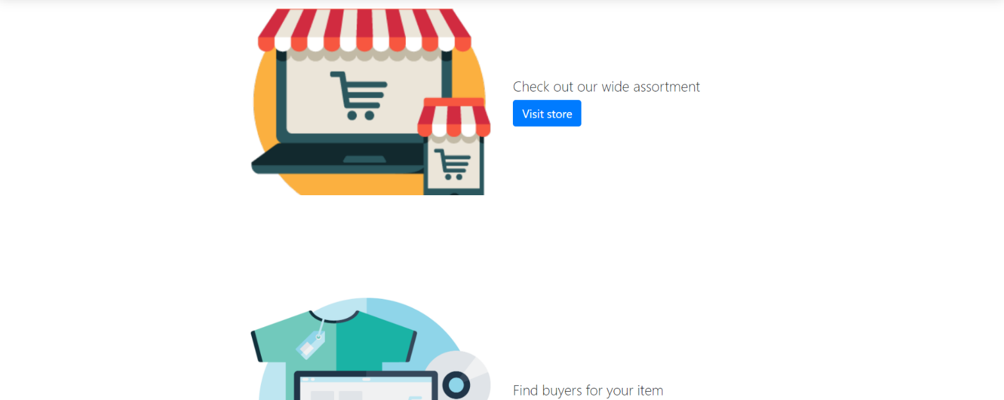 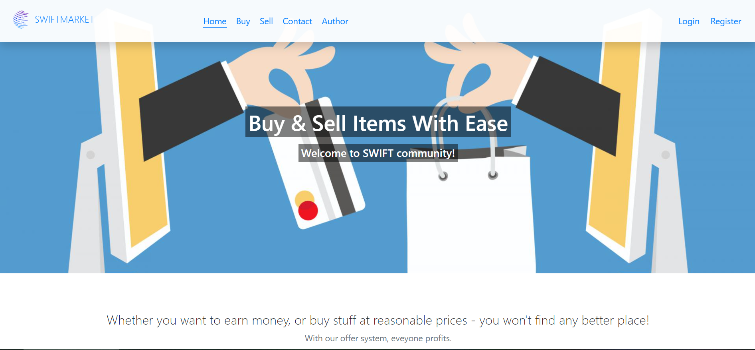

Na ovoj stranici se nalazi samo opšti sadržaj sajta. Cover slika i naslov se učitavaju iz baze na osnovu stranice na kojoj se korisnik nalazi.

Navigacija i korisnički panel (ako je korisnik autorizovan) su učitani iz baze, a tu su i linkovi ka listi želja i informacijama o nalogu, kao i link za odjavu (ako se korisnik nije ulogovao – ponuđeni su mu linkovi za registraciju i login).

### 2.3.2 buy

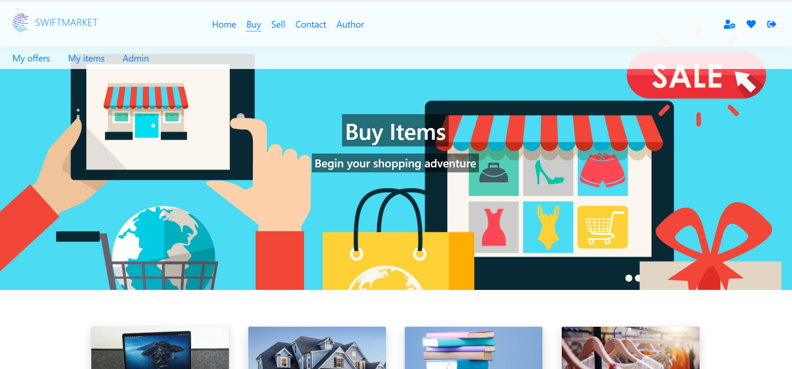

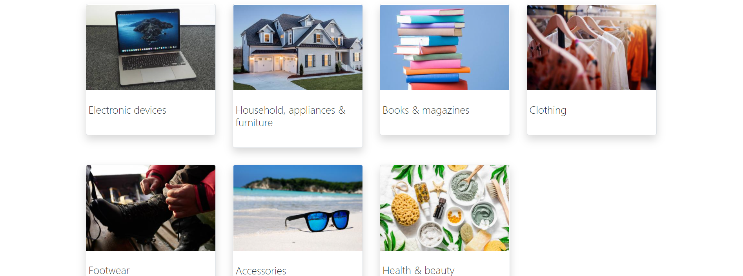

Na ovoj stranici se mogu videti svi sve glavne kategorije (koje nisu potkategorije). Prikazane slike kategorija su thumbnailovi.

Klikom na kategoriju odlazi se na stranicu sa proizvodima koji pripadaju svim njenim potkategorijama.

### 2.3.3 products

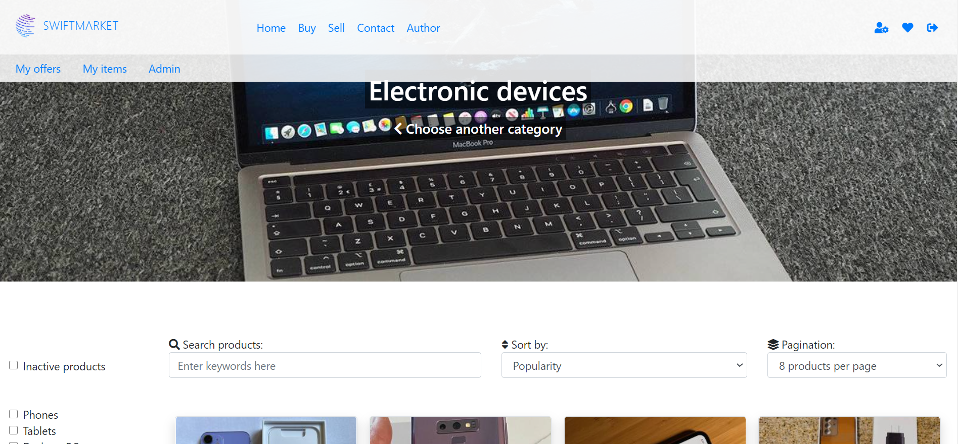



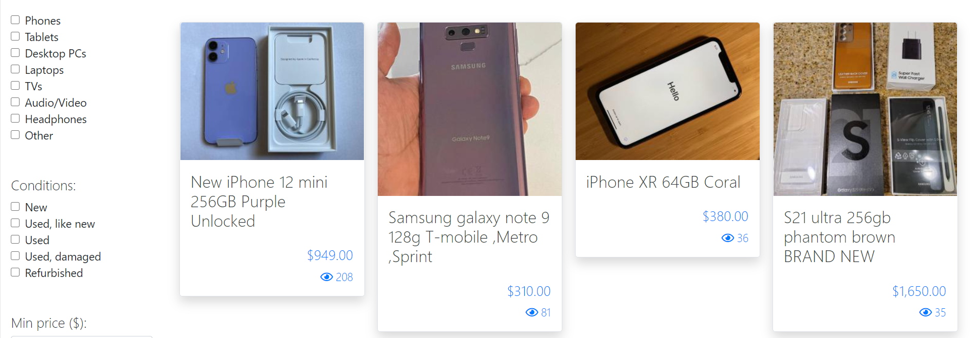

Na ovoj stranici se dinamički prikazuju svi proizvodi iz izabrane glavne kategorije sa thumbnail slikama, cenom i brojem pregleda. Za cover sliku se uzima slika glavne kategorije u punoj veličini.

Korisniku se nude opcije za filtriranje prema potkategorijama, stanju, ceni, lokaciji i u određenim kategorijama prema polu. Tu su i pretraga, sortiranje i straničenje.

Klikom na proizvod odlazi se na stranicu sa informacijama i opcijom za davanje ponude.

### 2.3.4 product

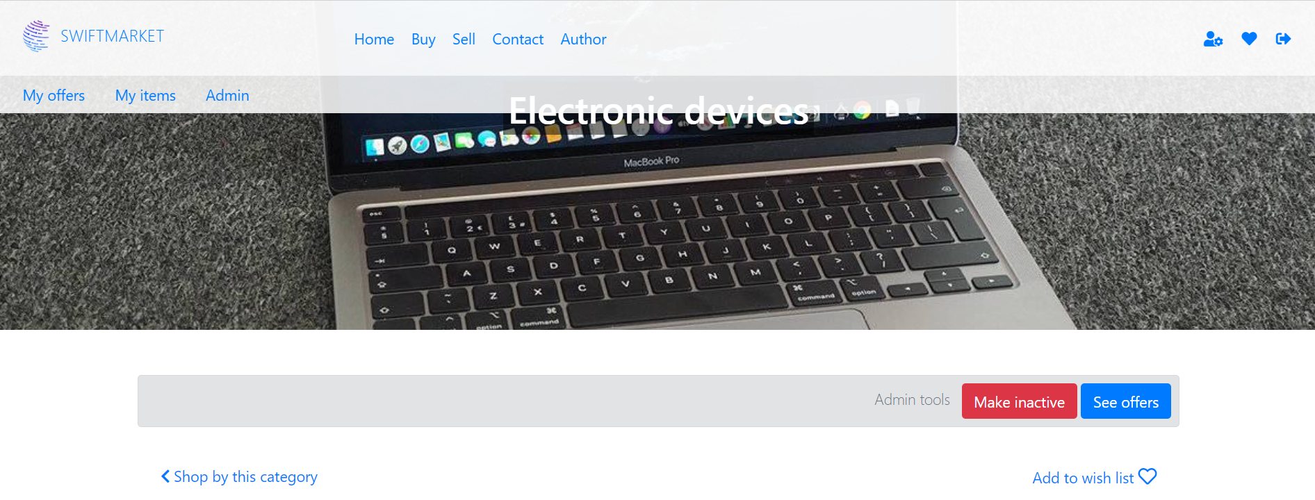

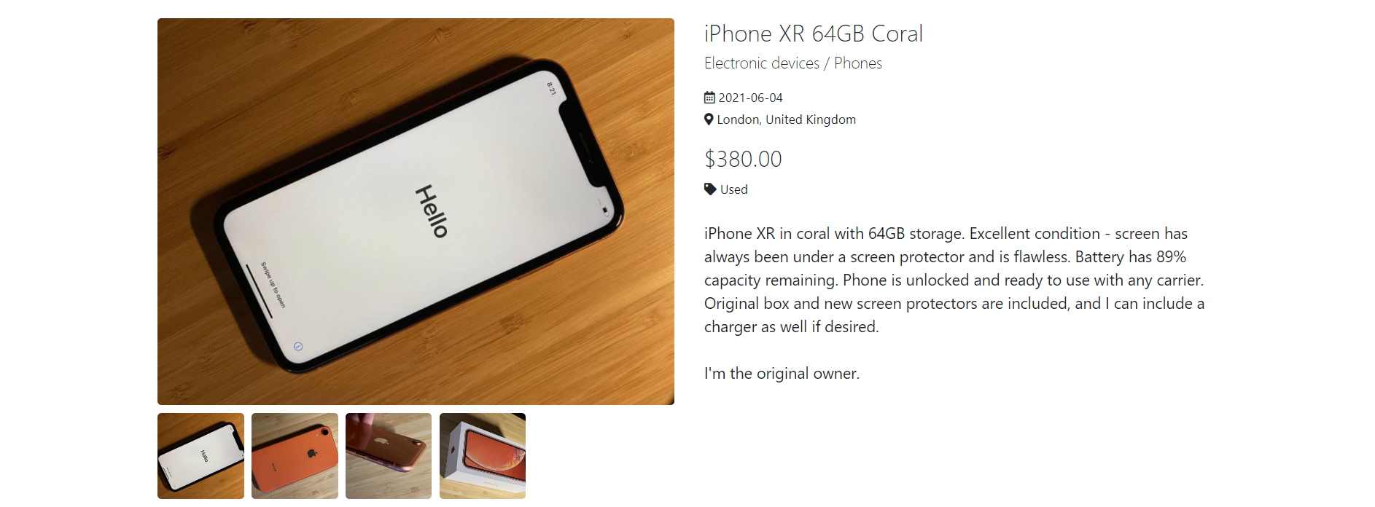



Ova stranica se dinamički popunjava u zavisnosti od toga koji je proizvod izabran, sa svim informacijama o njemu.

Korisnici mogu dodati proizvod na listu želja.

Prikazane su sve slike, jedna trenutno prikazana u punoj veličini, dok su ostale thumbnailovi, a klikom na njih dobija se slika u punom prikazu.

Ispod se nalaze broj pregleda, broj ponuda, prosečna ocena prodavca i polje za davanje ponude.

### 2.3.5 sell

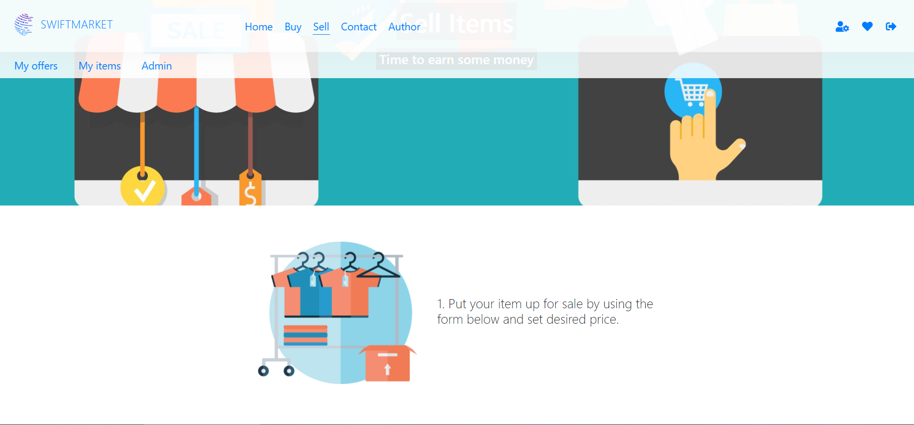 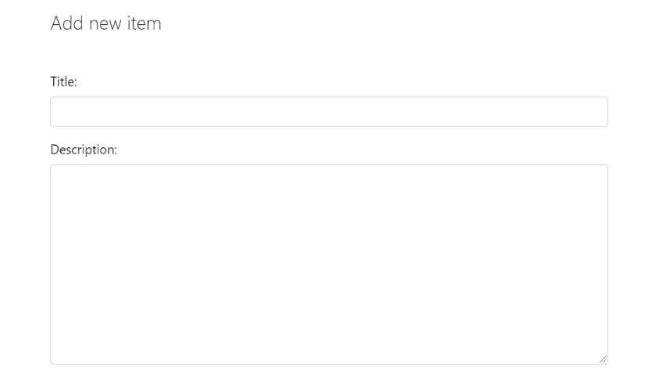

Prvo je objašnjen proces prodavanja proizvoda.

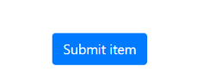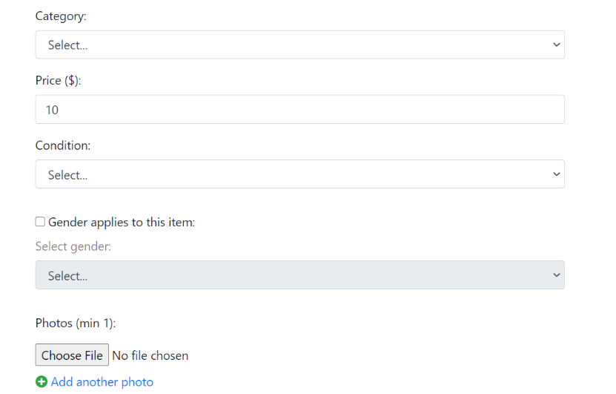Korisnicima se ispod nudi da dodaju nove proizvode kroz formu. Moguće je uploadovati više slika za jedan proizvod.

Svi podaci se proveravaju i na klijentskoj i na serverskoj strani.

### 2.3.4 login

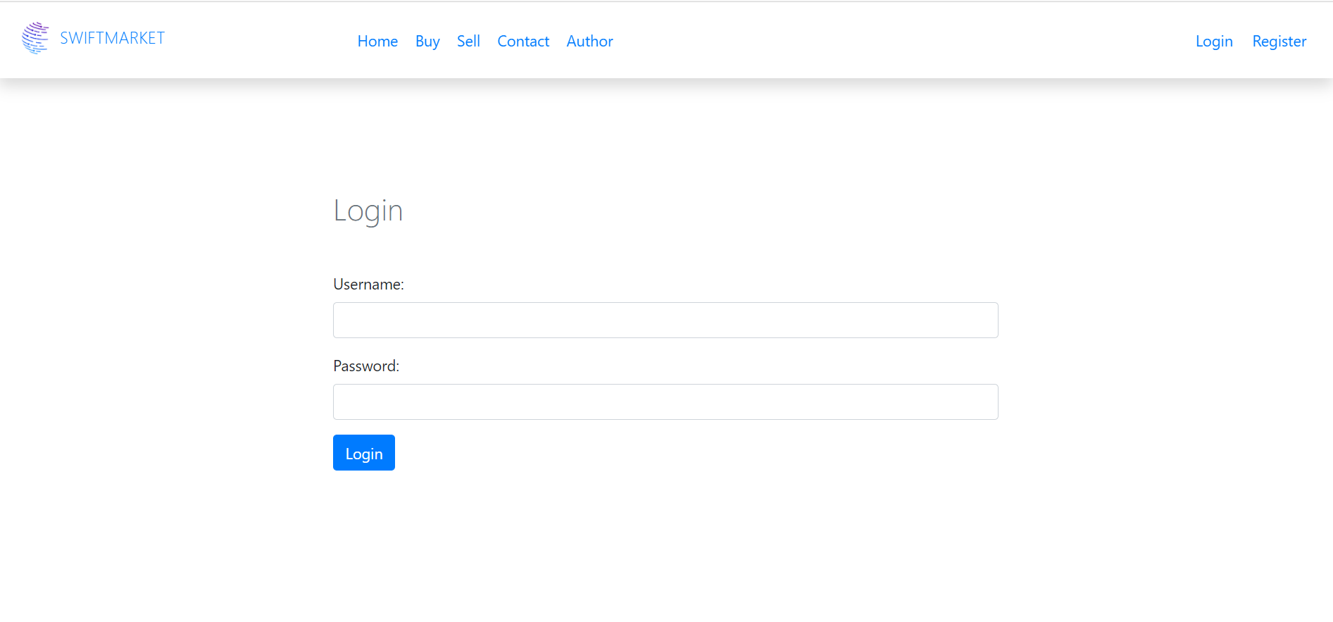

Na ovoj stranici posetioci se mogu ulogovati, a kredencijali se proveravaju na serveru. Polja se takođe proveravaju JavaScriptom kako se ne bi slali bespotrebni zahtevi ka serveru.

Ukoliko nalog postoji, a na klijentu se tri puta pogreši lozinka u roku od 5 minuta – taj nalog se zaključava i vlasniku naloga šalje se mejl sa linkom za otključavanje naloga.

### 2.3.5 register

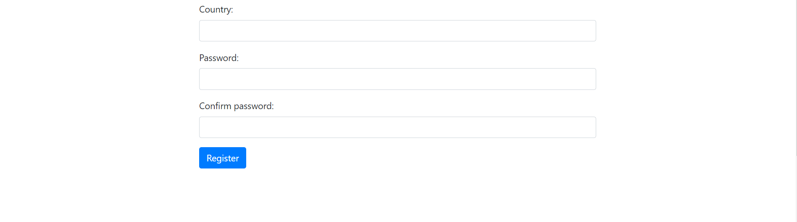

Ovde se vrši registracija novih korisnika, sva polja se proveravaju regularnim izrazima na oba kraja. Takođe, ne mogu se registrovati dva naloga sa istim korisničkim imenom ili imejl adresom, a krajnji korisnik će biti obavešten o ishodu registracije.

Ako je sve ispravno upisuju se podaci u bazu, a lozinke se upisuju samo kao md5 kriptografija.

### 2.3.6 wish-list

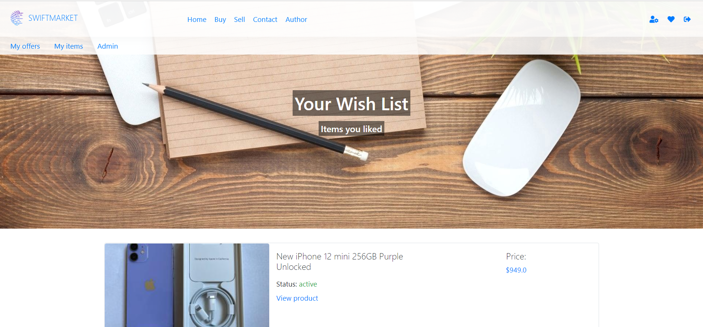

Na ovoj stranici se vidi sadržaj liste želja korisnika (ako ih nema onda se izdaje takva poruka).

Prikazani su i aktivni i neaktivni proizvodi.

### 2.3.7 profile

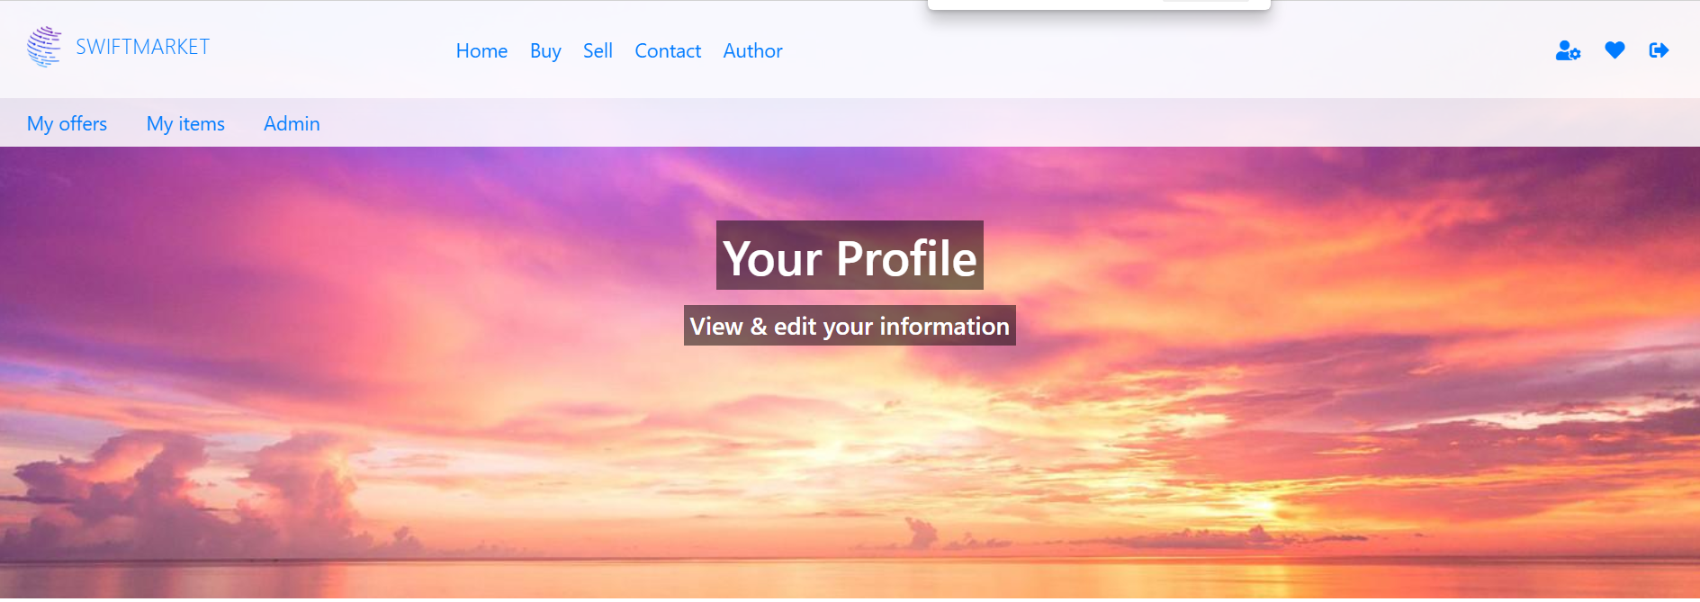



Na ovoj stranici ispisuju se informacije o korisničkom nalogu, a korisniku se takođe nudi promena lozinke. Provera se vrši regularnim izrazima.

### 2.3.8 contact

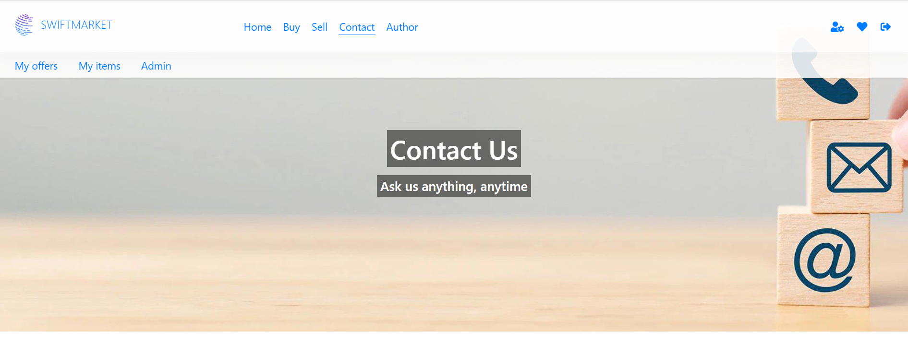

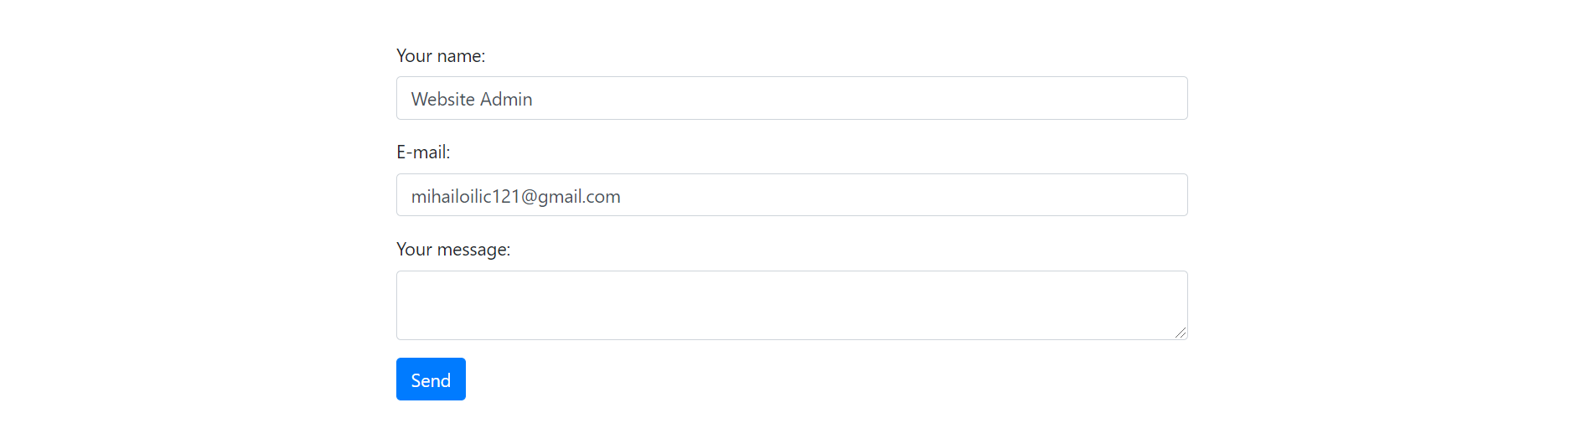

Slanje poruka administratorima sajta moguće je kroz ovu kontakt formu. Ulogovanim korisnicima se automatski popunjavaju ime i imejl adresa. Sadržaj ovih polja proverava se regularnim izrazima.

Poruke se šalju na predefinisanu e-mail adresu za primanje poruka kroz kontakt formu.

### 2.3.9 author

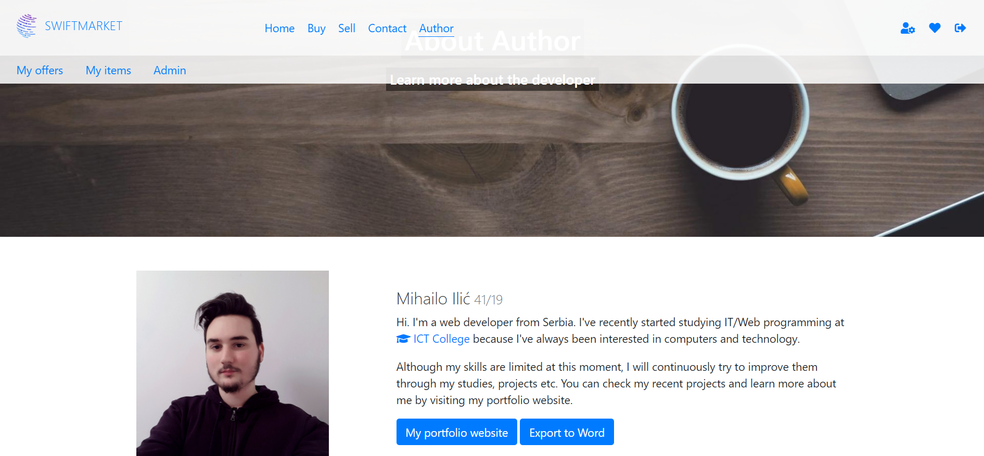

Informacije o autoru se mogu preuzeti u obliku Word dokumenta.

### 2.3.10 user-products

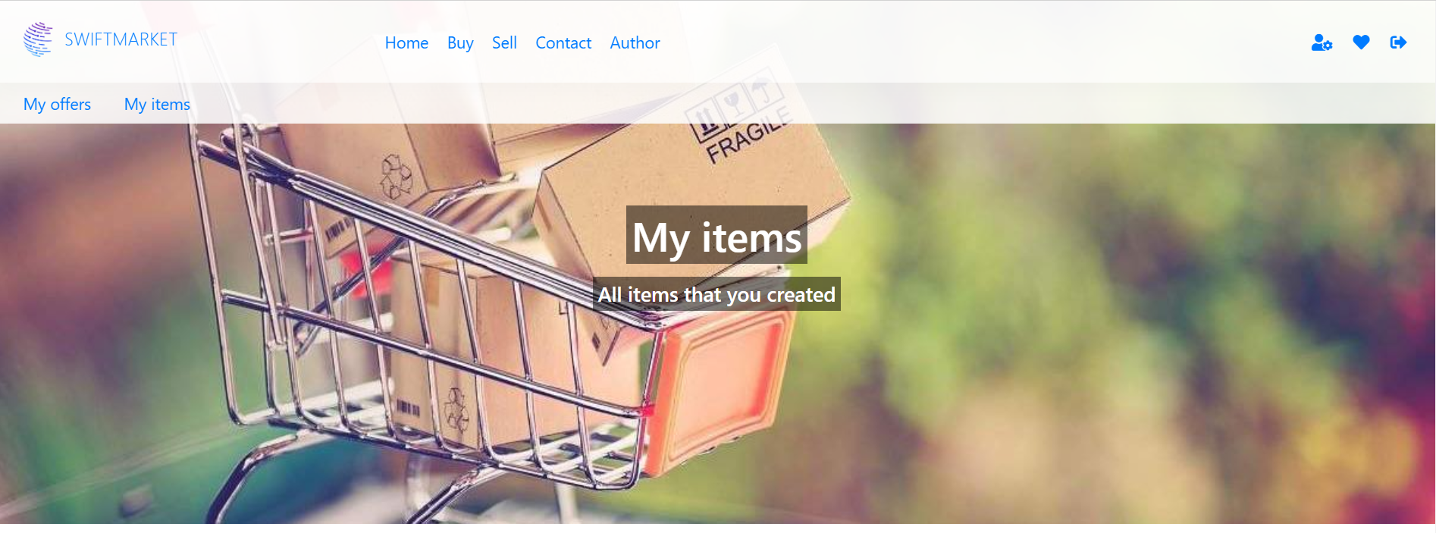

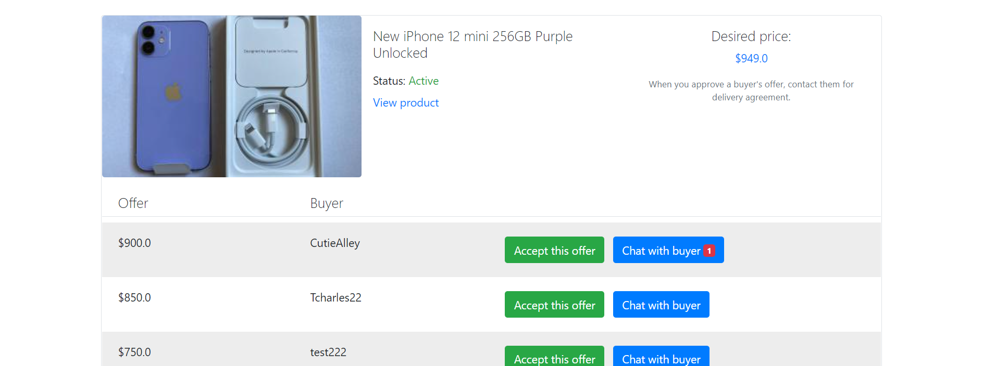

Na ovoj stranici nalaze se svi proizvodi koje je korisnik(prodavac) dodao, zajedno sa ponudama od strane drugih korisnika. Omogućen je i čet između kupca i prodavca.

Prodavac ima opciju da izabere ponudu koja mu najviše odgovara. Na taj način proizvod postaje neaktivan i sve ostale ponude dobijaju status da su odbijene.

Nakon prihvatanja ponude, prodavac i kupac se dogovaraju oko preuzimanja putem četa.

### 2.3.11 user-offers

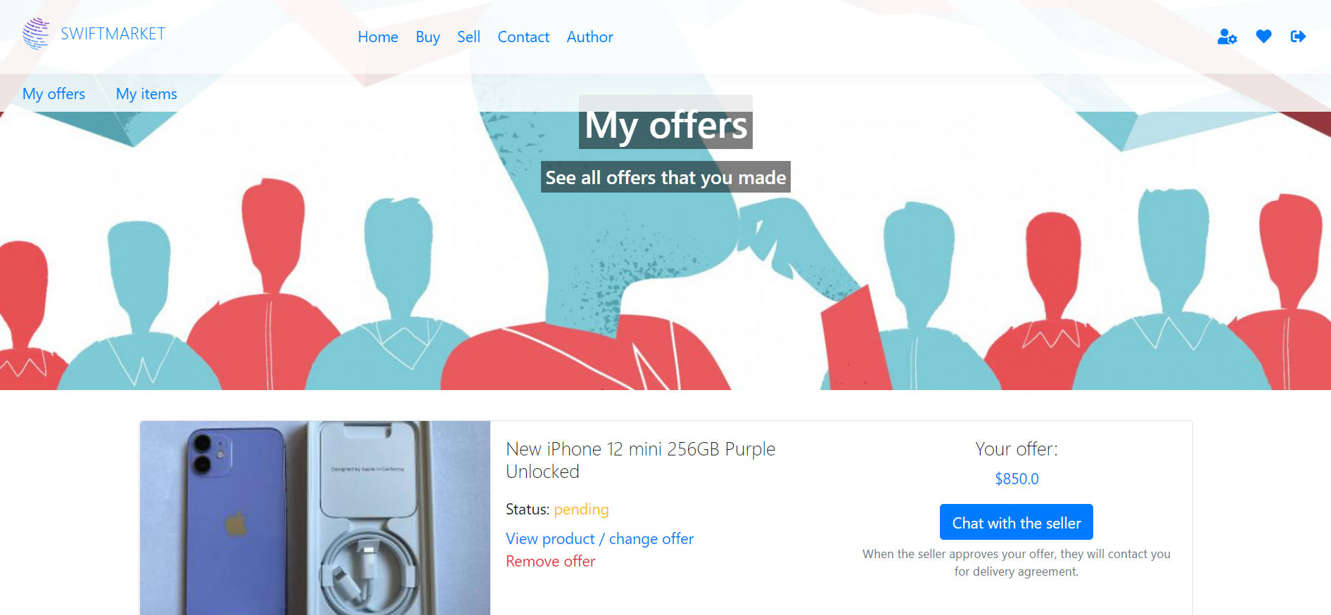

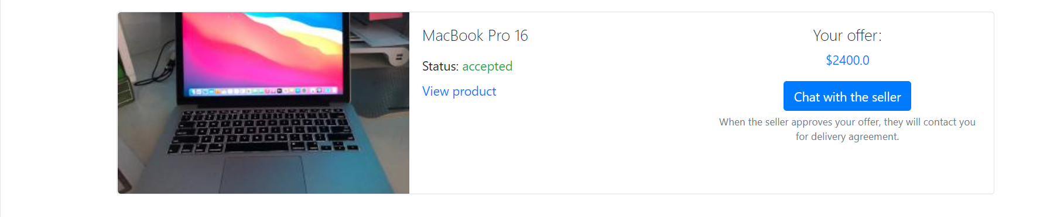

Na ovoj stranici nalaze se sve ponude koje je korisnik dao. Korisnik može da povuče ponudu ili da je izmeni odlaskom na stranicu za proizvod.

Ispisan je i njihov status, a čet sa prodavcem je omogućen ukoliko status proizvoda nije “rejected”. Ukoliko postoje nove poruke pojaviće se crveni bedž u okviru tastera za čet.

### 2.3.12 c-h-a-t

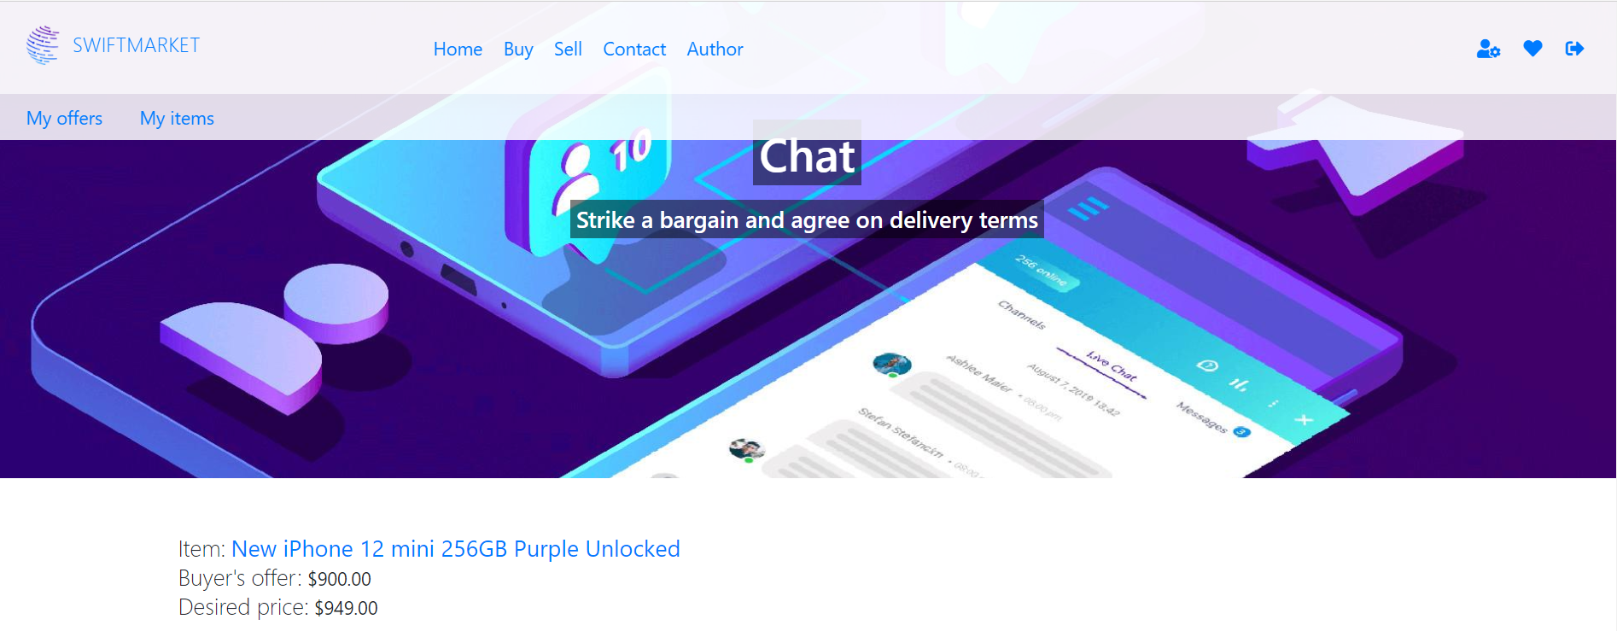

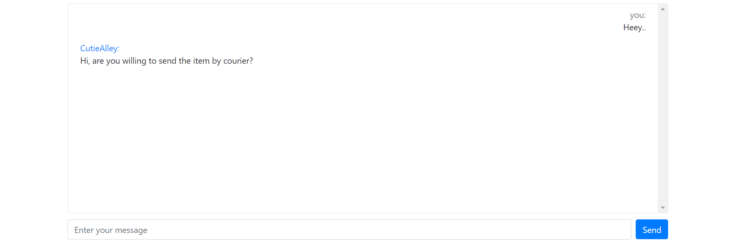

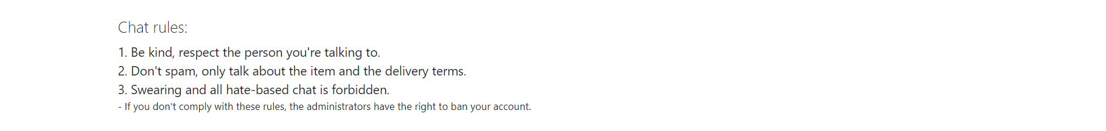

Na ovoj stranici omogućen je razgovor između kupca i prodavca.

Zbog toga što je kod free hosting provajdera blokirana upotreba četa, stranica je nazvana sa crticama između slova i osvežavanje poruka se vrši između 3 i 5 sekundi, kako se server ne bi preopteretio.

Pravila četa su ispisana iz tekstualnog fajla.

### 2.3.13 admin

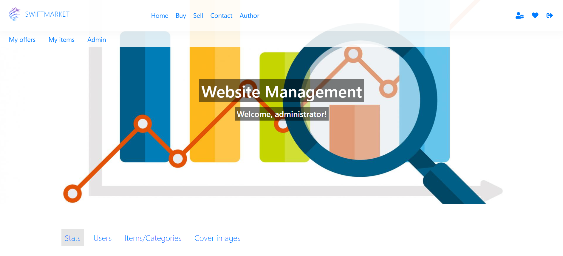

Na ovoj stranici nalaze se opcije namenjene administratoru sajta, i niko drugi ne može da joj pristupi. Podeljena je na tabove realizovane pomoću jQuery biblioteke.

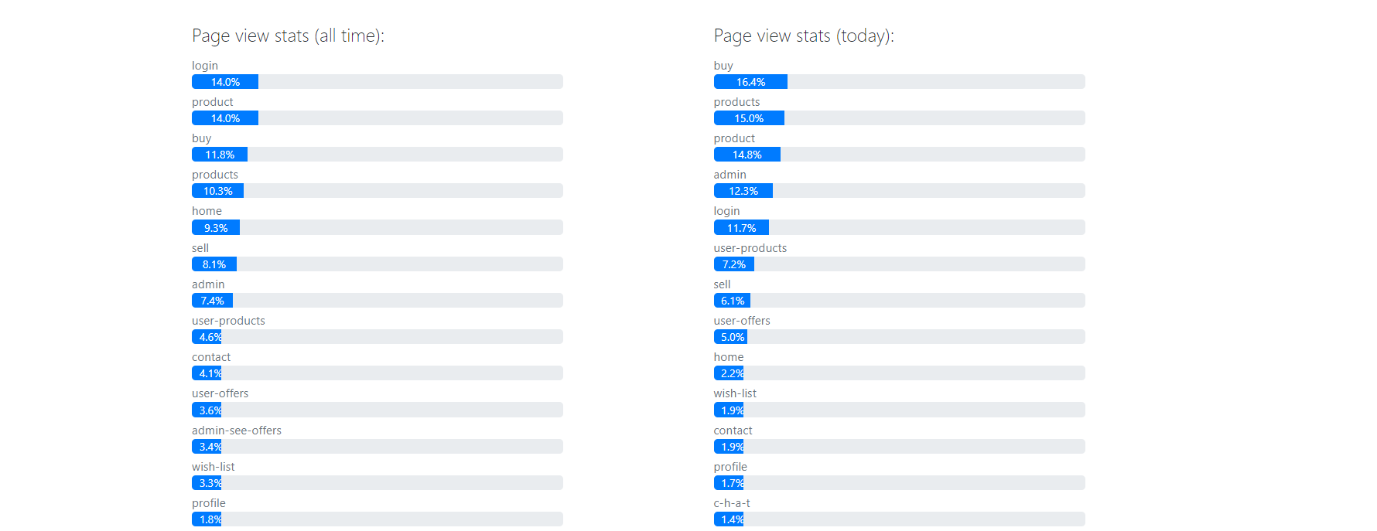

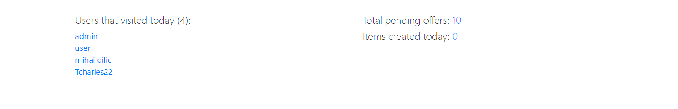

U odeljku Stats nalaze se statističke informacije o pristupu sajtu, kao i broj ponuda na čekanju i broj kreiranih proizvoda tekućeg dana.

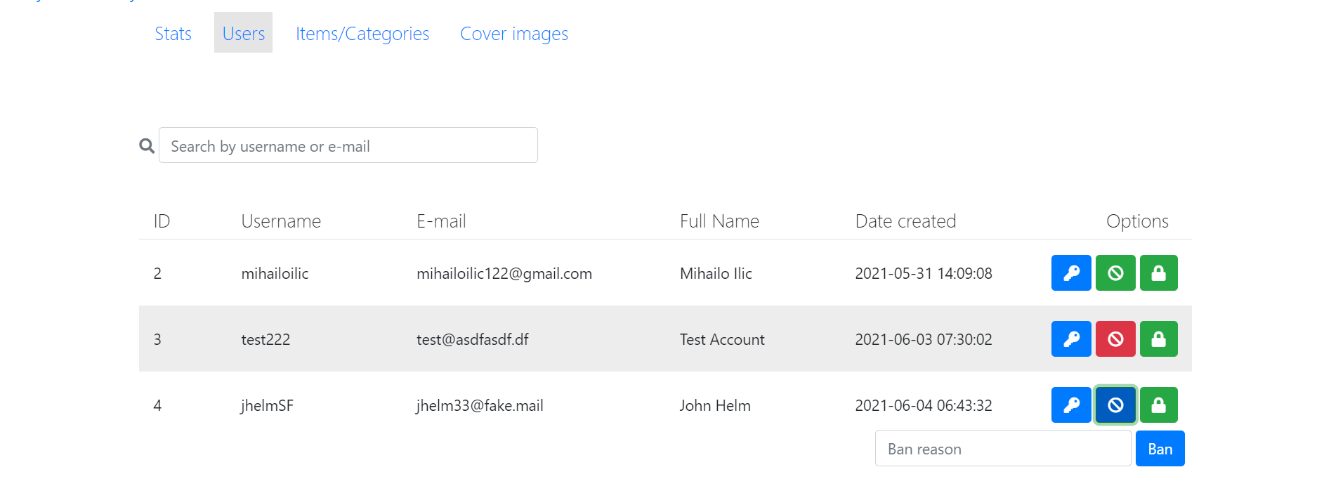

U odeljku Users administrator može da vidi informacije o svim nalozima koji nisu administratorski, i da vrši pretragu istih preko korisničkog imena ili imejl adrese.

Takođe su ponuđene opcije za jednostavnu promenu lozinke, banovanje naloga i otključavanje zaključanih naloga.

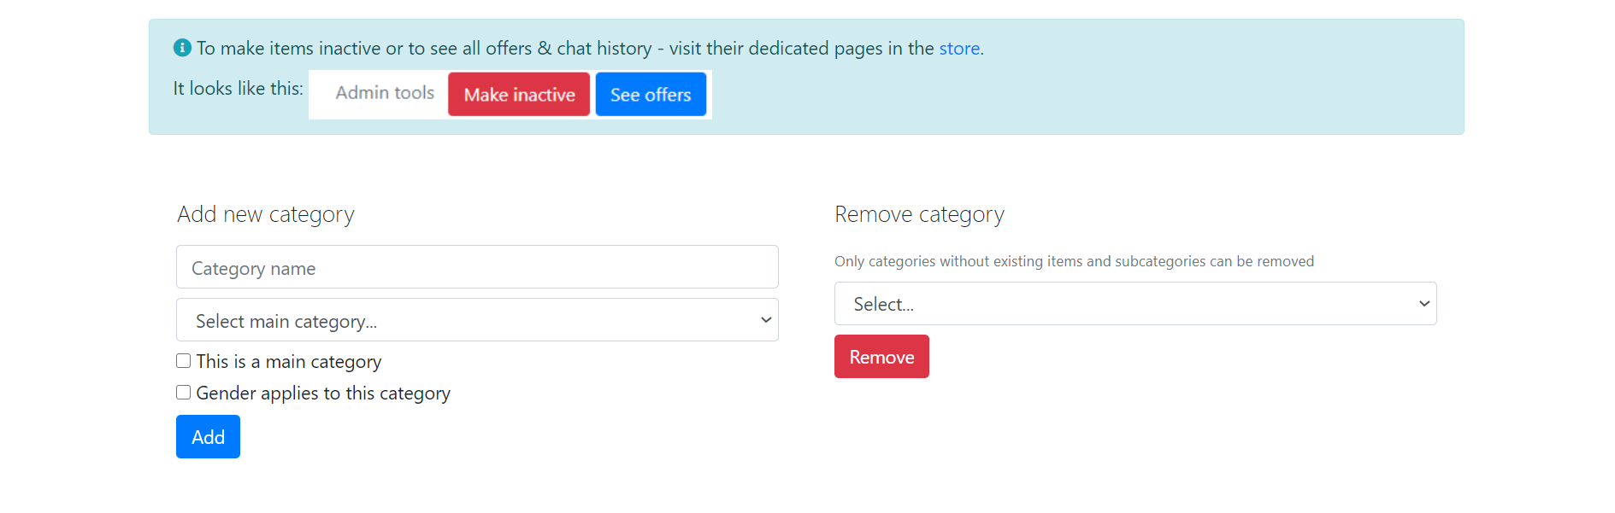

U odeljku Items/Categories administrator može dodavati nove kategorije i potkategorije, a može i brisati postojeće u kojima se ne nalazi nijedan proizvod/potkategorija.

Administrator je takođe obavešten da odlaskom na stranicu za konkretan proizvod dobija opciju da deaktivira proizvod ili vidi ponude za isti.

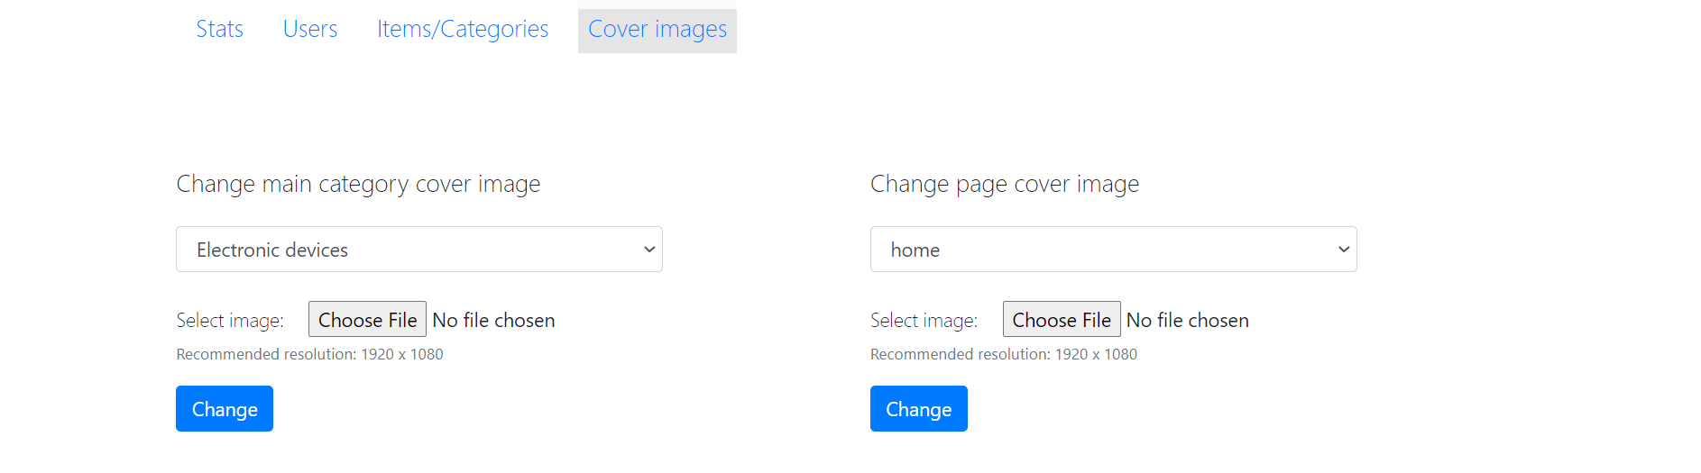

U odeljku Cover images administrator može menjati cover slike stranica i kategorija. Ove slike se koriste i na stranici buy ali u thumbnail varijanti.

### 2.3.14 admin-see-offers

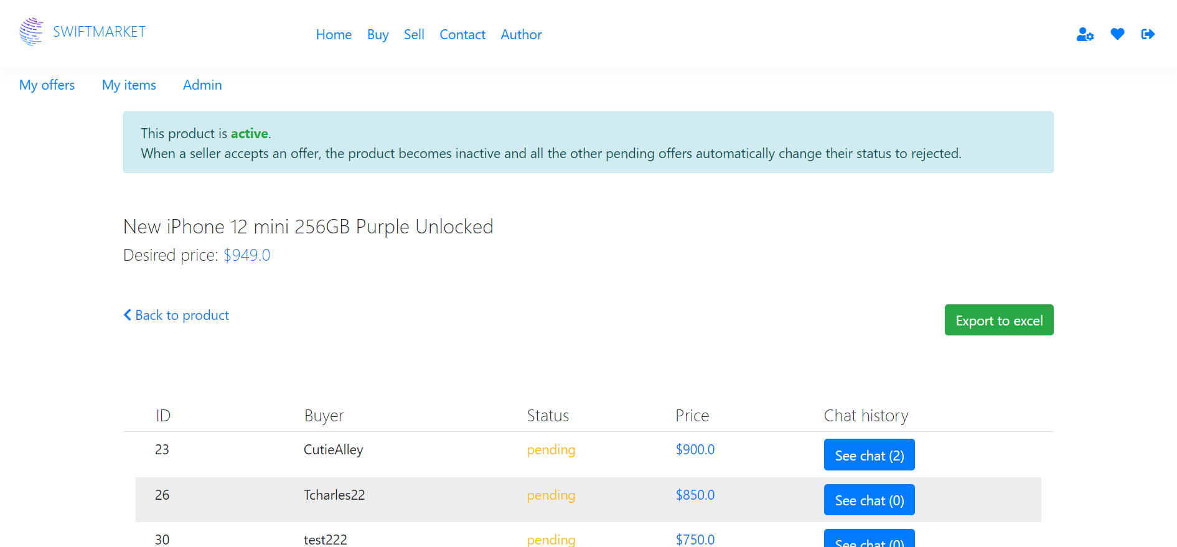

Na ovoj stranici administrator ima mogućnost da vidi sve ponude koje su korisnici dali za određeni proizvod. Tu je i mogućnost pregleda svih poruka između kupca i prodavca.

Spisak ponuda se može preuzeti u Excel formatu.

### 2.3.15 admin-see-chat

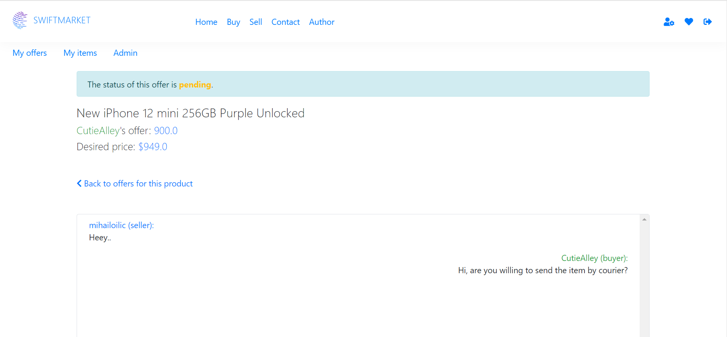

Na ovoj stranici administrator može videti sve poruke između kupca i prodavca za izabranu ponudu.

# 3. Kodovi

## 3.1 PHP

### 3.1.1 index.php

<?php

    ob_start();

    require_once "config/connection.php";

    $this_page = isset($_GET["page"]) ? $_GET["page"] : "home";

    if(!file_exists("views/pages/$this_page.php")){

        header("Location: index.php");

        die();

    }

    $pages = get_pages();

    require_once "views/fixed/head.php";

    require_once "views/fixed/nav.php";

    $file = "views/pages/$this_page.php";

    $info = get_page_info($this_page);

    if($info):

        if(!$user_obj && $info->requires_auth == "1"){

            header("Location: index.php");

            die();

        }

?>

    <main id="<?=$this_page?>">

        <section class="page-image w-100 d-flex flex-column justify-content-center align-items-center">

                <img id="page-bg-image" class="w-100 h-100"

                    src="assets/images/<?=$info->image_filename?>"

                    alt="<?=$info->image_title?>" />

                <h1 class="d-inline">

                    <?=$info->page_title?>

                </h1>

                <h2 class="d-inline mt-1 h5">

                    <?=$info->page_description?>

                </h2>

        </section>

        <?php

            require_once $file;

        ?>

    </main>

<?php

    else:

        require_once $file;

    endif;

    ob_end_flush();

    require_once "views/fixed/footer.php";

?>

### 3.1.2 views/fixed/head.php

<!DOCTYPE html>

<html lang="en">

<head>

    <meta charset="UTF-8">

    <meta name="viewport" content="width=device-width, initial-scale=1.0">

    <title>SWIFTMARKET - Buy & Sell Items With Ease</title>

    <meta name="keywords" content=""/>

    <meta name="author" content="Mihailo Ilic"/>

    <link rel="shortcut icon" href="favicon.ico" type="image/x-icon"/>

    <link rel="stylesheet" type="text/css" href="https://cdnjs.cloudflare.com/ajax/libs/font-awesome/5.15.2/css/all.min.css"/>

    <link rel="stylesheet" href="assets/css/bootstrap.min.css"/>

    <link rel="stylesheet" href="assets/css/style.css"/>

</head>

<body>

### 3.1.3 views/fixed/nav.php

<?php

            $nav_string = "";

            foreach($pages as $link){

                if($link->show_on_nav == "0"){

                    continue;

                }

                $active = $this_page==$link->page_name ? "active" : "";

                $link_title = ucfirst($link->page_name);

                $nav_string .= "<li class='m-2'>

                <a class='$active' href='index.php?page=$link->page_name'>$link_title</a>

                </li>";

            }

?>

<header id="header" class="position-fixed w-100 m-0 row align-items-center shadow">

        <div class="col-3 col-sm-6 col-md-4 col-lg-3">

            <!--*logo*-->

            <a class="font-weight-bold" href="index.php?page=home">

                <img src="assets/img/logo.png" alt="swiftmarket" id="logo-img"/>

                <span id="logo-title" class="d-none d-sm-inline font-weight-light"> SWIFTMARKET</span>

            </a>

        </div>

        <!--*glavni meni*-->

        <nav class="col-6 col-md-5 col-lg-6 d-none d-md-block">

            <ul id="menu" class="w-100 m-0 d-flex justify-content-start">

                <?=$nav_string?>

            </ul>

        </nav>

        <!--*opcije vezane za nalog, responsive meni toggle*-->

        <div id="side-togglers" class="col-9 col-sm-6 col-md-3 text-right">

            <?php

                if($user_obj):

            ?>

            <a class="position-relative d-inline mx-2 color-primary" href="index.php?page=profile">

                <span class="fas fa-user-cog"></span>

            </a>

            <a class="position-relative d-inline mx-2 color-primary" href="index.php?page=wish-list">

                <span class="fas fa-heart"></span>

            </a>

            <a class="position-relative d-inline mx-2 color-primary" href="models/users/logout.php">

                <span class="fas fa-sign-out-alt"></span>

            </a>

            <?php

                else:

            ?>

            <a class="position-relative d-inline mx-2 color-primary" href="index.php?page=login">

                Login

            </a>

            <a class="position-relative d-inline mx-2 color-primary" href="index.php?page=register">

                Register

            </a>

            <?php

                endif;

            ?>

            <a id="menu-button" class="position-relative d-inline d-md-none ml-3 mr-2 color-primary" href="#!">

                <span class="fas fa-bars"></span>

            </a>

        </div>

        <!--*user meni*-->

        <?php

            if($user_obj):

        ?>

        <nav id="user-menu-wrapper" class="position-absolute w-100 px-2">

            <ul id="user-menu" class="w-100 m-0 d-flex align-items-center">

                    <li class="m-2 mx-sm-3">

                        <a  href="index.php?page=user-offers">My offers</a>

                    </li>

                    <li class="m-2 mx-sm-3">

                        <a  href="index.php?page=user-products">My items</a>

                    </li>

                    <?php

                        if($user_obj->role_name == "Administrator"):

                    ?>

                        <li class="m-2 mx-sm-3">

                            <a  href="index.php?page=admin">Admin</a>

                        </li>

                    <?php

                        endif;

                    ?>

                </ul>

        </nav>

        <?php

            endif;

        ?>

        <!--*responsive meni*-->

        <nav id="responsive-menu-wrapper" class="position-absolute w-100 py-3 d-md-none">

            <ul id="responsive-menu" class="w-100 m-0 d-flex flex-column align-items-center">

                <?=$nav_string?>

            </ul>

        </nav>

</header>

### 3.1.4 views/fixed/footer.php

    <footer class="position-relative bg-light-trans w-100 border-top row m-0 pt-5">

        <div id="footer-company-info" class="col-12 col-md-4 text-center">

            <a class="font-weight-bold" href="index.php?page=home">

                <img src="assets/img/logo.png" id="footer-img"/><span class="h5 font-weight-light"> SWIFTMARKET</span>

            </a>

            <p class="text-muter text-center font-weight-light">Easy buying & selling</p>

        </div>

        <div id="footer-links" class="col-12 col-md-4 text-center mt-5 mt-md-0">

            <h5 id="footer-links-title" class="d-inline font-weight-light">Links</h5>

            <ul class="mt-2">

                <li>

                    <a href="documentation.pdf" target="_blank"><span class="far fa-file-pdf"></span> Documentation</a>

                </li>

                <li>

                    <a href="assets/js/main.js" target="_blank"><span class="far fa-file-code"></span> main.js</a>

                </li>

            </ul>

        </div>

        <p class="col-12 col-md-4 text-center text-muted pt-4 mt-5 mt-md-0">Mihailo Ilic 41/19</p>

    </footer>

    <script type="text/javascript" src="assets/js/jquery-3.5.1.min.js"></script>

    <script type="text/javascript" src="assets/js/main.js"></script>

</body>

</html>

### 3.1.5 views/pages/admin-see-chat.php

<?php

    if(!($user_obj && $user_obj->role_name == "Administrator" && isset($_GET["id"]))){

        header("Location: index.php?page=home");

        die();

    }

    require_once "models/admin/functions.php";

    $offer_id = $_GET["id"];

    $chat = get_chat_by_offer($offer_id);

    if($chat[0]->offer_status == "0"){

        $status_html = "<span class='text-warning font-weight-bold'>pending</span>";

    }

    elseif($chat[0]->offer_status == "1") {

        $status_html = "<span class='text-success font-weight-bold'>accepted</span>";

    }

    else {

        $status_html = "<span class='text-danger font-weight-bold'>rejected</span>";

    }

?>

<section id="admin-see-chat" class="custom container px-3">

    <p class="alert alert-info col-12 mt-3 mx-auto">

        The status of this offer is <?=$status_html?>.

    </p>

    <h1 class="font-weight-light h4"><?=$chat[0]->product_title?></h1>

    <h2 class="font-weight-light h5"><span class="text-success"><?=$chat[0]->buyer?></span>'s offer: <span class="text-primary"><?=$chat[0]->offer_price?></span></h2>

    <h2 class="font-weight-light h5">Desired price: <span class="text-primary">$<?=$chat[0]->product_price?></span></h2>

    <div class="my-5">

        <a href="index.php?page=admin-see-offers&id=<?=$chat[0]->product_id?>"><span class="fas fa-chevron-left"></span> Back to offers for this product</a>

    </div>

    <div class="border container-fluid rounded" id="admin-see-chat-box">

        <?php

            if($chat[0]->message_id === null):

        ?>

            <div class="message clearfix p-2">

                No messages

            </div>

        <?php

            else:

                foreach($chat as $message):

                    if($message->username == $chat[0]->buyer):

        ?>

                        <div class="message clearfix p-2">

                        <div class="message-sender w-75 w-md-50 text-success text-right float-right"><?=$message->username?> (buyer):</div>

                        <div class="message-content w-75 w-md-50 text-right float-right"><?=$message->message_text?></div>

        <?php

                    else:

        ?>

                        <div class="message clearfix p-2">

                            <div class="message-sender w-75 w-md-50 text-primary text-left"><?=$message->username?> (seller):</div>

                            <div class="message-content w-75 w-md-50 text-left"><?=$message->message_text?></div>

                        </div>

        <?php

                    endif;

                endforeach;

            endif;

        ?>

    </div>

</section>

### 3.1.6 views/pages/admin-see-offers.php

<?php

    if(!($user_obj && $user_obj->role_name == "Administrator" && isset($_GET["id"]))){

        header("Location: index.php?page=home");

        die();

    }

    require_once "models/admin/functions.php";

    $product_id = $_GET["id"];

    $offers = get_offers_by_product($product_id);

    if($offers[0]->active == "1"){

        $status_html = "<span class='text-success font-weight-bold'>active</span>";

    }

    else {

        $status_html = "<span class='text-danger font-weight-bold'>inactive</span>";

    }

?>

<section id="admin-see-offers" class="custom container px-3">

    <p class="alert alert-info col-12 mt-3 mx-auto">

        This product is <?=$status_html?>.<br/>

        When a seller accepts an offer, the product becomes inactive and all the other pending offers automatically change their status to rejected.

    </p>

    <h1 class="font-weight-light h4 mt-5"><?=$offers[0]->product_title?></h1>

    <h2 class="font-weight-light h5">Desired price: <span class="text-primary">$<?=$offers[0]->product_price?></span></h2>

    <div class="my-5">

        <a href="index.php?page=product&id=<?=$product_id?>"><span class="fas fa-chevron-left"></span> Back to product</a>

        <a href="models/admin/export-offers-to-excel.php?id=<?=$product_id?>" class="btn btn-success float-right">Export to excel</a>

    </div>

    <div id="admin-offers-wrapper" class="containter-fluid pt-5 mt-5">

        <div class="admin-offers-info row m-0 border-bottom px-4">

            <div class="col-2 h5 font-weight-light">ID</div>

            <div class="col-3 h5 font-weight-light">Buyer</div>

            <div class="col-2 h5 font-weight-light">Status</div>

            <div class="col-2 h5 font-weight-light">Price</div>

            <div class="col-3 h5 font-weight-light">Chat history</div>

        </div>

        <div id="admin-offers" class="container-fluid">

            <?php

                if($offers[0]->offer_id === null):

            ?>

                    <div class="col-12 h5 font-weight-light p-3">No offers to show</div>

            <?php

                else:

                    foreach($offers as $offer):

                        switch($offer->offer_status){

                            case "0":

                                $class = "text-warning";

                                $text = "pending";

                                break;

                            case "1":

                                $class = "text-success";

                                $text = "accepted";

                                break;

                            case "2":

                                $class = "text-danger";

                                $text = "rejected";

                                break;

                            default:

                                $class = "";

                                $text = "unknown";

                        }

            ?>

                <div class="admin-offer-row row m-0 p-2">

                    <div class="col-2"><?=$offer->offer_id?></div>

                    <div class="col-3"><?=$offer->buyer_username?></div>

                    <div class="col-2 <?=$class?>"><?=$text?></div>

                    <div class="col-2 text-primary">$<?=$offer->offer_price?></div>

                    <div class="col-3">

                        <a href="index.php?page=admin-see-chat&id=<?=$offer->offer_id?>" class="btn btn-primary">See chat (<?=$offer->message_count?>)</a>

                    </div>

                </div>

            <?php

                    endforeach;

                endif;

            ?>

        </div>

    </div>

</section>

### 3.1.7 views/pages/admin.php

<section id="admin-panel-wrapper" class="container py-3 mx-auto">

    <?php

        if(!($user_obj && $user_obj->role_name == "Administrator")){

            header("Location: index.php?page=home");

            die();

        }

        require_once "models/admin/functions.php";

        if(isset($_GET["message"])){

            echo "<p class='alert alert-info mt-3 mx-auto'>".$_GET["message"]."</p>";

        }

        if(isset($_GET["error"])){

            echo "<p class='alert alert-danger mt-3 mx-auto'>".$_GET["error"]."</p>";

        }

        $classes = [

            "stats"=> ["nav"=>"", "content"=>"d-none"],

            "users"=> ["nav"=>"", "content"=>"d-none"],

            "covers" => ["nav"=>"", "content"=>"d-none"],

            "products" => ["nav"=>"", "content"=>"d-none"]

        ];

        $panel = "stats";

        if(isset($_GET["panel"])){

            $panel = $_GET["panel"];

        }

        $classes[$panel] = ["nav"=>"active", "content"=>""];

    ?>

    <ul id="admin-nav" class="h5 font-weight-light d-flex flex-column flex-md-row my-5 pb-4">

        <li class="p-2">

            <a href="#!" class="p-2 admin-panel-link <?=$classes["stats"]["nav"]?>" data-target="#admin-panel-stats">Stats</a>

        </li>

        <li class="p-2">

            <a href="#!" class="p-2 admin-panel-link <?=$classes["users"]["nav"]?>" data-target="#admin-panel-users">Users</a>

        </li>

        <li class="p-2">

            <a href="#!" class="p-2 admin-panel-link <?=$classes["products"]["nav"]?>" data-target="#admin-panel-products">Items/Categories</a>

        </li>

        <li class="p-2">

            <a href="#!" class="p-2 admin-panel-link <?=$classes["covers"]["nav"]?>" data-target="#admin-panel-covers">Cover images</a>

        </li>

    </ul>

    <div class="p-2 admin-panel <?=$classes["stats"]["content"]?> row" id="admin-panel-stats">

        <?php

            $stats = get_stats();

            $stats_today = get_stats(true);

        ?>

                <div class="col-12 col-md-6 my-3">

                    <h3 class="font-weight-light h5">Page view stats (all time):</h3>

        <?php

                foreach($stats["page_percentages"] as $key=>$value):

        ?>

                    <span class="text-muted small"> <?=$key?></span><span class="progress">

                        <div class="progress-bar px-2" role="progressbar" aria-valuenow="<?=(int)$value?>"

                        aria-valuemin="0" aria-valuemax="100"><?=$value?>%</div>

                    </span>

        <?php

                endforeach;

        ?>

                </div>

                <div class="col-12 col-md-6 my-3">

                    <h3 class="font-weight-light h5">Page view stats (today):</h3>

        <?php

                foreach($stats_today["page_percentages"] as $key=>$value):

        ?>

                    <span class="text-muted small"> <?=$key?></span><span class="progress">

                        <div class="progress-bar px-2" role="progressbar" aria-valuenow="<?=(int)$value?>"

                        aria-valuemin="0" aria-valuemax="100"><?=$value?>%</div>

                    </span>

        <?php

                endforeach;

        ?>

                </div>

                <div class="col-12 col-md-6 my-3">

                    <h3 class="font-weight-light h5">Users that visited today (<?=count($stats_today["users"])?>):</h3>

                    <ul class="">

                        <?php

                            foreach($stats_today["users"] as $user):

                        ?>

                        <li class="text-primary">

                            <?=$user?>

                        </li>

                        <?php

                            endforeach;

                        ?>

                    </ul>

                </div>

                <div class="col-12 col-md-6 my-3">

                    <h3 class="font-weight-light h5">Total pending offers: <span class="text-primary"><?=pending_offers()?></span></h3>

                    <h3 class="font-weight-light h5">Items created today: <span class="text-primary"><?=products_created_today()?></span></h3>

                </div>

    </div>

    <div class="admin-panel <?=$classes["users"]["content"]?> py-2" id="admin-panel-users">

        <span class="fas fa-search text-muted"></span>

        <input type="text" id="search-users" class="form-control d-inline" placeholder="Search by username or e-mail" />

        <div id="users-wrapper" class="containter-fluid pt-5">

            <div class="user-info row m-0 border-bottom">

                <div class="col-1 user-id h5 font-weight-light">ID</div>

                <div class="col-2 username h5 font-weight-light">Username</div>

                <div class="col-3 user-email h5 font-weight-light">E-mail</div>

                <div class="col-2 user-full-name h5 font-weight-light">Full Name</div>

                <div class="col-2 user-date-created h5 font-weight-light">Date created</div>

                <div class="col-2 h5 font-weight-light text-right pr-4">Options</div>

            </div>

            <div id="users">

            </div>

        </div>

    </div>

    <div class="admin-panel <?=$classes["covers"]["content"]?> py-2 row" id="admin-panel-covers">

        <div class="col-12 col-md-6 my-3">

            <h3 class="font-weight-light h5 mb-4">Change main category cover image</h3>

            <form action="models/admin/change-cover-image.php" method="post" enctype="multipart/form-data" id="admin-change-category-cover-form">

                <input type="hidden" name="type" value="category"/>

                <select name="category-id" class="admin-panel-covers-select form-control">

            <?php

                require_once "models/products/functions.php";

                $main_cats = get_categories(true);

                foreach($main_cats as $cat):

            ?>

                    <option value="<?=$cat->category_id?>"><?=$cat->category_name?></option>

            <?php

                endforeach;

            ?>

                </select><br/>

                <span class="font-weight-light mr-3">Select image:</span>

                <input type="file" name="cover-image" /><br/>

                <small class="text-muted">Recommended resolution: 1920 x 1080</small><br/>

                <button type="submit" name="btn-change" class="mt-3 btn btn-primary">Change</button>

            </form>

        </div>

        <div class="col-12 col-md-6 my-3">

            <h3 class="font-weight-light h5 mb-4">Change page cover image</h3>

            <form action="models/admin/change-cover-image.php" method="post" enctype="multipart/form-data" id="admin-change-page-cover-form">

                <input type="hidden" name="type" value="page"/>

                <select name="page-id" class="admin-panel-covers-select form-control">

            <?php

                require_once "models/functions.php";

                $pages = get_pages();

                foreach($pages as $page):

            ?>

                    <option value="<?=$page->page_id?>"><?=$page->page_name?></option>

            <?php

                endforeach;

            ?>

                </select><br/>

                <span class="font-weight-light mr-3">Select image:</span>

                <input type="file" name="cover-image" /><br/>

                <small class="text-muted">Recommended resolution: 1920 x 1080</small><br/>

                <button type="submit" name="btn-change" class="mt-3 btn btn-primary">Change</button>

            </form>

        </div>

    </div>

    <div class="admin-panel <?=$classes["products"]["content"]?> py-2 row" id="admin-panel-products">

        <div class="alert alert-info col-12"><span class="fas fa-info-circle text-info"></span> To make items inactive or to see all offers & chat history - visit their dedicated pages in the <a href="index.php?page=buy">store</a>.<br/>

        It looks like this: <img class="mt-2" src="assets/img/admin-demo.png" alt="admin demo"/>

        </div>

        <form action="models/admin/add-category.php" method="post" id="admin-add-category" class="col-12 col-md-6 p-4">

            <h3 class="h5 font-weight-light my-3">Add new category</h3>

            <input type="text" name="name" id="category-name" class="form-control" placeholder="Category name"/>

            <select name="main" id="main-cat" class="form-control mt-2">

                <option value="0">Select main category...</option>

                <?php

                    $main_cats = get_categories(true);

                    foreach($main_cats as $cat):

                ?>

                        <option value="<?=$cat->category_id?>"><?=$cat->category_name?></option>

                <?php

                    endforeach;

                ?>

            </select>

            <div class="form-check pl-0  mt-1">

                <input type="checkbox" name="is-main" id="is-main-cat" value="true" />

                <label class="form-check-label" for="is-main-cat">

                This is a main category

                </label>

            </div>

            <div class="form-check pl-0  mt-1">

                <input type="checkbox" name="gender-applies" id="gender-applies" value="true" />

                <label class="form-check-label" for="gender-applies">

                Gender applies to this category

                </label>

            </div>

            <button type="submit" name="btn-add" class="btn btn-primary mt-2">Add</button>

        </form>

        <form action="models/admin/remove-category.php" method="post" id="admin-remove-category" class="col-12 col-md-6 p-4">

            <h3 class="h5 font-weight-light my-3">Remove category</h3>

            <small class="text-muted">Only categories without existing items and subcategories can be removed</small>

            <select name="remove-category-id" id="remove-category-id" class="form-control mt-2">

                <option value="0">Select...</option>

                    <?php

                        $arranged_categories = arrange_categories(get_categories());

                        foreach($arranged_categories as $cat):

                    ?>

                        <optgroup label="<?=$cat["name"]?>">

                        <option value="<?=$cat["id"]?>">Main category: <?=$cat["name"]?></option>

                        <?php

                            foreach($cat["subcategories"] as $subcat):

                        ?>

                                <option value="<?=$subcat["id"]?>"><?=$subcat["name"]?></option>

                        <?php

                            endforeach;

                        ?>

                        </optgroup>

                    <?php

                        endforeach;

                    ?>

            </select>

            <button type="submit" name="btn-remove" class="btn btn-danger mt-2">Remove</button>

        </form>

    </div>

</section>

### 3.1.8 views/pages/author.php

<section id="author-data" class="row container mx-auto justify-content-center align-items-center">

            <div id="author-portrait" class="col-10 col-md-4 p-5 p-md-2 p-lg-5">

                <img src="assets/img/author-portrait.jpg" class="img-fluid" alt="Author"/>

            </div>

            <div id="author-info" class="col-12 col-md-8 p-5">

                <h4 class="font-weight-light h4">Mihailo Ilić<small class="text-muted font-weight-light"> 41/19</small></h4>

                <p>Hi. I'm a web developer from Serbia. I've recently started studying IT/Web programming at <a href="https://ict.edu.rs/" class="primary-color" target="_blank"><span class="fa fa-graduation-cap"></span> ICT College</a> because I've always been interested in computers and technology.</p>

                <p>Although my skills are limited at this moment, I will continuously try to improve them through my studies, projects etc. You can check my recent projects and learn more about me by visiting my portfolio website.</p>

                <a href="https://mihailoilic.github.io/portfolio/" target="_blank" class="btn btn-primary text-center">My portfolio website</a>

                <a href="models/export-author-to-word.php"  class="btn btn-primary text-center">Export to Word</a>

            </div>

        </section>

### 3.1.9 views/pages/buy.php

<div class="container row mx-auto my-5" id="categories">

</div>

### 3.1.10 views/pages/c-h-a-t.php

<?php

    if(!isset($_GET["offer-id"])){

        header("Location: index.php");

        die();

    }

    $offer_id = $_GET["offer-id"];

    require_once "models/offers/functions.php";

    $offer_info = get_offer_info_for_chat($offer_id);

    if(!$offer_info){

        header("Location: index.php");

        die();

    }

    list($role, $offer) = $offer_info;

    if(!in_array($offer->offer_id, $_SESSION["allowed_chats"])){

        $_SESSION["allowed_chats"] []= $offer->offer_id;

    }

    $_SESSION["chat_role"][$offer->offer_id] = $role;

?>

    <section id="chat-info" class="container mx-auto p-4 mt-4">

        <span class="h5 font-weight-light">Item:</span> <a class="h5 font-weight-normal" href="index.php?page=product&id=<?=$offer->product_id?>"><?=$offer->product_title?></a><br/>

        <span class="h5 font-weight-light">Buyer's offer:</span> <span id="chat-buyer-offer" data-amount="<?=$offer->offer_price?>"></span><br/>

        <span class="h5 font-weight-light">Desired price:</span> <span id="chat-desired-price" data-amount="<?=$offer->product_price?>"></span>

    </section>

    <section class="border container rounded" id="chat-box" data-offer-id="<?=$offer->offer_id?>">

    </section>

    <section class="container px-0 py-2 my-1 mx-auto d-flex" id="chat-box-send-wrapper">

        <div class="w-100">

            <input type="text" class="form-control" id="tb-send-message" placeholder="Enter your message"/>

        </div>

        <div>

            <button type="button" id="btn-send-message" class="btn btn-primary ml-2">Send</button>

        </div>

    </section>

    <section id="chat-rules" class="container mx-auto p-4 mt-4">

        <h3 class="h5 font-weight-light">Chat rules:</h3>

        <?=get_chat_rules_html()?>

        <div class="small"> - If you don't comply with these rules, the administrators have the right to ban your account.</div>

    </section>

### 3.1.11 views/pages/contact.php

<?php

    $name = "";

    $email = "";

    if($user_obj){

        $name = $user_obj->full_name;

        $email = $user_obj->email;

    }

?>

<form id="contact-form" class="slim mx-auto my-5" name="contact-form" method="post" action="models/mail/send-mail.php">

        <?php

            if(isset($_GET["error"])){

                echo "<p class='alert alert-danger mt-3 mx-auto'>".$_GET["error"]."</p>";

            }

            if(isset($_GET["message"])){

                echo "<p class='alert alert-info mt-3 mx-auto'>".$_GET["message"]."</p>";

            }

        ?>

        <div class="form-group">

            <label for="name">Your name:</label>

            <input type="text" name="name" id="name" data-title="Name" class="form-control" value="<?=$name?>"/>

        </div>

        <div class="form-group">

            <label for="username">E-mail:</label>

            <input type="text" name="email" id="email" data-title="E-mail" class="form-control" value="<?=$email?>"/>

        </div>

        <div class="form-group">

            <label for="username">Your message:</label>

            <textarea class="form-control" id="message" name="message" data-title="Message"></textarea>

        </div>

        <input type="submit" value="Send" name="btn-send" id="btn-send" class="btn btn-primary"/>

</form>

### 3.1.12 views/pages/home.php

<section id="home-hero" class="text-center py-5 my-4 mx-auto container">

    <h3 class="h4 font-weight-light" id="hero-title">Whether you want to earn money, or buy stuff at reasonable prices - you won't find any better place!</h3>

    <p class="text-muted">With our offer system, eveyone profits.</p>

</section>

<section id="home-promo" class="p-2 container mx-auto">

    <div id="home-promo-buy" class="py-5 m-0 row container-fluid justify-content-center align-items-center">

        <img class="col-12 col-md-4" src="assets/img/buy-promo.png"/>

        <div class="col-12 col-md-4 p-3">

            <h4 class="h5 font-weight-light">Check out our wide assortment</h4>

            <a href="index.php?page=buy" class="btn btn-primary">Visit store</a>

        </div>

    </div>

    <div id="home-promo-sell" class="py-5 m-0 mt-5 row container-fluid justify-content-center align-items-center">

        <img class="col-12 col-md-4" src="assets/img/sell-promo.png"/>

        <div class="col-12 col-md-4 p-3">

            <h4 class="h5 font-weight-light">Find buyers for your item</h4>

            <a href="index.php?page=sell" class="btn btn-primary">Start selling</a>

        </div>

    </div>

</section>

### 3.1.13 views/pages/login.php

<main id="login" class="custom slim container position-relative mx-auto mb-5">

        <h1 class="text-muted my-5 font-weight-light h2 mx-auto">

            Login

        </h1>

        <form id="login-form" class="mx-auto my-5" name="loginForm" method="post" action="models/users/login.php">

            <div class="form-group">

                <label for="username">Username:</label>

                <input type="text" name="username" id="username" data-title="username" class="form-control"/>

            </div>

            <div class="form-group">

                <label for="username">Password:</label>

                <input type="password" name="password" id="password" data-title="password" class="form-control"/>

            </div>

            <input type="submit" value="Login" name="btn-login" class="btn btn-primary"/>

        </form>

        <?php

            if(isset($_GET["error"])){

                echo "<p class='alert alert-danger mt-3 mx-auto'>".$_GET["error"]."</p>";

            }

            if(isset($_GET["message"])){

                echo "<p class='alert alert-info mt-3 mx-auto'>".$_GET["message"]."</p>";

            }

        ?>

    </main>

### 3.1.14 views/pages/product.php

<?php

    if(!isset($_GET["id"])){

        header("Location: index.php?page=buy");

        die();

    }

    require_once "models/products/functions.php";

    $product_id = $_GET["id"];

    $product_info = get_product_info($product_id);

    if(!$product_info){

        header("Location: index.php?page=buy");

    }

    $category_info = get_category_info($product_info[0]->parent_category_id);

    increment_product_views($product_id);

?>

<main id="product-view" class="container-fluid position-relative p-0">

    <section class="page-image w-100 d-flex flex-column justify-content-center align-items-center">

            <img id="page-bg-image" class="w-100 h-100"

                src="assets/images/<?=$category_info->image_filename?>"

                alt="<?=$category_info->image_title?>" />

            <h1 class="d-inline">

                <?=$category_info->category_name?>

            </h1>

    </section>

    <section class="mt-5 container row mx-auto mb-5">

    <?php

            if(isset($_GET["message"])){

                echo "<p class='alert alert-info mt-3 col-12 mx-auto'>".$_GET["message"]."</p>";

            }

            if(isset($_GET["error"])){

                echo "<p class='alert alert-danger col-12 mt-3 mx-auto'>".$_GET["error"]."</p>";

            }

            if($user_obj && $user_obj->role_name == "Administrator"):

    ?>

                <div id="admin-tools" class="alert alert-secondary col-12 text-right p-2"><span class="text-muted px-2 font-weight-light">Admin tools</span>

                    <?php

                        if($product_info[0]->active == "1"):

                    ?>

                        <a id="admin-make-inactive" href="models/admin/make-product-inactive.php?id=<?=$product_id?>" class="btn btn-danger">Make inactive</a>

                    <?php

                        endif;

                    ?>

                    <a href="index.php?page=admin-see-offers&id=<?=$product_id?>" class="btn btn-primary">See offers</a>

                </div>

    <?php

            endif;

    ?>

    <div class="p-4 col-12">

        <a href="index.php?page=products&category=<?=$category_info->category_id?>"><span class="fas fa-chevron-left"></span> Shop by this category</a>

        <?php

            if($user_obj):

        ?>

            <a href="#!" id="wish-list-toggle" class="float-right" data-id="<?=$product_id?>">

            <span class="wish-list-toggle-text">Add to wish list</span> <span class="h5"><span class="wish-list-toggle-icon far fa-heart"></span></span></a>

        <?php

            endif;

        ?>

    </div>

    <div id="product-images" class="col-12 col-md-6">

        <img src="assets/images/<?=$product_info[0]->image_filename?>" id="product-image" alt="<?=$product_info[0]->image_title?>" class="img-fluid rounded"/>

        <div id="product-all-images" class="row mx-0">

            <?php

                foreach($product_info as $image):

            ?>

                <div class="col-2 mr-2 mt-2 p-0">

                    <a href="#!" class="product-image-link" data-href="assets/images/<?=$image->image_filename?>">

                        <img src="assets/images/<?=$image->image_thumbnail_filename?>" alt="<?=$image->image_title?>" class="rounded img-fluid"/></a>

                </div>

            <?php

                endforeach;

            ?>

        </div>

    </div>

    <div id="product-info" class="col-12 col-md-6">

        <h2 class="h4 font-weight-light"><?=$product_info[0]->product_title?></h2>

        <h3 class="h6 font-weight-light"><?=$category_info->category_name." / ".$product_info[0]->category_name?></h3>

        <p id="product-date" class="mt-3 mb-0 small">

            <span class="far fa-calendar-alt"></span>

            <?=date("Y-m-d", strtotime($product_info[0]->product_date_created))?>

        </p>

        <p id="product-date" class="mt-1 mb-0 small">

            <span class="fas fa-map-marker-alt"></span>

            <?=$product_info[0]->city.", ".$product_info[0]->country?>

        </p>

        <p id="product-price" class="h4 font-weight-light mt-3" data-amount="<?=$product_info[0]->product_price?>">

        </p>

        <p id="product-condition" class="mt-2 small"><span class="fas fa-tag"></span> <?=$product_info[0]->condition_name?></p>

        <p id="product-description" class="my-4"><?=$product_info[0]->product_description?></p>

    </div>

    <div id="product-stats" class="mt-4 col-12 container-fluid row">

        <div id="product-views" class="col-12 col-sm-4 d-flex flex-column justify-content-center align-items-center font-weight-light border-right pt-4">

            <div class="h5 font-weight-light">Views</div>

            <div><span class="far fa-eye text-primary"></span> <?=$product_info[0]->product_views?></div>

        </div>

        <div id="product-offers" class="col-12 col-sm-4 d-flex flex-column justify-content-center align-items-center font-weight-light border-right pt-4">

            <div class="h5 font-weight-light">Offers</div>

            <div><span class="fas fa-users text-primary"></span> <?=$product_info[0]->product_offers?></div>

        </div>

        <div id="product-seller" class="col-12 col-sm-4 d-flex flex-column justify-content-center align-items-center font-weight-light pt-4">

            <div class="h5 font-weight-light">Seller</div>

            <div class="text-primary"><?=$product_info[0]->username?></div>

            <?php

                $rating = $product_info[0]->rating;

                if($rating != "No ratings yet"){

                    $rating = number_format($rating, 1);

                }

            ?>

            <div><span class="fas fa-star text-warning"></span><?=$rating?></div>

        </div>

    </div>

    <div id="product-buyer-offer" class="mt-5 p-4 col-12 rounded">

        <?php

        if($product_info[0]->active == "1"):

            if(!$user_obj || ($user_obj && $user_obj->user_id != $product_info[0]->seller_id)):

                require_once "models/offers/functions.php";

                $existing_offer = false;

                if($user_obj){

                    $existing_offer = get_existing_offer($product_id, $user_obj->user_id);

                }

                $text = "Your offer ($):";

                $amount = "";

                if($existing_offer){

                    $text = "Update offer ($):";

                    $amount = $existing_offer->offer_price;

                }

        ?>

            <form action="models/offers/user-submit-offer.php" method="post" id="product-buyer-offer-form">

                <input type="hidden" name="product-id" value="<?=$product_info[0]->product_id?>"/>

                <div class="row container-fluid p-0 m-0">

                    <span class="font-weight-light h5 col-12 col-sm-5 col-md-4 col-lg-3 text-sm-right mt-3"><?=$text?></span>

                    <input type="number" id="amount" name="amount" min="0.1" value="<?=$amount?>" placeholder="Enter your offer" step="0.1" class="form-control m-2 col-12 col-sm-3"/>

                    <div class="d-md-inline">

                        <input type="submit" name="btn-submit" value="Submit" class="m-2 py-1 px-2 btn btn-primary text-sm-left"/>

                        <?php

                            if($existing_offer):

                        ?>

                            <a href="models/offers/user-remove-offer.php?product-id=<?=$product_id?>" class="m-2 px-2 btn btn-danger text-sm-left"> Remove</a>

                        <?php

                            endif;

                        ?>

                    </div>

                </div>

            </form>

        <?php

                else:

        ?>

                <p class="m-0">This item was created by you.</p>

        <?php

                endif;

            else:

        ?>

            <p class="m-0">This item is no longer active.</p>

        <?php

            endif;

        ?>

    </div>

</section>

</main>

### 3.1.15 views/pages/products.php

<?php

    if(!isset($_GET["category"])){

        header("Location: index.php?page=buy");

        die();

    }

    require_once "models/products/functions.php";

    $category_id = $_GET["category"];

    $category = get_category_info($category_id);

    if(!$category){

        header("Location: index.php?page=buy");

        die();

    }

?>

<!--*Prenos iz PHP-a u JS*-->

<script>

    window.category_info = JSON.parse(`<?=json_encode($category)?>`);

</script>

<main id="products">

    <section class="page-image w-100 d-flex flex-column justify-content-center align-items-center">

            <img id="page-bg-image" class="w-100 h-100"

                src="assets/images/<?=$category->image_filename?>"

                alt="<?=$category->image_title?>" />

            <h1 class="d-inline">

                <?=$category->category_name?>

            </h1>

            <h2 class="d-inline mt-1 h5">

                <a href="index.php?page=buy" class="text-white"><span class="fas fa-chevron-left"></span> Choose another category</a>

            </h2>

    </section>

    <section id="products-wrapper" class="row mx-auto mt-5 py-4">

            <div id="products-filters" class="col-12 col-sm-5 col-md-4 col-lg-4 col-xl-2 m-0">

                <div>

                    <a href="#!" id="clear-filters"><span class="fas fa-times"></span> Clear all filters</a>&nbsp;

                </div>

                <?php

                    $admin_class="d-none";

                    if($user_obj && $user_obj->role_name == "Administrator"){

                        $admin_class = "";

                    }

                ?>

                <div class="mt-3 mb-5 form-check <?=$admin_class?>">

                    <input class="form-check-input" type="checkbox" id="inactive" value="true"/>

                    <label class="form-check-label" for="inactive">

                    Inactive products

                    </label>

                </div>

                <div class="mt-3 mb-5">

                    <!--*<h3 class="h5 font-weight-light">Subcategories: </h3>*-->

                    <ul id="subcategories">

                        <?php

                            foreach(get_subcategories($category->category_id) as $cat):

                        ?>

                            <li class="form-check">

                                <input class="form-check-input" type="checkbox" id="subcategory-<?=$cat->category_id?>" value="<?=$cat->category_id?>"/>

                                <label class="form-check-label" for="subcategory-<?=$cat->category_id?>">

                                <?=$cat->category_name?>

                                </label>

                            </li>

                        <?php

                            endforeach;

                        ?>

                    </ul>

                </div>

                <?php

                    if($category->genders_apply == "1"):

                ?>

                <div class="my-5">

                    <h3 class="h5 font-weight-light">Genders: </h3>

                    <ul id="genders">

                        <?php

                            foreach(get_genders() as $gender):

                        ?>

                            <li class="form-check">

                                <input class="form-check-input" type="checkbox" id="gender-<?=$gender->gender_id?>" value="<?=$gender->gender_id?>"/>

                                <label class="form-check-label" for="gender-<?=$gender->gender_id?>">

                                <?=$gender->gender_name?>

                                </label>

                            </li>

                        <?php

                            endforeach;

                        ?>

                    </ul>

                </div>

                <?php

                    endif;

                ?>

                <div class="my-5">

                    <h3 class="h5 font-weight-light">Conditions: </h3>

                    <ul id="conditions">

                        <?php

                            foreach(get_conditions() as $cond):

                        ?>

                            <li class="form-check">

                                <input class="form-check-input" type="checkbox" id="condition-<?=$cond->condition_id?>" value="<?=$cond->condition_id?>"/>

                                <label class="form-check-label" for="condition-<?=$cond->condition_id?>">

                                <?=$cond->condition_name?>

                                </label>

                            </li>

                        <?php

                            endforeach;

                        ?>

                    </ul>

                </div>

                <div class="form-group">

                    <label for="min-price" class="font-weight-light h5">Min price ($):</label>

                    <input type="text" id="min-price" class="form-control" placeholder="For example: 15"/>

                </div>

                <div class="form-group">

                    <label for="max-price" class="font-weight-light h5">Max price ($):</label>

                    <input type="text" id="max-price" class="form-control" placeholder="For example: 45"/>

                </div>

                <div class="form-group pt-3">

                    <label for="min-price" class="font-weight-light h5">Location:</label><br/>

                    <?php

                        $d_class = $user_obj ? "" : "d-none";

                    ?>

                    <div class="form-check <?=$d_class?>">

                        <input class="form-check-input" type="checkbox" id="user-location" value="true"/>

                        <label class="form-check-label" for="user-location">

                        Only my location

                        </label>

                    </div>

                    <input type="text" id="location" class="form-control" placeholder="Enter city and/or country"/>

                    <small class="text-muted">Example 1: Belgrade, Serbia</small><br/>

                    <small class="text-muted">Example 2: London</small>

                </div>

            </div>

            <div id="products-panel" class="col-12 col-sm-7 col-md-8 col-lg-8 col-xl-10 m-0">

                <div id="products-grid-options" class="row justify-content-between">

                    <div class="col-12 col-sm-12 col-xl-5 my-2 m-md-none">

                        <span><span class="fas fa-search"></span> Search products:</span>

                        <div class="row m-0">

                            <input type="text" class="form-control col-12" value="" id="search-products" placeholder="Enter keywords here"/>

                            <!--*<a href="#!" id="search-products-btn" class="col-2 btn btn-primary"><span class="fas fa-search"></span></a>*-->

                        </div>

                    </div>

                    <div class="col-12 col-sm-6 col-xl-4 my-2 m-md-none">

                        <span><span class="fas fa-sort"></span> Sort by:</span>

                        <select class="form-control" id="sort-products">

                            <option value="product_views desc">Popularity</option>

                            <option value="product_date_created desc">Most recently added</option>

                            <option value="product_price asc">Price ascending</option>

                            <option value="product_price desc">Price descending</option>

                            <option value="product_title asc">Name ascending</option>

                            <option value="product_title desc">Name descending</option>

                          </select>

                    </div>

                    <div class="col-12 col-sm-6 col-xl-3 my-2 m-md-none">

                        <span><span class="fas fa-layer-group"></span> Pagination:</span>

                        <select class="form-control" id="paginate-products">

                            <option value="0">None</option>

                            <option value="8" selected="selected">8 products per page</option>

                            <option value="16">16 products per page</option>

                          </select>

                    </div>

                </div>

                <div id="products-grid" class="row m-0 mt-4">

                    <!--*<div class="product-wrapper col-12 col-md-6 col-xl-3 p-4">*

*<a class="product" href="index.php?page=product&id=1">*

*<div class="border rounded shadow row">*

*<img class="col-12 p-0 rounded" src="assets/images/test.jpg" alt="ddf"/>*

*<h5 class="col-12 h4 pt-3 font-weight-light text-dark">Naslov proizvodaa Naslov proizvodaa Naslov proizvodaa Naslov proizvodaa Naslov proizvodaa </h5>*

*<div class="col-12 d-flex flex-column justify-content-center text-right p-3 text-primary">*

*<div class="h5 font-weight-light">$1.300,00</div>*

*<div class="font-weight-light"><span class="far fa-eye"></span> 451</div>*

*</div>*

*</div>*

*</a>*

*</div>*-->

                </div>

                <div id="pagination" class="mt-5 text-center">

                </div>

            </div>

        </section>

</main>

### 3.1.16 views/pages/profile.php

<section id="account-panel" class="slim row p-4 h6 font-weight-light">

    <div id="account-info" class="col-12 col-md-6">

        <h2 class="text-muted my-3 font-weight-light h4">Info</h2>

        <div class="my-2">

            <span class="fas fa-user color-primary"></span> <?=$user_obj->username?>

        </div>

        <div class="my-2">

            <span class="fas fa-signature color-primary"></span> <?=$user_obj->full_name?>

        </div>

        <div class="my-2">

            <span class="fas fa-envelope color-primary"></span> <?=$user_obj->email?>

        </div>

        <div class="my-2">

            <span class="fas fa-map-marker-alt color-primary"></span> <?=$user_obj->city?>, <?=$user_obj->country?>

        </div>

        <div class="my-2">

            <span class="fas fa-calendar-alt color-primary"></span> Date created: <?=$user_obj->user_date_created?>

        </div>

        <div class="my-2">

            <span class="fas fa-laptop-house color-primary"></span> Role: <?=$user_obj->role_name?>

        </div>

    </div>

    <div id="change-pw-wrapper" class="col-12 col-md-6">

        <h2 class="text-muted my-3 font-weight-light h4">Change password</h2>

        <form name="change-pw" id="change-pw" action="models/users/user-change-pw.php" method="post">

            <input type="password" name="old-pw" id="old-pw" class="form-control my-2" placeholder="Old password" data-title="old password"/>

            <input type="password" name="new-pw" id="new-pw" class="form-control my-2" placeholder="New password" data-title="new password"/>

            <input type="password" name="confirm-pw" id="confirm-pw" class="form-control my-2" placeholder="Confirm new password" data-title="password confirmation"/>

            <button type="submit" id="btn-change-pw" name="btn-change-pw" class="btn btn-primary">Change</button>

        </form>

        <?php

            if(isset($_GET["error"])){

                echo "<p class='alert alert-danger mt-3'>".$_GET["error"]."</p>";

            }

            if(isset($_GET["message"])){

            echo "<p class='alert alert-info mt-3'>".$_GET["message"]."</p>";

            }

        ?>

    </div>

</section>

### 3.1.17 views/pages/register.php

    <main id="register" class="custom slim container position-relative mx-auto mb-5">

        <?php

            if(isset($_GET["message"])){

                echo "<p class='alert alert-info mt-3 mx-auto'>".$_GET["message"]."</p>";

            }

            if(isset($_GET["error"])){

                echo "<p class='alert alert-danger mt-3 mx-auto'>".$_GET["error"]."</p>";

            }

        ?>

        <h1 class="text-muted my-5 font-weight-light h2 mx-auto">

            Registration

        </h1>

        <form id="register-form" class="mx-auto my-5" name="registerForm" method="post" action="models/users/register.php">

            <div class="form-group">

                <label for="full-name">Full Name:</label>

                <input type="text" name="full-name" id="full-name" data-title="Full name" class="form-control"/>

            </div>

            <div class="form-group">

                <label for="email">E-mail:</label>

                <input type="text" name="email" id="email" data-title="E-mail" class="form-control"/>

            </div>

            <div class="form-group">

                <label for="username">Username:</label>

                <input type="text" name="username" id="username" data-title="Username" class="form-control"/>

            </div>

            <div class="form-group">

                <label for="username">City/area:</label>

                <input type="text" name="city" id="city" data-title="City" class="form-control"/>

            </div>

            <div class="form-group">

                <label for="username">Country:</label>

                <input type="text" name="country" id="country" data-title="Country" class="form-control"/>

            </div>

            <div class="form-group">

                <label for="password">Password:</label>

                <input type="password" name="password" id="password" data-title="Password" class="form-control"/>

            </div>

            <div class="form-group">

                <label for="password-repeat">Confirm password:</label>

                <input type="password" name="password-repeat" id="password-repeat" data-title="Password repeat" class="form-control"/>

            </div>

            <input type="submit" value="Register" name="btn-register" class="btn btn-primary"/>

        </form>

    </main>

### 3.1.18 views/pages/sell.php

<section id="sell-promo" class="p-2 container mx-auto">

        <?php

            if(isset($_GET["message"])){

                echo "<p class='alert alert-info mt-3 mx-auto'>".$_GET["message"]."</p>";

            }

            if(isset($_GET["error"])){

                echo "<p class='alert alert-danger mt-3 mx-auto'>".$_GET["error"]."</p>";

            }

        ?>

    <div id="sell-promo-1" class="py-5 m-0 row container-fluid justify-content-center align-items-center">

        <img class="col-7 col-md-3" src="assets/img/sell-step-1.png"/>

        <div class="col-7 col-md-4 p-3">

            <h4 class="h5 font-weight-light">1. Put your item up for sale by using the form below and set desired price.</h4>

        </div>

    </div>

    <div id="sell-promo-2" class="py-5 m-0 row container-fluid justify-content-center align-items-center">

        <div class="col-7 col-md-4 p-3">

            <h4 class="h5 font-weight-light text-right">2. Wait for buyers to make offers. You can also chat with them after their price proposal.</h4>

        </div>

        <img class="col-7 col-md-3" src="assets/img/sell-step-2.png"/>

    </div>

    <div id="sell-promo-3" class="py-5 m-0 row container-fluid justify-content-center align-items-center">

        <img class="col-7 col-md-3" src="assets/img/sell-step-3.png"/>

        <div class="col-7 col-md-4 p-3">

            <h4 class="h5 font-weight-light">3. Accept the best offer and contact the buyer about delivery or picking up terms.</h4>

        </div>

    </div>

</section>

<?php

    if(!$user_obj):

?>

    <p class="p-5 text-center">To add new item, you must <a href="index.php?page=login" class="font-weight-bold">log in</a> first.</p>

<?php

    else:

        require_once "models/products/functions.php";

        $categories = get_categories();

        $arranged_categories = arrange_categories($categories);

        $conditions = get_conditions();

        $genders = get_genders();

?>

<section id="add-product-wrapper" class="slim row mx-auto mt-5 py-4">

    <h3 class="h4 font-weight-light my-5">Add new item</h3>

    <form id="sell-item-form" action="models/products/user-submit-new-product.php" method="post" enctype="multipart/form-data" class="w-100">

        <div class="form-group">

                <label for="product-title">Title:</label>

                <input type="text" name="product-title" id="product-title" data-title="Title" class="form-control"/>

        </div>

        <div class="form-group">

                <label for="product-description">Description:</label>

                <textarea name="product-description" id="product-description" data-title="Description" class="form-control"rows="10"></textarea>

        </div>

        <div class="form-group">

                <label for="product-category">Category:</label>

                <select name="product-category" id="product-category" data-title="category" class="form-control">

                    <option value="0">Select...</option>

                    <?php

                        foreach($arranged_categories as $cat):

                    ?>

                        <optgroup label="<?=$cat["name"]?>">

                        <?php

                            foreach($cat["subcategories"] as $subcat):

                        ?>

                                <option value="<?=$subcat["id"]?>"><?=$subcat["name"]?></option>

                        <?php

                            endforeach;

                        ?>

                        </optgroup>

                    <?php

                        endforeach;

                    ?>

                </select>

        </div>

        <div class="form-group">

                <label for="product-price">Price ($):</label>

                <input type="number" name="product-price" id="product-price" data-title="Price" min="0.1" value="10" step="0.1" class="form-control"/>

        </div>

        <div class="form-group">

                <label for="product-condition">Condition:</label>

                <select name="product-condition" id="product-condition" data-title="condition" class="form-control">

                    <option value="0" selected="selected">Select...</option>

                    <?php

                        foreach($conditions as $cond):

                    ?>

                        <option value="<?=$cond->condition_id?>"><?=$cond->condition_name?></option>

                    <?php

                        endforeach;

                    ?>

                </select>

        </div>

        <div class="form-group mb-0 pt-3">

                <input type="checkbox" name="genders-apply" id="genders-apply"/>

                <label for="genders-apply">Gender applies to this item:</label>

        </div>

        <div class="form-group">

                <label for="gender" class="text-black-50">Select gender:</label>

                <select name="gender" disabled="disabled" id="gender" class="form-control">

                    <option value="0" selected="selected">Select...</option>

                    <?php

                        foreach($genders as $gend):

                    ?>

                        <option value="<?=$gend->gender_id?>"><?=$gend->gender_name?></option>

                    <?php

                        endforeach;

                    ?>

                </select>

        </div>

        <p class="pt-3">Photos (min 1):</p>

        <div id="product-photos" class="my-2">

            <div class="my-2">

                <input type="file" name="photo-1"/>

            </div>

        </div>

        <a href="#!" id="add-new-photo"><span class="fas fa-plus-circle text-success"></span> Add another photo</a>

        <input type="submit" name="btn-add-product" value="Submit item" class="d-block mt-5 btn btn-primary"/>

    </form>

</section>

<?php

    endif;

?>

### 3.1.19 views/pages/user-offers.php

<section id="all-offers-wrapper" class="container py-3 mx-auto">

    <?php

            if(isset($_GET["message"])){

                echo "<p class='alert alert-info mt-3 mx-auto'>".$_GET["message"]."</p>";

            }

            if(isset($_GET["error"])){

                echo "<p class='alert alert-danger mt-3 mx-auto'>".$_GET["error"]."</p>";

            }

            require_once "models/offers/functions.php";

            $offers = get_all_offers_by_user($user_obj->user_id);

            if($offers):

                foreach($offers as $offer):

                    switch($offer->offer_status){

                        case "0":

                            $class="warning";

                            $status = "pending";

                            break;

                        case "1":

                            $class="success";

                            $status = "accepted";

                            break;

                        case "2":

                            $class="danger";

                            $status="rejected";

                            break;

                        default:

                            $class="muted";

                            $status ="unknown";

                    }

    ?>

    <div id="offer-wrapper" class="p-0 mx-0 my-3 container-fluid row border rounded">

        <img class="offer-product-image col-12 col-sm-5 col-md-4 p-0 rounded" src="assets/images/<?=$offer->product_thumbnail?>"  alt="<?=$offer->product_title?>"/>

        <div class="offer-info col-12 col-sm-4 col-md-4 p-3">

              <h3 class="h5 font-weight-light mb-3"><?=$offer->product_title?></h3>

              <div class="mb-2">

                Status: <span class="text-<?=$class?>"><?=$status?></span>

              </div>

              <div>

                <a href="index.php?page=product&id=<?=$offer->product_id?>">View product

                <?php

                    if($offer->active == "1"):

                ?>

                / change offer

                <?php

                    endif;

                ?></a>

              </div>

              <?php

                if($status == "pending"):

              ?>

              <div>

                <a href="models/offers/user-remove-offer.php?product-id=<?=$offer->product_id?>&return=user-offers" class="text-danger">Remove offer</a>

              </div>

              <?php

                endif;

                if($status=="accepted" && $offer->buyer_rating == null):

              ?>

                    <form id="rate-seller" action="models/offers/rate-seller.php" method="POST" class="pt-3 d-flex align-items-start">

                        <input type="hidden" name="offer-id" value="<?=$offer->offer_id?>"/>

                        <input type="number" min="1" max="5" value="5" name="rating" class="form-control"/>

                        <input type="submit" value="Rate seller" class="btn btn-primary ml-2" name="btn-rate"/>

                    </form>

            <?php

                endif;

            ?>

        </div>

        <div class="offer-amount-chat col-12 col-sm-3 col-md-4 text-sm-center p-3">

            <h4 class="h5 font-weight-light">Your offer:</h4>

            <div class="text-primary mb-3">$<?=$offer->offer_price?></div>

            <?php

                if($offer->offer_status != "2"):

            ?>

                <div><a href="index.php?page=c-h-a-t&offer-id=<?=$offer->offer_id?>" class="btn btn-primary">Chat with the seller

                <?php

                    if($offer->buyer_new_messages > 0):

                ?>

                        <div class="badge badge-danger"><?=$offer->buyer_new_messages?></div>

                <?php

                    endif;

                ?>

                </a>

                </div>

                <p class="text-muted small mt-1">When the seller approves your offer, they will contact you for delivery agreement.</p>

            <?php

                endif;

            ?>

        </div>

    </div>

    <?php

            endforeach;

        else:

    ?>

        <p class="alert alert-secondary my-5 mx-auto">You haven't made any offers yet.</p>

    <?php

        endif;

    ?>

</section>

### 3.1.20 views/pages/user-products.php

<section id="all-product-offers-grid" class="container py-3 mx-auto">

<?php

    require_once "models/offers/functions.php";

    $arranged_products = (arrange_products_with_offers(get_all_products_with_offers_by_seller()));

    if(isset($_GET["message"])){

        echo "<p class='alert alert-info container mt-3 mx-auto'>".$_GET["message"]."</p>";

    }

    if(isset($_GET["error"])){

        echo "<p class='alert alert-danger container mt-3 mx-auto'>".$_GET["error"]."</p>";

    }

    if(count($arranged_products) <= 0){

        echo "<p class='alert alert-secondary container py-3 my-5 mx-auto'>You haven't created any items yet.</p>";

        die();

    }

    foreach($arranged_products as $product):

        if($product["status"]=="0"){

            $status = "Inactive";

            $class = "danger";

        }

        else {

            $status = "Active";

            $class ="success";

        }

?>

    <div id="product-wrapper" class="p-0 mx-0 my-3 container-fluid row border rounded">

        <img class="product-image col-12 col-sm-5 col-md-4 p-0 rounded" src="assets/images/<?=$product["thumbnail"]?>"  alt="<?=$product["title"]?>"/>

        <div class="product-info col-12 col-sm-4 col-md-4 p-3">

              <h3 class="h5 font-weight-light mb-3"><?=$product["title"]?></h3>

              <div class="mb-2">

                Status: <span class="text-<?=$class?>"><?=$status?></span>

              </div>

              <div>

                <a href="index.php?page=product&id=<?=$product["id"]?>">View product</a>

              </div>

        </div>

        <div class="product-price col-12 col-sm-3 col-md-4 text-sm-center p-3">

            <h4 class="h5 font-weight-light">Desired price:</h4>

            <div class="text-primary mb-3">$<?=$product["price"]?></div>

            <p class="text-muted small mt-1">When you approve a buyer's offer, contact them for delivery agreement.</p>

        </div>

        <div class="product-offers-wrapper mt-3 col-12">

            <div class="product-offer p-2 row  h5 font-weight-light border-bottom">

                <div class="col-6 col-md-3">Offer</div>

                <div class="col-6 col-md-3">Buyer</div>

                <div class="d-none d-md-block col-sm-6"></div>

            </div>

            <?php

                if(count($product["offers"])<=0):

                    echo "<p class='p-3 font-weight-light'>No offers.</p>";

                elseif($status == "Active"):

                    foreach($product["offers"] as $offer):

            ?>

            <div class="product-offer p-2 row ">

                <div class="col-6 col-md-3 py-2">$<?=$offer->offer_price?></div>

                <div class="col-6 col-md-3 py-2"><?=$offer->username?></div>

                <div class="col-12 col-md-6 py-2">

                    <a href="models/offers/seller-accept.php?id=<?=$offer->offer_id?>" class="btn btn-success m-1">Accept this offer</a>

                    <a href="index.php?page=c-h-a-t&offer-id=<?=$offer->offer_id?>" class="btn btn-primary m-1">Chat with buyer

                    <?php

                        if($offer->seller_new_messages > 0):

                    ?>

                            <div class="badge badge-danger"><?=$offer->seller_new_messages?></div>

                    <?php

                        endif;

                    ?>

                    </a>

                </div>

            </div>

            <?php

                    endforeach;

                else:

                    $accepted_offer = (object)["offer_price"=>"Unknown", "username"=>"unknown", "offer_id"=>"-1"];

                    foreach($product["offers"] as $offer){

                        if($offer->offer_status == "1"){

                            $accepted_offer = $offer;

                            break;

                        }

                    }

            ?>

            <div class="product-offer p-2 row ">

                <div class="col-6 col-md-3 py-2">$<?=$accepted_offer->offer_price?></div>

                <div class="col-6 col-md-3 py-2"><?=$accepted_offer->username?></div>

                <div class="col-12 col-md-6 py-2">

                    <span class="px-2 text-success">Accepted offer</span>

                    <a href="index.php?page=c-h-a-t&offer-id=<?=$accepted_offer->offer_id?>" class="btn btn-primary m-1">Chat with buyer

                    <?php

                        if($offer->seller_new_messages > 0):

                    ?>

                            <div class="badge badge-danger"><?=$offer->seller_new_messages?></div>

                    <?php

                        endif;

                    ?>

                    </a>

                </div>

            </div>

            <?php

                endif;

            ?>

        </div>

    </div>

    <?php

        endforeach;

    ?>

</section>

### 3.1.21 views/pages/wish-list.php

<?php

    require_once "models/products/functions.php";

    $products = get_products_from_wish_list();

?>

    <section id="wish-list-products" class="container py-3 mx-auto">

    <?php

        if(count($products) > 0):

            foreach($products as $product):

    ?>

            <div id="wish-list-product" class="p-0 mx-0 my-3 container-fluid row border rounded">

                <img class="wish-list-product-image col-12 col-sm-5 col-md-4 p-0 rounded" src="assets/images/<?=$product->product_thumbnail?>"  alt="<?=$product->product_title?>"/>

                <div class="wish-list-product-info col-12 col-sm-4 col-md-4 p-3">

                    <h3 class="h5 font-weight-light mb-3"><?=$product->product_title?></h3>

                    <div class="mb-2">

                        Status: <?=$product->active == "1" ? "<span class='text-success'>active" : "<span class='text-danger'>inactive"?></span>

                    </div>

                    <a href="index.php?page=product&id=<?=$product->product_id?>">View product</a>

                </div>

                <div class="wish-list-product-price col-12 col-sm-3 col-md-4 text-sm-center p-3">

                    <h4 class="h5 font-weight-light">Price:</h4>

                    <div class="text-primary mb-3">$<?=$product->product_price?></div>

                </div>

            </div>

    <?php

            endforeach;

        else:

    ?>

        <div class="alert alert-secondary my-5">Your wish list is empty.</div>

    <?php

        endif;

    ?>

    </section>

### 3.1.22 models/admin/add-category.php

<?php

require_once "../../config/connection.php";

if(!($user_obj && $user_obj->role_name == "Administrator")){

    header("Location: ../../index.php");

    die();

}

if(!isset($_POST["btn-add"])){

    header("Location: ../../index.php");

    die();

}

$params = [];

$main_cat = "";

$q_mark = "";

$image_id = 0;

$is_main = isset($_POST["is-main"]);

if(!$is_main){

    $main_cat = "parent_category_id, ";

    $q_mark = "?,";

    $image_id = "NULL";

    $params []= $_POST["main"];

}

$params []= $_POST["name"];

$params []= isset($_POST["gender-applies"]) ? "1" : "0";

try {

    $insert= $conn->prepare("INSERT INTO categories($main_cat category_name, category_image_id, genders_apply) VALUES($q_mark?,$image_id,?)");

    $operation_result = $insert->execute($params);

    if($operation_result){

        $message = "You have successfully added the category. Change the cover image by visiting Cover images in Admin panel.";

        header("Location: ../../index.php?page=admin&panel=products&message=$message");

        die();

    }

    $error = "Failed to add the category.";

}

catch(PDOException $ex){

    $error = "Failed to add the category, database error.";

    create_log(ERROR_LOG_FILE, $ex->getMessage());

}

header("Location: ../../index.php?page=admin&panel=products&error=$error");

### 3.1.23 models/admin/change-cover-image.php

<?php

require_once "../../config/connection.php";

if(!($user_obj && $user_obj->role_name == "Administrator")){

    header("Location: ../../index.php");

    die();

}

if(!isset($_POST["btn-change"])){

    header("Location: ../../index.php");

    die();

}

$tmp_name = $_FILES["cover-image"]["tmp_name"];

$filename = $_FILES["cover-image"]["name"];

$size = $_FILES["cover-image"]["size"];

if($filename == ""){

    header("Location: ../../index.php?page=admin&panel=covers&error=No file provided.");

    die();

}

if($size > 3 * 1024 * 1024){

    header("Location: ../../index.php?page=admin&panel=covers&error=Max. size is 3MB");

    die();

}

$ext = pathinfo($filename, PATHINFO_EXTENSION);

$allowed_ext = ["jpg", "jpeg", "png", "gif"];

if(!in_array($ext, $allowed_ext)){

    header("Location: ../../index.php?page=admin&panel=covers&error=Allowed extenstions jpg, jpeg, png, gif");

    die();

}

$new_filename = create_image($tmp_name, $ext);

$new_thumbnail_filename = create_thumbnail($tmp_name, $ext);

if($new_filename && $new_thumbnail_filename){

    try {

        $insert = $conn->prepare("INSERT INTO images(image_filename, image_thumbnail_filename, image_title) VALUES(?,?,?)");

        $result = $insert->execute([$new_filename, $new_thumbnail_filename, "Cover image"]);

        if($_POST["type"]=="category"){

            $query_string = "UPDATE categories SET category_image_id = ? WHERE category_id = ?";

            $query_params = [$conn->lastInsertId(), $_POST["category-id"]];

        }

        elseif($_POST["type"]=="page") {

            $query_string = "UPDATE page_info SET page_image_id = ? WHERE page_id = ?";

            $query_params = [$conn->lastInsertId(), $_POST["page-id"]];

        }

        $update= $conn->prepare($query_string);

        $operation_result = $update->execute($query_params);

        if($operation_result){

            $message = "You have successfully changed the cover image.";

            header("Location: ../../index.php?page=admin&panel=covers&message=$message");

            die();

        }

        $error = "Failed to change the cover.";

    }

    catch(PDOException $ex){

        $error = "Failed to change the cover.";

        create_log(ERROR_LOG_FILE, $ex->getMessage());

    }

}

else {

    $error = "Failed to create image.";

}

header("Location: ../../index.php?page=admin&panel=covers&error=$error");

### 3.1.24 models/admin/change-user-ban-status.php

<?php

require_once "../../config/connection.php";

if(!($user_obj && $user_obj->role_name == "Administrator")){

    header("Location: ../../index.php");

    die();

}

if(!isset($_GET["id"])){

    header("Location: ../../index.php");

    die();

}

$user_id = $_GET["id"];

$description =  isset($_GET["description"]) ? $_GET["description"] : false;

if($description){

    try {

        $insert_query = $conn->prepare("INSERT INTO bans(user_id, ban_description) VALUES(?,?)");

        $operation_result = $insert_query->execute([$user_id, $description]);

        if($operation_result){

            $message = "You have successfully banned the user.";

            header("Location: ../../index.php?page=admin&panel=users&message=$message");

            die();

        }

        $error = "Failed to ban the user.";

    }

    catch(PDOException $ex){

        $error = "Failed to ban the user, database error.";

        create_log(ERROR_LOG_FILE, $ex->getMessage());

    }

}

else {

    try {

        $insert_query = $conn->prepare("DELETE FROM bans WHERE user_id = ?");

        $operation_result = $insert_query->execute([$user_id]);

        if($operation_result){

            $message = "You have successfully unbanned the user.";

            header("Location: ../../index.php?page=admin&panel=users&message=$message");

            die();

        }

        $error = "Failed to unban the user.";

    }

    catch(PDOException $ex){

        $error = "Failed to unban the user, database error.";

        create_log(ERROR_LOG_FILE, $ex->getMessage());

    }

}

header("Location: ../../index.php?page=admin&panel=users&error=$error");

### 3.1.25 models/admin/change-user-password.php

<?php

require_once "../../config/connection.php";

if(!($user_obj && $user_obj->role_name == "Administrator")){

    header("Location: ../../index.php");

    die();

}

if(!isset($_POST["id"])){

    header("Location: ../../index.php");

    die();

}

$user_id = $_POST["id"];

$pw = md5($_POST["password"]);

try {

    $update= $conn->prepare("UPDATE users SET password = ? WHERE user_id = ?");

    $operation_result = $update->execute([$pw, $user_id]);

    if($operation_result){

        $message = "You have successfully changed the user's password.";

        header("Location: ../../index.php?page=admin&panel=users&message=$message");

        die();

    }

    $error = "Failed to change the user's password.";

}

catch(PDOException $ex){

    $error = "Failed to change the user's password, database error.";

    create_log(ERROR_LOG_FILE, $ex->getMessage());

}

header("Location: ../../index.php?page=admin&panel=users&error=$error");

### 3.1.26 models/admin/export-offers-to-excel.php

<?php

    require_once "../../config/connection.php";

    require_once "functions.php";

    if(!($user_obj && $user_obj->role_name == "Administrator")){

        header("Location: ../../index.php");

        die();

    }

    if(!isset($_GET["id"])){

        header("Location: ../../index.php");

        die();

    }

    $id = $_GET["id"];

    $offers = get_offers_by_product($id);

    header("Content-Disposition: attachment; filename=offers_for_product_$id.xls");

    header("Content-Type: application/vnd.ms-excel");

    $excel_string = "<table border=\"1\">";

    if($offers[0]->offer_id != null){

        add_offer_line("ID", "Buyer", "Price", "Status", "Message count");

        foreach($offers as $offer){

            switch($offer->offer_status){

                case 0: $status = "pending"; break;

                case 1: $status = "accepted"; break;

                case 2: $status = "rejected"; break;

                default: $status = "unknown";

            }

            add_offer_line($offer->offer_id, $offer->buyer_username, "$".$offer->offer_price, $status, $offer->message_count);

        }

    }

    else {

        $excel_string .= "<tr><td>No offers.</td></tr>";

    }

    echo $excel_string."</table>";

    function add_offer_line($id, $buyer, $status, $price, $chat_count){

        global $excel_string;

        $excel_string.="<tr>

            <td>$id</td>

            <td>$buyer</td>

            <td>$status</td>

            <td>$price</td>

            <td>$chat_count</td>

        </tr>";

    }

### 3.1.27 models/admin/functions.php

<?php

    function get_stats($today=false){

        $page_stats = [];

        $users = [];

        $count = 0;

        $log_file = fopen(LOG_FILE, "r");

        if($log_file) {

            $size = filesize(LOG_FILE);

            while (!feof($log_file)) {

                $line = stream_get_line($log_file, $size, "\n\n");

                if(!trim($line)){

                    continue;

                }

                list($timestamp, $username, $ip, $url, $target) = explode("\n", $line);

                if($target == "(no target page)"){

                    continue;

                }

                if($today){

                    $min = strtotime("today 00:00:01");

                    if(strtotime($timestamp) < $min){

                        continue;

                    }

                    if($username != "(guest)" && !in_array($username, $users)){

                        $users []= $username;

                    }

                }

                $count++;

                if(isset($page_stats[$target])){

                    $page_stats[$target]++;

                }

                else {

                    $page_stats[$target] = 1;

                }

            }

            fclose($log_file);

            arsort($page_stats);

        }

        return ["page_percentages"=>get_page_view_percentages($page_stats, $count), "users"=>$users];

    }

    function get_page_view_percentages($page_stats, $total){

        if($total == 0){

            return $page_stats;

        }

        foreach($page_stats as $i=>$value){

            $page_stats[$i] = number_format($value / $total * 100, 1);

        }

        return $page_stats;

    }

    function pending_offers(){

        try {

            $result = select_query("SELECT COUNT(*) AS offer_count FROM offers WHERE offer_status = 0", true);

            if(!$result){

                return 0;

            }

            else {

                return $result[0]->offer_count;

            }

        }

        catch(PDOException $ex){

            create_log(ERROR_LOG_FILE, $ex->getMessage());

            return 0;

        }

    }

    function products_created_today(){

        try {

            $result = select_query("SELECT COUNT(*) AS product_count FROM products WHERE product_date_created > CURDATE()", true);

            if(!$result){

                return 0;

            }

            else {

                return $result[0]->product_count;

            }

        }

        catch(PDOException $ex){

            create_log(ERROR_LOG_FILE, $ex->getMessage());

            return 0;

        }

    }

    function get_offers_by_product($product_id){

        global $conn;

        try {

            $select = $conn->prepare("SELECT o.*, p.product_title, p.active, p.product_price, u.username AS buyer_username, (SELECT COUNT(*) FROM messages WHERE offer_id = o.offer_id) AS message_count FROM  products p LEFT JOIN offers o ON o.product_id = p.product_id LEFT JOIN users u ON u.user_id = o.buyer_id WHERE p.product_id = ?");

            $select->execute([$product_id]);

            $result = $select->fetchAll();

            if(!$result){

                $result = [];

            }

        }

        catch(PDOException $ex){

            create_log(ERROR_LOG_FILE, $ex->getMessage());

            $result = [];

        }

        return $result;

    }

    function get_chat_by_offer($offer_id){

        global $conn;

        try {

            $select = $conn->prepare("SELECT *, (SELECT username FROM users WHERE user_id = o.buyer_id) AS buyer FROM  offers o JOIN products p ON o.product_id = p.product_id LEFT JOIN messages m ON m.offer_id = o.offer_id LEFT JOIN users u ON u.user_id = m.sender_id WHERE o.offer_id = ? ORDER BY m.message_timestamp ASC");

            $select->execute([$offer_id]);

            $result = $select->fetchAll();

            if(!$result){

                $result = [];

            }

        }

        catch(PDOException $ex){

            create_log(ERROR_LOG_FILE, $ex->getMessage());

            $result = [];

        }

        return $result;

    }

### 3.1.28 models/admin/get-users.php

<?php

    if(!isset($_POST["search"])){

        header("Location: ../../index.php");

        die();

    }

    require_once "../../config/connection.php";

    header("Content-Type: application/json");

    if(!($user_obj && $user_obj->role_name == "Administrator")){

        echo json_encode([]);

        http_response_code(406);

        die();

    }

    $search = $_POST["search"];

    try {

        $select = $conn->prepare("SELECT u.*, b.ban_description FROM users u LEFT JOIN bans b ON u.user_id = b.user_id WHERE u.role_id <> 2 AND (username LIKE ? OR email LIKE ?) ORDER BY u.user_id");

        $select->execute(["%$search%","%$search%"]);

        $users = $select->fetchAll();

        if($users){

            $response_code = 200;

        }

        else {

            $users = [];

            $response_code = 204;

        }

    }

    catch(PDOException $ex){

        $users = [];

        create_log(ERROR_LOG_FILE, $ex->getMessage());

        $response_code = 500;

    }

    echo json_encode($users);

    http_response_code($response_code);

### 3.1.29 models/admin/make-product-inactive.php

<?php

require_once "../../config/connection.php";

if(!($user_obj && $user_obj->role_name == "Administrator")){

    header("Location: ../../index.php");

    die();

}

if(!isset($_GET["id"])){

    header("Location: ../../index.php");

    die();

}

$product_id = $_GET["id"];

try {

    $update= $conn->prepare("UPDATE products SET active = 0 WHERE product_id = ?;

        UPDATE offers SET offer_status = 2 WHERE product_id = ?");

    $operation_result = $update->execute([$product_id, $product_id]);

    if($operation_result){

        $message = "You have successfully made the product inactive.";

        header("Location: ../../index.php?page=product&id=$product_id&message=$message");

        die();

    }

    $error = "Failed to make the product inactive.";

}

catch(PDOException $ex){

    $error = "Failed to make the product inactive, database error.";

    create_log(ERROR_LOG_FILE, $ex->getMessage());

}

header("Location: ../../index.php?page=product&id=$product_id&error=$error");

### 3.1.30 models/admin/remove-category.php

<?php

require_once "../../config/connection.php";

if(!($user_obj && $user_obj->role_name == "Administrator")){

    header("Location: ../../index.php");

    die();

}

if(!isset($_POST["btn-remove"])){

    header("Location: ../../index.php");

    die();

}

$id = $_POST["remove-category-id"];

try {

    $test= $conn->prepare("SELECT * FROM categories c WHERE c.category_id = ? AND (EXISTS(SELECT * FROM products WHERE category_id = c.category_id) OR EXISTS (SELECT * FROM categories WHERE parent_category_id = c.category_id))");

    $test->execute([$id]);

    $exists = $test->fetch();

    if(!$exists){

        $delete= $conn->prepare("DELETE FROM categories WHERE category_id = ?");

        $operation_result = $delete->execute([$id]);

        if($operation_result){

            $message = "You have successfully removed the category.";

            header("Location: ../../index.php?page=admin&panel=products&message=$message");

            die();

        }

    }

    $error = "Failed to remove the category. Maybe it contains items or subcategories?";

}

catch(PDOException $ex){

    $error = "Failed to remove the category, database error.";

    create_log(ERROR_LOG_FILE, $ex->getMessage());

}

header("Location: ../../index.php?page=admin&panel=products&error=$error");

### 3.1.31 models/admin/unlock-user.php

<?php

require_once "../../config/connection.php";

if(!($user_obj && $user_obj->role_name == "Administrator")){

    header("Location: ../../index.php");

    die();

}

if(!isset($_GET["id"])){

    header("Location: ../../index.php");

    die();

}

$user_id = $_GET["id"];

try {

    $update= $conn->prepare("UPDATE users SET unlock_code = NULL WHERE user_id = ?");

    $operation_result = $update->execute([$user_id]);

    if($operation_result){

        $message = "You have successfully unlocked the user.";

        header("Location: ../../index.php?page=admin&panel=users&message=$message");

        die();

    }

    $error = "Failed to unlock the user.";

}

catch(PDOException $ex){

    $error = "Failed to unlock the user, database error.";

    create_log(ERROR_LOG_FILE, $ex->getMessage());

}

header("Location: ../../index.php?page=admin&panel=users&error=$error");

### 3.1.32 models/mail/functions.php

<?php

    function send_mail($email, $subject, $html, $reply_info = false){

        $mail = new PHPMailer\PHPMailer\PHPMailer();

        $mail->isSMTP();

        $mail->Host = env("PHPMAILER_SMTP");

        $mail->SMTPAuth = true;

        $mail->SMTPSecure = "tls";

        $mail->Port = "587";

        $mail->Username = env("PHPMAILER_MAIL");

        $mail->Password = env("PHPMAILER_PASSWORD");

        $mail->Subject = $subject;

        $mail->setFrom(env("PHPMAILER_MAIL"));

        $mail->isHTML(true);

        $mail->Body = $html;

        $mail->addAddress($email);

        if($reply_info){

            $mail->AddReplyTo($reply_info["email"], "Reply to ".$reply_info["name"]);

        }

        $result = $mail->send();

        $mail->smtpClose();

        return [$result, $mail];

    }

### 3.1.33 models/mail/send-mail.php

<?php

    if(!isset($_POST["btn-send"])){

        header("Location: ../../index.php?page=home");

        die();

    }

    require_once "../../config/connection.php";

    require_once "functions.php";

    require_once "../../PHPMailer/includes/PHPMailer.php";

    require_once "../../PHPMailer/includes/SMTP.php";

    require_once "../../PHPMailer/includes/Exception.php";

    $name = $_POST["name"];

    $email = $_POST["email"];

    $message = $_POST["message"];

    $html = "

        <h1>Message by $name</h1>

        <h2>Email address: $email</h2>

        <br/>

        <p>$message</p>";

    $response = send_mail("swiftmarket.infinityapp@gmail.com", "New message from $name", $html, ["email"=>$email, "name"=>$name]);

    if ($response[0]) {

        header("Location: ../../index.php?page=contact&message=Message successfully sent. We will reply to you.");

    }

    else{

        header("Location: ../../index.php?page=contact&error=Error sending message. Try again later.");

        create_log(ERROR_LOG_FILE, "Mailer Error: ".$response[1]->ErrorInfo);

    }

### 3.1.34 models/offers/functions.php

<?php

    function get_existing_offer($product_id, $buyer_id){

        try{

            global $conn;

            $select_query = $conn->prepare("SELECT * FROM offers WHERE product_id = ? AND buyer_id = ?");

            $select_query->execute([$product_id, $buyer_id]);

            return $select_query->fetch();

        }

        catch(PDOException $ex){

            create_log(ERROR_LOG_FILE, $ex->getMessage());

            return false;

        }

    }

    function get_all_offers_by_user($id){

        try {

            global $conn;

            $select_query = $conn->prepare("SELECT *, (SELECT image_thumbnail_filename FROM images WHERE product_id = p.product_id LIMIT 1) AS product_thumbnail FROM offers o JOIN products p ON o.product_id = p.product_id  WHERE  buyer_id = ?");

            $select_query->execute([$id]);

            return $select_query->fetchAll();

        }

        catch(PDOException $ex){

            create_log(ERROR_LOG_FILE, $ex->getMessage());

            return false;

        }

    }

    function get_offer_info_for_chat($offer_id){

        global $conn, $user_obj;

        $user_id = $user_obj->user_id;

        try{

            $select_query = $conn->prepare("SELECT * FROM  offers o JOIN products p ON p.product_id = o.product_id WHERE o.offer_id = ? AND (p.seller_id = ? OR o.buyer_id = ?) AND o.offer_status <> 2");

            $select_query->execute([$offer_id, $user_id, $user_id]);

            $result = $select_query->fetch();

            if(!$result){

                return false;

            }

            if($result->seller_id == $user_id){

                $role = "seller";

            }

            elseif($result->buyer_id == $user_id){

                $role = "buyer";

            }

            else {

                return false;

            }

            return [$role, $result];

        }

        catch(PDOException $ex){

            create_log(ERROR_LOG_FILE, $ex->getMessage());

            return false;

        }

    }

    function get_chat_rules_html(){

        $lines = file(ABSOLUTE_PATH."/data/chat-rules.txt");

        $html = "";

        foreach($lines as $i=>$rule){

            $html .= "<div>".($i+1).". ".trim($rule)."</div>";

        }

        return $html;

    }

    function increment_new_messages($offer_id, $column){

        global $conn;

        try{

            $update = $conn->prepare("UPDATE offers SET `$column` = `$column` + 1 WHERE offer_id = ?");

            $update->execute([$offer_id]);

        }

        catch(PDOException $ex){

            create_log(ERROR_LOG_FILE, $ex->getMessage());

        }

    }

    function reset_new_messages($offer_id, $column){

        global $conn;

        try{

            $update = $conn->prepare("UPDATE offers SET $column = 0 WHERE offer_id = ?");

            $update->execute([$offer_id]);

        }

        catch(PDOException $ex){

            create_log(ERROR_LOG_FILE, $ex->getMessage());

        }

    }

    function get_all_products_with_offers_by_seller(){

        global $conn, $user_obj;

        try {

            $select_query = $conn->prepare("SELECT *,(SELECT image_thumbnail_filename FROM images WHERE product_id = p.product_id LIMIT 1) AS product_thumbnail FROM offers o JOIN users u ON u.user_id = o.buyer_id RIGHT JOIN products p ON p.product_id = o.product_id WHERE p.seller_id = ? ORDER BY p.active DESC");

            $select_query->execute([$user_obj->user_id]);

            return $select_query->fetchAll();

        }

        catch(PDOException $ex){

            create_log(ERROR_LOG_FILE, $ex->getMessage());

            return false;

        }

    }

    function arrange_products_with_offers($array){

        $arranged_products = [];

        $existing_products = [];

        foreach($array as $offer){

            if(in_array($offer->product_id, $existing_products)){

                continue;

            }

            $arranged_products []= [

                "id"=>$offer->product_id,

                "title"=>$offer->product_title,

                "status"=>$offer->active,

                "price"=>$offer->product_price,

                "thumbnail"=>$offer->product_thumbnail,

                "offers"=>[]

            ];

            $existing_products []= $offer->product_id;

        }

        foreach($array as $offer){

            if($offer->offer_id == null){

                continue;

            }

            $index = array_search($offer->product_id, array_column($arranged_products, "id"));

            $arranged_products[$index]["offers"] []= $offer;

        }

        return $arranged_products;

    }

### 3.1.35 models/offers/rate-seller.php

<?php

    require_once "../../config/connection.php";

    if(!isset($_POST["offer-id"])){

        header("Location: ../../index.php");

        die();

    }

    if(!$user_obj){

        header("Location: ../../index.php?page=login&messsage=You must log in first.");

        die();

    }

    $offer_id = $_POST["offer-id"];

    $buyer_id = $user_obj->user_id;

    $rating = $_POST["rating"];

    try {

        $update = $conn->prepare("UPDATE offers SET buyer_rating = ? WHERE offer_id = ? AND buyer_id = ?");

        $operation_result = $update->execute([$rating, $offer_id, $buyer_id]);

        if($operation_result){

            $message = "You have successfully rated the seller.";

            header("Location: ../../index.php?page=user-offers&message=$message");

            die();

        }

        $error = "Failed to rate the seller, try again later.";

    }

    catch(PDOException $ex){

        $error = "Failed to rate the seller, database error.";

        create_log(ERROR_LOG_FILE, $ex->getMessage());

    }

    header("Location: ../../index.php?page=user-offers&error=$error");

### 3.1.36 models/offers/seller-accept.php

<?php

    require_once "../../config/connection.php";

    if(!isset($_GET["id"])){

        header("Location: ../../index.php");

        die();

    }

    if(!$user_obj){

        header("Location: ../../index.php?page=login&messsage=You must log in first.");

        die();

    }

    $offer_id = $_GET["id"];

    $user_id = $user_obj->user_id;

    try {

        $update = $conn->prepare("UPDATE offers o JOIN products p ON p.product_id = o.product_id

            SET o.offer_status = 2

            WHERE o.product_id = (SELECT product_id FROM offers WHERE offer_id = ?)

                AND p.seller_id = ?;

            UPDATE offers o JOIN products p ON p.product_id = o.product_id

                SET o.offer_status = 1

                WHERE o.offer_id = ? AND p.seller_id = ?;

            UPDATE products

                SET active = 0

                WHERE product_id = (SELECT product_id FROM offers WHERE offer_id = ?);

        ");

        $operation_result = $update->execute([$offer_id, $user_id, $offer_id, $user_id, $offer_id]);

        if($operation_result){

            $message = "You have successfully accepted the offer.";

            header("Location: ../../index.php?page=user-products&message=$message");

            die();

        }

        $error = "Failed to accept the offer, try again later.";

    }

    catch(PDOException $ex){

        $error = "Failed to accept the offer, database error.";

        create_log(ERROR_LOG_FILE, $ex->getMessage());

    }

    header("Location: ../../index.php?page=user-products&error=$error");

### 3.1.37 models/offers/send-m-e-s-s-a-g-e.php

<?php

    header("Content-type: application/json");

    if(!isset($_POST["offer-id"])){

        header("Location: ../../index.php");

        die();

    }

    require_once "../../config/connection.php";

    require_once "../functions.php";

    require_once "functions.php";

    $offer_id = $_POST["offer-id"];

    $text = $_POST["text"];

    if(!($user_obj && in_array($offer_id, $_SESSION["allowed_chats"]))){

        echo json_encode(["success"=>false]);

        http_response_code(406);

        die();

    }

    $user_id = $user_obj->user_id;

    try {

        $insert = $conn->prepare("INSERT INTO messages(sender_id, message_text, offer_id) VALUES(?,?,?)");

        $success = $insert->execute([$user_id, $text, $offer_id]);

        if($success){

            $response_code = 201;

            $isSeller = $_SESSION["chat_role"][$offer_id] == "seller";

            $isBuyer = $_SESSION["chat_role"][$offer_id] == "buyer";

            if($isSeller){

                increment_new_messages($offer_id, "buyer_new_messages");

            }

            elseif($isBuyer) {

                increment_new_messages($offer_id, "seller_new_messages");

            }

        }

        else {

            $response_code = 406;

        }

    }

    catch(PDOException $ex){

        create_log(ERROR_LOG_FILE, $ex->getMessage());

        $success = false;

        $response_code = 500;

    }

    echo json_encode(["success"=>$success]);

    http_response_code($response_code);

### 3.1.38 models/offers/show-m-e-s-s-a-g-e-s.php

<?php

    header("Content-type: application/json");

    if(!isset($_GET["offer-id"])){

        header("Location: ../../index.php");

        die();

    }

    require_once "../../config/connection.php";

    require_once "../functions.php";

    require_once "functions.php";

    $offer_id = $_GET["offer-id"];

    if(!($user_obj && in_array($offer_id, $_SESSION["allowed_chats"]))){

        echo json_encode(["messages"=>[]]);

        http_response_code(406);

        die();

    }

    $user_id = $user_obj->user_id;

    try {

        $select_query = $conn->prepare("SELECT *, (SELECT username FROM users WHERE user_id = m.sender_id) AS sender_username FROM messages m JOIN offers o ON o.offer_id = m.offer_id JOIN products p ON p.product_id = o.product_id WHERE o.offer_id = ? ORDER BY message_timestamp ASC");

        $select_query->execute([$offer_id]);

        $messages = $select_query->fetchAll();

        if($messages){

            $response_code = 200;

            $isSeller = $messages[0]->seller_id == $user_id;

            $isBuyer = $messages[0]->buyer_id == $user_id;

            if($isSeller && $messages[0]->seller_new_messages != 0){

                reset_new_messages($offer_id, "seller_new_messages");

            }

            elseif ($isBuyer && $messages[0]->buyer_new_messages != 0){

                reset_new_messages($offer_id, "buyer_new_messages");

            }

        }

        else {

            $response_code = 204;

        }

    }

    catch(PDOException $ex){

        create_log(ERROR_LOG_FILE, $ex->getMessage());

        $messages = [];

        $response_code = 500;

    }

    echo json_encode(["user_id"=>$user_id, "messages"=>$messages]);

    http_response_code($response_code);

### 3.1.39 models/offers/user-remove-offer.php

<?php

    require_once "../../config/connection.php";

    require_once "functions.php";

    if(!isset($_GET["product-id"])){

        header("Location: ../../index.php");

        die();

    }

    if(!$user_obj){

        header("Location: ../../index.php?page=login&messsage=You must log in first.");

        die();

    }

    $buyer_id = $user_obj->user_id;

    $product_id = $_GET["product-id"];

    try {

        $delete = $conn->prepare("DELETE FROM offers WHERE product_id = ? AND buyer_id = ? AND offer_status = 0");

        $operation_result = $delete->execute([$product_id, $buyer_id]);

        if($operation_result){

            $return_page = "product&id=$product_id";

            if(isset($_GET["return"])){

                $return_page = $_GET["return"];

            }

            $message = "You have successfully removed your offer.";

            header("Location: ../../index.php?page=$return_page&message=$message");

            die();

        }

        $error = "Failed to remove your offer, try again later.";

    }

    catch(PDOException $ex){

        $error = "Failed to remove your offer, database error.";

        create_log(ERROR_LOG_FILE, $ex->getMessage());

    }

    header("Location: ../../index.php?page=product&id=$product_id&error=$error");

### 3.1.40 models/offers/user-submit-offer.php

<?php

    require_once "../../config/connection.php";

    require_once "functions.php";

    if(!isset($_POST["btn-submit"])){

        header("Location: ../../index.php");

        die();

    }

    if(!$user_obj){

        header("Location: ../../index.php?page=login&message=You must log in first.");

        die();

    }

    $buyer_id = $user_obj->user_id;

    $product_id = $_POST["product-id"];

    $amount = $_POST["amount"];

    try {

        $already = get_existing_offer($product_id, $buyer_id);

        if($already){

            $update_query = $conn->prepare("UPDATE offers SET offer_price = ? WHERE product_id = ? AND buyer_id = ?");

            $operation_result = $update_query->execute([$amount, $product_id, $buyer_id]);

        }

        else {

            $insert_query = $conn->prepare("INSERT INTO offers(product_id, buyer_id, offer_price) VALUES(?,?,?)");

            $operation_result = $insert_query->execute([$product_id, $buyer_id, $amount]);

        }

        if($operation_result){

            $message = "You have successfully submitted your offer, see more details by visiting My offers page.";

            header("Location: ../../index.php?page=product&id=$product_id&message=$message");

            die();

        }

        $error = "Failed to submit your offer, try again later.";

    }

    catch(PDOException $ex){

        $error = "Failed to submit your offer, database error.";

        create_log(ERROR_LOG_FILE, $ex->getMessage());

    }

    header("Location: ../../index.php?page=product&id=$product_id&error=$error");

### 3.1.41 models/products/functions.php

<?php

    function get_category_info($id){

        global $conn;

        try {

            $select_query = $conn->prepare("SELECT * FROM categories c JOIN images i ON i.image_id = c.category_image_id WHERE c.category_id = ?");

            $select_query->execute([$id]);

            return $select_query->fetch();

        }

        catch(PDOException $ex){

            create_log(ERROR_LOG_FILE, $ex->getMessage());

            return false;

        }

    }

    function get_subcategories($id){

        global $conn;

        try {

            $select_query = $conn->prepare("SELECT * FROM categories c WHERE parent_category_id = ?");

            $select_query->execute([$id]);

            $result = $select_query->fetchAll();

            if(!$result){

                $result = [];

            }

            return $result;

        }

        catch(PDOException $ex){

            create_log(ERROR_LOG_FILE, $ex->getMessage());

            return [];

        }

    }

    function get_categories($main = false){

        $where = "";

        if($main){

            $where = " WHERE parent_category_id IS NULL";

        }

        try {

            $result = select_query("categories$where");

            if(!$result){

                $result = [];

            }

            return $result;

        }

        catch(PDOException $ex){

            create_log(ERROR_LOG_FILE, $ex->getMessage());

            return [];

        }

    }

    function arrange_categories($categories){

        $arranged = [];

        foreach($categories as $cat){

            if($cat->parent_category_id == null){

                $arranged []=  ["id"=>$cat->category_id, "name" => $cat->category_name, "subcategories"=>[]];

            }

        }

        foreach($categories as $cat){

            if($cat->parent_category_id != null){

                $index = array_search($cat->parent_category_id, array_column($arranged, "id"));

                if($index !== false){

                    $arranged[$index]["subcategories"] []= ["id"=>$cat->category_id, "name" => $cat->category_name];

                }

            }

        }

        return $arranged;

    }

    function get_genders(){

        try {

            $result = select_query("genders");

            if(!$result){

                $result = [];

            }

            return $result;

        }

        catch(PDOException $ex){

            create_log(ERROR_LOG_FILE, $ex->getMessage());

            return [];

        }

    }

    function get_conditions(){

        try {

            $result = select_query("conditions");

            if(!$result){

                $result = [];

            }

            return $result;

        }

        catch(PDOException $ex){

            create_log(ERROR_LOG_FILE, $ex->getMessage());

            return [];

        }

    }

    function get_product_info($id){

        global $conn;

        try {

            $select_query = $conn->prepare("SELECT *, (SELECT COUNT(*) FROM offers WHERE product_id = p.product_id) AS product_offers, IFNULL((SELECT AVG(buyer_rating) FROM offers WHERE product_id IN (SELECT product_id FROM products p2 WHERE p2.seller_id = p.seller_id)), 'No ratings yet') AS rating FROM products p JOIN images i ON i.product_id = p.product_id JOIN categories c ON c.category_id = p.category_id JOIN conditions cond ON cond.condition_id = p.condition_id JOIN users u ON u.user_id = p.seller_id WHERE p.product_id = ?");

            $select_query->execute([$id]);

            return $select_query->fetchAll();

        }

        catch(PDOException $ex){

            create_log(ERROR_LOG_FILE, $ex->getMessage());

            return false;

        }

    }

    function increment_product_views($id){

        global $conn;

        try {

            $update_query = $conn->prepare("UPDATE products SET product_views = product_views + 1 WHERE product_id = ?");

            return $update_query->execute([$id]);

        }

        catch(PDOException $ex){

            create_log(ERROR_LOG_FILE, $ex->getMessage());

            return false;

        }

    }

    function get_products_from_wish_list(){

        global $conn, $user_obj;

        try {

            $select_query = $conn->prepare("SELECT *, (SELECT image_thumbnail_filename FROM images WHERE product_id = p.product_id LIMIT 1) AS product_thumbnail FROM wish_list wl JOIN products p ON p.product_id = wl.product_id WHERE wl.user_id = ?");

            $select_query->execute([$user_obj->user_id]);

            return $select_query->fetchAll();

        }

        catch(PDOException $ex){

            create_log(ERROR_LOG_FILE, $ex->getMessage());

            return false;

        }

    }

### 3.1.42 models/products/get-categories.php

<?php

    header("Content-type: application/json");

    if(!isset($_GET["ajax"])){

        header("Location: ../../index.php");

        die();

    }

    require_once "../../config/connection.php";

    require_once "../functions.php";

    try {

        $select_query = $conn->query("SELECT * FROM categories c JOIN images i ON i.image_id = c.category_image_id");

        $categories = $select_query->fetchAll();

        if(!$categories){

            $categories = [];

        }

        $response_code = 200;

    }

    catch(PDOException $ex){

        create_log(ERROR_LOG_FILE, $ex->getMessage());

        $categories = [];

        $response_code = 500;

    }

    echo json_encode($categories);

    http_response_code($response_code);

### 3.1.43 models/products/get-products.php

<?php

    header("Content-type: application/json");

    if(!isset($_GET["cat_id"])){

        header("Location: ../../index.php");

        die();

    }

    require_once "../../config/connection.php";

    require_once "../functions.php";

    $status = 1;

    if($user_obj && $user_obj->role_name == "Administrator" && isset($_GET["inactive"]) && $_GET["inactive"]=="true"){

        $status =   0;

    }

    $cat_id = $_GET["cat_id"];

    $subcats = isset($_GET["subcategories"]) ? $_GET["subcategories"] : false;

    $genders = isset($_GET["genders"]) ? $_GET["genders"] : false;

    $conditions = isset($_GET["conditions"]) ? $_GET["conditions"] : false;

    $min_price = isset($_GET["min_price"]) ? trim($_GET["min_price"]) : false;

    $max_price = isset($_GET["max_price"]) ? trim($_GET["max_price"]) : false;

    $user_location = isset($_GET["user_location"]) ? $_GET["user_location"] : false;

    $location = isset($_GET["location"]) ? trim($_GET["location"]) : false;

    $search = isset($_GET["search"]) ? trim($_GET["search"]) : false;

    $sort = isset($_GET["sort"]) ? $_GET["sort"] : "product_views desc";

    $pagination = isset($_GET["pagination"]) ? $_GET["pagination"] : 8;

    $page = isset($_GET["page_no"]) ? $_GET["page_no"] : 1;

    $filter_string = "";

    $params_array = [$cat_id];

    prepare_multi_value_filter($subcats, "category_id");

    prepare_multi_value_filter($genders, "gender_id");

    prepare_multi_value_filter($conditions, "condition_id");

    function convert_to_int($el){

        return (int)$el;

    }

    function prepare_multi_value_filter($input, $column){

        global $filter_string, $params_array;

        if($input){

            $array = array_map("convert_to_int", explode(",",$input));

            $q_marks = implode(",", array_fill(0, count($array), "?"));

            $filter_string .= " AND $column IN (".$q_marks.")";

            $params_array = array_merge($params_array, $array);

        }

    }

    if($min_price){

        $filter_string .= " AND product_price > ?";

        $params_array []= $min_price;

    }

    if($max_price){

        $filter_string .= " AND product_price < ?";

        $params_array []= $max_price;

    }

    if($user_location == "true" && $user_obj){

        $filter_string .= " AND seller_id IN (SELECT user_id FROM users WHERE ? = LOWER(CONCAT(city, ', ', country)))";

        $params_array []= $user_obj->city.", ".$user_obj->country;

    }

    elseif($location){

        $filter_string .= " AND seller_id IN (SELECT user_id FROM users WHERE  LOWER(CONCAT(city, ', ', country)) LIKE ?)";

        $params_array []= "%$location%";

    }

    if($search){

        $filter_string .= " AND LOWER(product_title) LIKE ?";

        $params_array []= "%$search%";

    }

    if($sort){

        $col = explode(" ", $sort)[0];

        $dir = explode(" ", $sort)[1];

        if(in_array($col, ["product_views", "product_title", "product_price", "product_date_created"]) && in_array($dir, ["asc", "desc"])){

            $filter_string .= " ORDER BY $col $dir";

        }

    }

    if($pagination != 0){

        $limit_start = ((int)$page - 1) * (int)$pagination;

        $filter_string .= " LIMIT $limit_start, $pagination";

    }

    $count = 0;

    try {

        $select_query = $conn->prepare("SELECT *, (SELECT image_thumbnail_filename FROM images i WHERE i.product_id = p.product_id LIMIT 1) AS thumbnail

            FROM products p

            WHERE p.category_id IN

                    (SELECT category_id FROM categories WHERE parent_category_id = ?)

            AND p.active = $status $filter_string");

        $select_query->execute($params_array);

        $products = $select_query->fetchAll();

        if(isset($_GET["count_products"])){

            $count_query = $conn->prepare("SELECT COUNT(*) AS p_count

            FROM products p

            WHERE p.category_id IN

                    (SELECT category_id FROM categories WHERE parent_category_id = ?)

            AND p.active = $status $filter_string");

            $count_query->execute($params_array);

            $result = $count_query->fetch();

            if($result){

                $count = $result->p_count;

            }

        }

        if(!$products){

            $products = [];

        }

        $response_code = 200;

    }

    catch(PDOException $ex){

        create_log(ERROR_LOG_FILE, $ex->getMessage());

        $products = [];

        $response_code = 500;

    }

    echo json_encode(["product_count"=>$count,"products"=>$products]);

    http_response_code($response_code);

### 3.1.44 models/products/get-wish-list-status.php

<?php

    require_once "../../config/connection.php";

    header("Content-Type: application/json");

    if(!isset($_GET["product_id"]) || !$user_obj){

        echo json_encode(["message"=>"Bad request"]);

        http_response_code(400);

        die();

    }

    $user_id = $user_obj->user_id;

    $product_id = $_GET["product_id"];

    try {

        $select = $conn->prepare("SELECT * FROM wish_list WHERE user_id = ? AND product_id = ?");

        $select->execute([$user_id, $product_id]);

        $result = $select->fetch();

        $response_code = 200;

        if(!$result){

            $response = "false";

        }

        else {

            $response = "true";

        }

    }

    catch(PDOException $ex){

        create_log(ERROR_LOG_FILE, $ex->getMessage());

        $response = "unknown";

        $response_code = 500;

    }

    echo json_encode($response);

    http_response_code($response_code);

### 3.1.45 models/products/set-wish-list-status.php

<?php

    require_once "../../config/connection.php";

    header("Content-Type: application/json");

    if(!isset($_GET["product_id"]) || !$user_obj){

        echo json_encode(["message"=>"Bad request"]);

        http_response_code(400);

        die();

    }

    $user_id = $user_obj->user_id;

    $product_id = $_GET["product_id"];

    $current_status = $_GET["current_status"];

    try {

        if($current_status == "true"){

            $delete = $conn->prepare("DELETE FROM wish_list WHERE user_id = ? AND product_id = ?");

            $result = $delete->execute([$user_id, $product_id]);

        }

        else {

            $insert = $conn->prepare("INSERT INTO wish_list(user_id, product_id) VALUES(?,?)");

            $result = $insert->execute([$user_id, $product_id]);

        }

        $response_code = 201;

        if(!$result){

            $response = $current_status;

        }

        else {

            $response = $current_status == "true" ? "false" : "true";

        }

    }

    catch(PDOException $ex){

        create_log(ERROR_LOG_FILE, $ex->getMessage());

        $response = $current_status;

        $response_code = 500;

    }

    echo json_encode($response);

    http_response_code($response_code);

### 3.1.46 models/products/user-submit-new-product.php

<?php

    require_once "../../config/connection.php";

    require_once "functions.php";

    if(!isset($_POST["btn-add-product"])){

        header("Location: ../../index.php?page=home");

        die();

    }

    if(!$user_obj){

        header("Location: ../../index.php?page=login&error=Session%20expired.");

        die();

    }

    $title = $_POST["product-title"];

    $reg_title = "/^.{10,70}$/";

    if(!preg_match($reg_title, $title)){

        header("Location: ../../index.php?page=sell&error=Invalid title.");

        die();

    }

    $desc = $_POST["product-description"];

    $reg_desc = "/^.{20,1000}$/s";

    if(!preg_match($reg_desc, $desc)){

        header("Location: ../../index.php?page=sell&error=Invalid description.");

        die();

    }

    $cat_id = $_POST["product-category"];

    if($cat_id == "0"){

        header("Location: ../../index.php?page=sell&error=Invalid category.");

        die();

    }

    $price = $_POST["product-price"];

    $reg_price = "/^\d+(\.\d+)?$/";

    if(!preg_match($reg_price, $price)){

        header("Location: ../../index.php?page=sell&error=Invalid price.");

        die();

    }

    $condition_id = $_POST["product-condition"];

    if($condition_id == "0"){

        header("Location: ../../index.php?page=sell&error=Invalid condition.");

        die();

    }

    if(isset($_POST["genders-apply"])){

        $gender_id = $_POST["gender"];

        if($gender_id == "0"){

            header("Location: ../../index.php?page=sell&error=Invalid gender.");

            die();

        }

    }

    else {

        $gender_id = null;

    }

    $seller_id = $user_obj->user_id;

    $insert_parameters = [$title, $desc, $price, $condition_id, $gender_id, $seller_id, $cat_id];

    $conn->beginTransaction();

    try{

        $insert_query = $conn->prepare("INSERT INTO products(product_title, product_description, product_price, condition_id, gender_id, seller_id, category_id) VALUES (?,?,?,?,?,?,?)");

        $insert_query->execute($insert_parameters);

        $product_id = $conn->lastInsertId();

        $insert_images_string = "INSERT INTO images(image_filename, image_thumbnail_filename, image_title, product_id) VALUES";

        $insert_images_params = [];

        foreach($_FILES as $photo){

            if($photo["name"] == ""){

                $conn->rollBack();

                header("Location: ../../index.php?page=sell&error=You must provide images in all fields");

                die();

            }

            if($photo["size"] > 3 * 1024 * 1024){

                $conn->rollBack();

                header("Location: ../../index.php?page=sell&error=Max. filesize for one image is 3MB");

                die();

            }

            $ext = pathinfo($photo["name"], PATHINFO_EXTENSION);

            $allowed_ext = ["jpg", "jpeg", "png", "gif"];

            if(!in_array($ext, $allowed_ext)){

                $conn->rollBack();

                header("Location: ../../index.php?page=sell&error=Allowed extenstions jpg, jpeg, png, gif");

                die();

            }

            $image_filename = create_image($photo["tmp_name"], $ext);

            $thumbnail_filename = create_thumbnail($photo["tmp_name"], $ext);

            $insert_images_string .= "(?,?,?,?),";

            array_push($insert_images_params, $image_filename, $thumbnail_filename, $title, $product_id);

        }

        $insert_images_string = substr($insert_images_string, 0, -1);

        $insert_query = $conn->prepare($insert_images_string);

        $insert_query->execute($insert_images_params);

        $conn->commit();

    }

    catch(PDOException $ex){

        create_log(ERROR_LOG_FILE, $ex->getMessage());

        $conn->rollBack();

        header("Location: ../../index.php?page=sell&error=Database error.Try again later.");

        die();

    }

    header("Location: ../../index.php?page=product&id=$product_id&message=Product successfully created.");

### 3.1.47 models/users/functions.php

<?php

    function failed_attempt($user_obj){

        $time_now = time();

        $username = $user_obj->username;

        if(isset($_SESSION["failed_attempts"])){

            if(isset($_SESSION["failed_attempts"][$username])){

                $_SESSION["failed_attempts"][$username] []= $time_now;

                $last_3_failed = array_slice($_SESSION["failed_attempts"][$username], -3);

                if(count($last_3_failed) >= 3){

                    $before_5_mins = false;

                    foreach($last_3_failed as $attempt){

                        if($time_now - $attempt > 300){

                            $before_5_mins = true;

                        }

                    }

                    if(!$before_5_mins){

                        return lock_account($user_obj);

                    }

                }

            }

            else {

                $_SESSION["failed_attempts"][$username] = [$time_now];

            }

        }

        else {

            $_SESSION["failed_attempts"] = [$username=>[$time_now]];

        }

        return false;

    }

    function lock_account($user_obj){

        global $conn;

        require_once "../mail/functions.php";

        $unlock_code = md5(rand());

        try{

            $update = $conn->prepare("UPDATE users SET unlock_code = ? WHERE user_id = ?");

            $result = $update->execute([$unlock_code, $user_obj->user_id]);

            if($result){

                $email = $user_obj->email;

                $name = $user_obj->full_name;

                $id = $user_obj->user_id;

                $link_href = ABSOLUTE_PATH."/models/users/user-unlock-account.php?user_id=$id&unlock_code=$unlock_code";

                $html = "

                <h2>Dear $name,</h2>

                <h3>Your account has been locked due to security measured, sorry for the inconvenience.</h3>

                <a href=\"$link_href\">Click here</a> to unlock your account.<br/>If the link doesn't work you can copy it here: <br/><small>$link_href</small>";

                $response = send_mail($email, "Your acccount has been locked", $html);

                if (!$response[0]) {

                    create_log(ERROR_LOG_FILE, "Mailer Error: ".$response[1]->ErrorInfo);

                }

                return true;

            }

        }

        catch(PDOException $ex){

            create_log(ERROR_LOG_FILE, $ex->getMessage());

        }

        return false;

    }

### 3.1.48 models/users/login.php

<?php

    require_once "../../config/connection.php";

    require_once "../../PHPMailer/includes/PHPMailer.php";

    require_once "../../PHPMailer/includes/SMTP.php";

    require_once "../../PHPMailer/includes/Exception.php";

    if(!isset($_POST["btn-login"])){

        header("Location: ../../index.php");

        die();

    }

    $reg_user = "/^\w{3,30}$/";

    if(!preg_match($reg_user, $_POST["username"])){

        header("Location: ../../index.php?page=login&error=Invalid%20username.");

        die();

    }

    $reg_pw = "/^.{3,50}$/";

    if(!preg_match($reg_pw, $_POST["password"])){

        header("Location: ../../index.php?page=login&error=Invalid%20password.");

        die();

    }

    $user = $_POST["username"];

    $pw = md5($_POST["password"]);

    try{

        $login_query = $conn->prepare("SELECT u.*, r.*, b.ban_id, b.ban_description FROM users u JOIN roles r ON u.role_id = r.role_id LEFT JOIN bans b ON b.user_id = u.user_id WHERE username = ?");

        $login_query->execute([$user]);

        $user_obj = $login_query->fetch();

    }

    catch(PDOException $ex){

        create_log(ERROR_LOG_FILE, $ex->getMessage());

        $error = "Database error. Please try again later.";

        header("Location: ../../index.php?page=login&error=".$error);

    }

    if($user_obj && $user_obj->password == $pw){

        if($user_obj->ban_id != null){

            $error = "You have been banned. Reason: ".$user_obj->ban_description;

            header("Location: ../../index.php?page=login&error=$error");

            die();

        }

        if($user_obj->unlock_code != null){

            $error = "Your account has been locked due to security measures. Please check your inbox for further instructions.";

            header("Location: ../../index.php?page=login&error=$error");

            die();

        }

        $_SESSION["allowed_chats"]=[];

        $_SESSION["user"] = $user_obj;

        unset($_SESSION["failed_attempts"][$user]);

        header("Location: ../../index.php");

    }

    else {

        $error = "Invalid username and/or password.";

        if($user_obj && $user_obj->unlock_code != null){

            $error = "Account $user has been locked due to security measures. Please check your e-mail.";

        }

        elseif($user_obj){

            require_once "functions.php";

            $is_locked = failed_attempt($user_obj);

            if($is_locked){

                $error = "Account $user has been locked due to security measures. Please check your e-mail.";

            }

        }

        header("Location: ../../index.php?page=login&error=$error");

    }

?>

### 3.1.49 models/users/logout.php

<?php

    session_start();

    unset($_SESSION["user"]);

    unset($_SESSION["allowed_chats"]);

    header("Location: ../../index.php");

?>

### 3.1.50 models/users/register.php

<?php

    if(!isset($_POST["btn-register"])){

        header("Location: ../../index.php");

        die();

    }

    session_start();

    require_once "../../config/connection.php";

    $reg_user = "/^\w{3,30}$/";

    if(!preg_match($reg_user, $_POST["username"])){

        header("Location: ../../index.php?page=register&error=Invalid%20username.");

        die();

    }

    $reg_pw = "/^(?=.*\p{Lu})(?=.*\p{Ll})(?=.*\d)(?=.{6,})/u";

    if(!preg_match($reg_pw, $_POST["password"])){

        header("Location: ../../index.php?page=register&error=Invalid%20password.");

        die();

    }

    $reg_email = "/^[a-z]((\.|-|_)?[a-z0-9]){2,}@[a-z]((\.|-)?[a-z0-9]+){2,}\.[a-z]{2,6}$/i";

    if(!preg_match($reg_email, $_POST["email"])){

        header("Location: ../../index.php?page=register&error=Invalid%20e-mail.");

        die();

    }

    $reg_full_name = "/^\p{Lu}\p{L}{1,14}(\s\p{Lu}\p{L}{1,14}){1,3}$/u";

    if(!preg_match($reg_full_name, $_POST["full-name"])){

        header("Location: ../../index.php?page=register&error=Invalid%20full%20name.");

        die();

    }

    $reg_city = "/^[\p{L}\w\.\-\s]{2,50}$/u";

    if(!preg_match($reg_city, $_POST["city"])){

        header("Location: ../../index.php?page=register&error=Invalid%20city.");

        die();

    }

    $reg_country = "/^[\p{L}\w\.\-\s]{2,50}$/u";

    if(!preg_match($reg_country, $_POST["country"])){

        header("Location: ../../index.php?page=register&error=Invalid%20country.");

        die();

    }

    $user = addslashes($_POST["username"]);

    $pw = md5(addslashes($_POST["password"]));

    $email = addslashes($_POST["email"]);

    $full_name = addslashes($_POST["full-name"]);

    $city = addslashes($_POST["city"]);

    $country = addslashes($_POST["country"]);

    try{

        $user_query = $conn->prepare("SELECT username, email FROM users WHERE username = ? OR email= ?");

        $user_query->execute([$user, $email]);

        $user_obj = $user_query->fetch();

    }

    catch(PDOException $ex){

        create_log(ERROR_LOG_FILE, $ex->getMessage());

        $error = "Database error, registration has failed. Please try again later.";

        header("Location: ../../index.php?page=register&error=".$error);

        die();

    }

    if($user_obj){

        if($user_obj->email == $email){

            $error = "This e-mail address has already been used by another person.";

        }

        else {

            $error = "This username has already been taken.";

        }

        header("Location: ../../index.php?page=register&error=".$error);

    }

    else {

        try {

            $register_query = $conn->prepare("INSERT INTO users(username, password, email, full_name, city, country) VALUES(?,?,?,?,?,?)");

            $rez = $register_query->execute([$user, $pw, $email, $full_name, $city, $country]);

            if($rez){

                $message = "Registration successful. You can login now.";

                header("Location: ../../index.php?page=login&message=".$message);

            }

            else {

                $error = "Database error, registration has failed. Please try again later.";

                header("Location: ../../index.php?page=register&error=".$error);

            }

        }

        catch(PDOException $ex){

            create_log(ERROR_LOG_FILE, $ex->getMessage());

            $error = "Database error, registration has failed. Please try again later.";

            header("Location: ../../index.php?page=register&error=".$error);

        }

    }

?>

### 3.1.51 models/users/user-change-pw.php

<?php

    require_once "../../config/connection.php";

    if($user_obj && isset($_POST["btn-change-pw"])){

        $reg_pw = "/^(?=.*\p{Lu})(?=.*\p{Ll})(?=.*\d)(?=.{6,50})/";

        if(!preg_match($reg_pw, $_POST["new-pw"])){

            $error = "Password too weak, or invalid password format.";

            header("Location: ../../index.php?page=profile&error=$error");

            die();

        }

        $old_pw = md5(addslashes($_POST["old-pw"]));

        $new_pw = md5(addslashes($_POST["new-pw"]));

        $confirm_pw = md5(addslashes($_POST["confirm-pw"]));

        $id = $user_obj->user_id;

        if($old_pw != $user_obj->password){

            $error = "Incorrect old password.";

            header("Location: ../../index.php?page=profile&error=$error");

            die();

        }

        if($new_pw != $confirm_pw){

            $error = "Passwords do not match.";

            header("Location: ../../index.php?page=profile&error=$error");

            die();

        }

        try {

            $update_query = $conn->prepare("UPDATE users SET password = ? WHERE user_id = ?");

            $rez = $update_query->execute([$new_pw, $id]);

            if($rez){

                $message =  "Password successfully changed.";

                header("Location: ../../index.php?page=profile&message=$message");

            }

            else {

                $error = "Error changing password. Try again later.";

                header("Location: ../../index.php?page=profile&error=$error");

            }

        }

        catch(PDOException $ex){

            create_log(ERROR_LOG_FILE, $ex->getMessage());

            $error = "Error changing password. Try again later.";

            header("Location: ../../index.php?page=profile&error=$error");

        }

    }

    else {

        header("Location: ../../index.php");

    }

?>

### 3.1.52 models/users/user-unlock-account.php

<?php

    if(!isset($_GET["user_id"])){

        header("Location: ../../index.php?page=home");

        die();

    }

    require_once "../../config/connection.php";

    $id = $_GET["user_id"];

    $code = $_GET["unlock_code"];

    try {

        $update = $conn->prepare("UPDATE users SET unlock_code = NULL WHERE unlock_code = ? AND user_id = ? ");

        $result = $update->execute([$code, $id]);

        if($result){

            header("Location: ../../index.php?page=login&message=Unlock attempt successful, please log in now.");

            die();

        }

    }

    catch(PDOException $ex){

        create_log(ERROR_LOG_FILE, $ex->getMessage());

    }

    header("Location: ../../index.php?page=login&error=Error unlocking your account. Contact the administrators for help.");

### 3.1.53 models/export-author-to-word.php

<?php

    header("Content-type: application/vnd.ms-word");

    header("Content-Disposition: attachment;Filename=Mihailo_Ilic_INFO.doc");

    $word_string = "<table>

        <thead>

            <tr>

                <th><b>Mihailo Ilic</b> 41/19</th>

            </tr>

        </thead>

        <tbody>

            <tr>

                <td>Hi. I'm a web developer from Serbia. I've recently started studying IT/Web programming at <a href=\"https://ict.edu.rs/\">ICT College</a> because I've always been interested in computers and technology.</td>

            </tr>

            <tr>

                <td>Although my skills are limited at this moment, I will continuously try to improve them through my studies, projects etc. You can check my recent projects and learn more about me by visiting my <a href=\"https://mihailoilic.github.io/portfolio/\"> portfolio website</a>.</td>

            </tr>

        </tbody>

    </table>";

    echo $word_string;

### 3.1.54 models/functions.php

<?php

    function check_session(){

        session_start();

        global $user_obj;

        if(isset($_SESSION["user"])){

            $user_obj = $_SESSION["user"];

        }

    }

    function create_log($filename, $message){

        global $user_obj;

        $user = "(guest)";

        if($user_obj){

            $user = $user_obj->username;

        }

        $ip_address = $_SERVER["REMOTE_ADDR"];

        $timestamp = date("Y-m-d H:i:s");

        $url = $_SERVER["PHP_SELF"];

        $target_page = isset($_GET["page"]) ? $_GET["page"] : "(no target page)";

        $new_log_line = "$timestamp\n$user\n$ip_address\n$url\n$target_page\n$message\n-------\n\n";

        file_put_contents($filename, $new_log_line, FILE_APPEND);

    }

    function get_pages(){

        global $conn;

        try {

            return select_query("page_info p LEFT JOIN images i ON p.page_image_id = i.image_id");

        }

        catch(PDOException $ex){

            create_log(ERROR_LOG_FILE, $ex->getMessage());

            return false;

        }

    }

    function get_page_info($this_page){

        global $pages;

        foreach($pages as $page){

            if($page->page_name == $this_page){

                return $page;

            }

        }

        return false;

    }

    function get_image_resource($path, $ext){

        switch($ext){

            case "jpg":

            case "jpeg":

                $image = imagecreatefromjpeg($path);

                break;

            case "png":

                $image = imagecreatefrompng($path);

                break;

            case "gif":

                $image = imagecreatefromgif($path);

                break;

            default:

                $image = false;

        }

        return $image;

    }

    function create_image_from_resource($image, $new_filename, $ext){

        $new_path = ABSOLUTE_PATH."/assets/images/$new_filename";

        switch($ext){

            case "jpg":

            case "jpeg":

                return imagejpeg($image, $new_path);

            case "png":

                return imagepng($image, $new_path);

            case "gif":

                return imagegif($image, $new_path);

        }

    }

    function create_image($tmp_filename, $ext){

        $image = get_image_resource($tmp_filename, $ext);

        $width = imagesx($image);

        $height = imagesy($image);

        if($width > 1920){

            $new_height = 1920 * $height / $width;

            $new_image = imagecreatetruecolor(1920, $new_height);

            imagecopyresampled($new_image, $image, 0,0,0,0, 1920, $new_height, $width, $height);

            imagedestroy($image);

            $image = $new_image;

        }

        elseif($height > 1080){

            $new_width = 1080 * $width / $height;

            $new_image = imagecreatetruecolor($new_width, 1080);

            imagecopyresampled($new_image, $image, 0,0,0,0, $new_width, 1080, $width, $height);

            imagedestroy($image);

            $image = $new_image;

        }

        $new_filename = str_replace(" ","", microtime()).".$ext";

        create_image_from_resource($image, $new_filename, $ext);

        imagedestroy($image);

        return $new_filename;

    }

    function create_thumbnail($tmp_filename, $ext){

        $image = get_image_resource($tmp_filename, $ext);

        $width = imagesx($image);

        $height = imagesy($image);

        if($width > 400){

            $new_height = 400 * $height / $width;

            $new_image = imagecreatetruecolor(400, $new_height);

            imagecopyresampled($new_image, $image, 0,0,0,0, 400, $new_height, $width, $height);

            imagedestroy($image);

            $image = $new_image;

        }

        $new_filename = str_replace(" ","", microtime())."-thumbnail.$ext";

        create_image_from_resource($image, $new_filename, $ext);

        imagedestroy($image);

        return $new_filename;

    }

### 3.1.55 config/config.php

<?php

define("ABSOLUTE_PATH", $_SERVER["DOCUMENT_ROOT"]."/PraktPHP/swiftmarket");

define("ENV_FILE", ABSOLUTE_PATH."/config/.env");

define("LOG_FILE", ABSOLUTE_PATH."/data/log.txt");

define("ERROR_LOG_FILE", ABSOLUTE_PATH."/data/errors.txt");

define("SERVER", env("SERVER"));

define("DATABASE", env("DBNAME"));

define("USERNAME", env("USERNAME"));

define("PASSWORD", env("PASSWORD"));

function env($flag){

    $lines = file(ENV_FILE);

    $result = "";

    foreach($lines as $line){

        list($name, $value) = explode("=", trim($line));

        if($name == $flag){

            $result = $value;

        }

    }

    return $result;

}

### 3.1.56 config/connection.php

<?php

require_once "config.php";

require_once ABSOLUTE_PATH."/models/functions.php";

$user_obj = false;

check_session();

create_log(LOG_FILE, "A user has accessed this page.");

try {

    $conn = new PDO("mysql:host=".SERVER.";dbname=".DATABASE.";charset=utf8", USERNAME, PASSWORD);

    $conn->setAttribute(PDO::ATTR_DEFAULT_FETCH_MODE, PDO::FETCH_OBJ);

    $conn->setAttribute(PDO::ATTR_ERRMODE, PDO::ERRMODE_EXCEPTION);

}

catch(PDOException $ex){

    echo $ex->getMessage();

}

function select_query($table, $custom = false){

    global $conn;

    if($custom){

        $query = $conn->query("$table");

    }

    else {

        $query = $conn->query("SELECT * FROM $table");

    }

    return $query->fetchAll();

}

## 3.2 JS

### 3.2.1 assets/js/main.js

$(document).ready(function(){

    loadMobileMenu();

    loadRegularExpressions();

    pageRelatedFeatures();

});

function loadMobileMenu(){

    $("#menu-button").click(function(){

        $("#responsive-menu-wrapper")

        .toggle(300);

    });

    if($("#user-menu-wrapper").length){

        $("#responsive-menu-wrapper").css("top", "120px");

    }

}

function ajaxData(url, method, data = {}){

    return new Promise((resolve, reject) => {

        $.ajax({

            url: url,

            method: method,

            dataType: "json",

            data: data,

            success: function(data){

                resolve(data);

            },

            error: function(xhr){

                reject("Error communicating with " + url + ", status: " + xhr.status);

                console.log(xhr);

            }

        });

    });

}

function loadRegularExpressions(){

    window.forms = {};

    window.forms.name = {

        "regex" : /^\p{Uppercase_Letter}\p{Letter}{1,14}(\s\p{Uppercase_Letter}\p{Letter}{1,14}){0,3}$/u,

        "length": 30,

        "message": "All words must begin with a capital letter."

    };

    window.forms.fullName = {

        "regex" : /^\p{Uppercase_Letter}\p{Letter}{1,14}(\s\p{Uppercase_Letter}\p{Letter}{1,14}){1,3}$/u,

        "length": 30,

        "message": "All words must begin with a capital letter."

    };

    window.forms.title = {

        "regex" : /^.{10,70}$/,

        "length": 70,

        "message": "Title must have at least 10 characters."

    };

    window.forms.description = {

        "regex" : /^.{20,1000}$/s,

        "length": 1000,

        "message": "Description must have at least 20 characters."

    };

    window.forms.price = {

        "regex" : /^\d+(\.\d+)?$/,

        "length": 10,

        "message": "Use digits, you can separate with dot."

    };

    window.forms.email = {

        "regex" : /^[a-z]((\.|-|_)?[a-z0-9]){2,}@[a-z]((\.|-)?[a-z0-9]+){2,}\.[a-z]{2,6}$/i,

        "length": 50,

        "message": "Use only letters, numbers and symbols @.-_"

    };

    window.forms.city = {

        "regex" : /^[\p{L}\w\.\-\s]{2,50}$/u,

        "length": 50,

        "message": "Enter your city/area correctly."

    };

    window.forms.country = {

        "regex" : /^[\p{L}\w\.\-\s]{2,50}$/u,

        "length": 50,

        "message": "Enter your country correctly."

    };

    window.forms.subject = {

        "regex": /^[\p{L}\w\.,\?!\/\-]{2,30}$/u,

        "length": 30,

        "message": "You can use letters, numbers and symbols .,-/?!"

    };

    window.forms.message = {

        "regex": /.{20,}/,

        "length": 200,

        "message": "Message must be at least 20 characters long."

    };

    window.forms.password = {

        "regex": /^(?=.*\p{Uppercase_Letter})(?=.*\p{Lowercase_Letter})(?=.*\d)(?=.{6,50})/u,

        "length": 50,

        "message": "Password must be between 6 and 50 characters and contain 1 uppercase, 1 lowercase letter and 1 number."

    };

    window.forms.username = {

        "regex": /^\w{3,30}$/,

        "length": 30,

        "message": "Username should be at least 3 characters long and contain only letters, numbers and symbol _"

    };

}

function validateString(string, validation){

    if(string == ""){

        return "empty";

    }

    if(string.length > validation.length){

        return "long";

    }

    if(!validation.regex.test(string)){

        return "incorrect";

    }

    return "valid";

}

function validateElement(element, validation){

    let fieldName = $(element).data("title");

    let fieldValidation = validateString($(element).val(), validation);

    if(fieldValidation == "empty"){

        formError(element, `Please input ${fieldName.toLowerCase()}.`);

    }

    if(fieldValidation == "long"){

        formError(element, `${fieldName} is too long. Maximum characters: ${validation.length}.`);

    }

    else if(fieldValidation == "incorrect"){

        formError(element, `${fieldName} is invalid. ${validation.message}`);

    }

}

function formError(element, message){

    $(`<p class="form-error small text-danger">${message}</p>`).insertAfter($(element));

    window.forms.error = true;

}

function resetFormMessages(){

    $(".form-error").remove();

    $(".form-success").remove();

}

function pageRelatedFeatures(){

    if($("main#buy").length){

        loadBuyPage();

    }

    if($("main#products").length){

        loadProductsPage();

    }

    if($("main#sell").length){

        loadSellPage();

    }

    if($("main#product-view").length){

        loadProductViewPage();

    }

    if($("main#c-h-a-t").length){

        loadChatPage();

    }

    if($("main#admin").length){

        loadAdminPage();

    }

    if($("main#contact").length){

        loadContactPage();

    }

    if($("main#register").length){

        loadRegisterPage();

    }

    if($("main#login").length){

        loadLoginPage();

    }

}

async function loadBuyPage(){

    try {

        let categories = await ajaxData("models/products/get-categories.php", "get", {"ajax":"true"});

        let html = "";

        for(let cat of categories){

            html += `<div class="col-12 col-sm-6 col-md-4 col-lg-3 p-3">

            <a class="category text-dark" href="index.php?page=products&category=${cat.category_id}">

                <div class="card category border rounded shadow">

                    <img class="card-img" src="assets/images/${cat.image_thumbnail_filename}" alt="${cat.image_title}" />

                    <div class="card-body py-4 px-1">

                        <h3 class="card-title h5 font-weight-light">${cat.category_name}</h3>

                    </div>

                </div>

            </a>

        </div>`;

        }

        $("#categories").html(html);

    }

    catch(ex){

    }

}

async function loadProductsPage(){

    let catId = category_info.category_id;

    try {

        let response = await ajaxData("models/products/get-products.php", "get", {"cat_id":catId, "count_products":"true"});

        filterChangeDetector();

        window.productCount = response.product_count;

        showPaginationLinks(8, 1);

        showProducts(response.products);

        $("#products-filters input, #search-products, #sort-products, #paginate-products").change(function(){

            refreshProducts();

        });

        $("#clear-filters").click(clearFilters);

    }

    catch(ex){

    }

}

function showProducts(array){

    let html="";

    if(array && array.length == 0){

        $("#products-grid").html("<p class='pt-5 px-2 h5 font-weight-light'>No products to show :(</p>");

        return;

    }

    for(let p of array){

        html += `

        <div class="product-wrapper col-12 col-md-6 col-xl-3 p-4">

            <a class="product" href="index.php?page=product&id=${p.product_id}">

                <div class="border rounded shadow row">

                    <img class="col-12 p-0 rounded" src="assets/images/${p.thumbnail}" alt="${p.product_title}"/>

                    <h5 class="col-12 h4 pt-3 font-weight-light text-dark">${p.product_title}</h5>

                    <div class="col-12 d-flex flex-column justify-content-center text-right p-3 text-primary">

                        <div class="h5 font-weight-light">${formatPrice(Number(p.product_price))}</div>

                        <div class="font-weight-light"><span class="far fa-eye"></span> ${p.product_views}</div>

                    </div>

                </div>

            </a>

        </div>`;

    }

    $("#products-grid").html(html);

}

function formatPrice(price){

    return price.toLocaleString("en-US",{style: 'currency', currency: 'USD'});

}

function filterChangeDetector(){

    let change = false;

    if($("#products-filters").find("input:checked").length){

        change = true;

    }

    else if ($("#search-products").val() + $("#max-price").val() + $("#min-price").val() + $("#location").val() != ""){

        change = true;

    }

    if(change){

        $("#clear-filters").show();

    }

    else {

        $("#clear-filters").hide();

    }

}

function clearFilters(){

    $("#products-filters input:checkbox").prop("checked", false);

    $("#products-filters input:text, #search-products").val("");

    $(this).hide();

    refreshProducts(1);

}

async function refreshProducts(pageNo = 1, countProducts = true){

    filterChangeDetector();

    let pagination =  $("#paginate-products").val();

    let filterObj = {

        "inactive": String($("#inactive")[0].checked),

        "cat_id": category_info.category_id,

        "subcategories": $("#subcategories input:checked").get().map(x=>x.value).join(),

        "genders": $("#genders input:checked").get().map(x=>x.value).join(),

        "conditions": $("#conditions input:checked").get().map(x=>x.value).join(),

        "min_price": $("#min-price").val(),

        "max_price": $("#max-price").val(),

        "user_location": String($("#user-location")[0].checked),

        "location": $("#location").val(),

        "search": $("#search-products").val(),

        "sort": $("#sort-products").val(),

        "pagination": pagination,

        "page_no": pageNo

    };

    if(countProducts){

        filterObj["count_products"] = "true";

    }

    try {

        let response = await ajaxData("models/products/get-products.php", "get", filterObj);

        showProducts(response.products);

        if(countProducts){

            window.productCount = response.product_count;

            showPaginationLinks(pagination, pageNo);

        }

    }

    catch(ex){

    }

}

function showPaginationLinks(pagination, pageNo){

    $("#pagination").html("");

    if(pagination == 0){

        return;

    }

    pageCount = Math.floor(productCount / pagination);

    if(productCount % pagination){

        pageCount++;

    }

    if(pageNo > 1){

        createPageLink(pagination, pageNo-1,false, "product-prev-page", "<span class='fas fa-chevron-left px-2'></span>");

    }

    else if(productCount > 0) {

        $("#pagination").append(`<span class="text-black-25 fas fa-chevron-left px-3"></a>`);

    }

    for(let i=0; i<pageCount; i++){

        createPageLink(pagination, i+1, i+1 == pageNo);

    }

    if(pageNo < pageCount){

        createPageLink(pagination, pageNo+1,false, "product-next-page", "<span class='fas fa-chevron-right px-2'></span>");

    }

    else if(productCount > 0) {

        $("#pagination").append(`<span class="text-black-25 fas fa-chevron-right px-3"></a>`);

    }

}

function createPageLink(pagination, pageNo, active = false, linkClass = "border ", linkText = false){

    $("#pagination").append(`<a href="#!" class="${linkClass} product-page-link p-2 ${active ? " active" : ""}">${linkText ? linkText : pageNo}</a>`);

        $(".product-page-link:last").click(function(){

            $(".product-page-link").removeClass("active");

            $(this).addClass("active");

            refreshProducts(pageNo, false);

            showPaginationLinks(pagination, pageNo);

            $("html").scrollTop($("#products-wrapper").offset().top - 200);

        });

}

function loadSellPage(){

    $("#genders-apply").change(function(){

        if($(this).prop("checked")){

            $("#gender").prop("disabled", false);

            $("label[for=gender]").removeClass("text-black-50");

        }

        else {

            $("#gender").prop("disabled", true);

            $("label[for=gender]").addClass("text-black-50");

        }

    });

    let photosCount = 1;

    $("#add-new-photo").click(function(){

        photosCount++;

        $("#product-photos").append(`

        <div class="product-photo my-2" data-photo-id="${photosCount}">

            <input type="file" name="photo-${photosCount}"/>

            <a href="#!" class="remove-photo" data-photo-id="${photosCount}"><span class="fas fa-minus-circle text-danger"></span> Remove</a>

        </div>`);

    });

    $(document).on("click", ".remove-photo", function(){

        let photoId = $(this).data("photo-id");

        $(`.product-photo[data-photo-id=${photoId}]`).remove();

    });

    $("#sell-item-form").submit(validateSellItemForm);

}

function validateSellItemForm(e){

    resetFormMessages();

    window.forms.error = false;

    let title = $("#product-title");

    let description = $("#product-description");

    let price = $("#product-price");

    let category = $("#product-category");

    let condition = $("#product-condition");

    let gender = $("#gender");

    let photos = $("#product-photos input");

    validateElement(title, forms.title);

    validateElement(description, forms.description);

    validateElement(price, forms.price);

    if($(category).val() == "0"){

        formError(category, "Please select category");

    }

    if($(condition).val() == "0"){

        formError(condition, "Please select condition");

    }

    if($("#genders-apply")[0].checked && $(gender).val() == "0"){

        formError(gender, "Please select gender");

    }

    let allowedExt = ["jpg", "jpeg", "png", "gif"];

    $(photos).each(function(){

        if(this.files.length == 0){

            formError($(this).parent(), "Choose a file.");

        }

        else if(!allowedExt.includes(this.files[0].name.split(".").slice(-1)[0])){

            formError($(this).parent(), "Allowed extensions are: jpg, jpeg, gif, png");

        }

        else if(this.files[0].size > 3 * 1024 * 1024){

            formError($(this).parent(), "Max. size per image: 3MB");

        }

    });

    if(forms.error){

        e.preventDefault();

    }

}

function loadProductViewPage(){

    resizeProductImageLinks();

    $(window).resize(resizeProductImageLinks);

    $(".product-image-link").click(changeProductViewImage);

    $("#product-price").html(formatPrice(Number($("#product-price").data("amount"))));

    $("#admin-make-inactive").click(adminMakeInactiveConfirmation);

    if($("#wish-list-toggle").length){

        loadProductViewWishListToggle();

    }

    $("#product-buyer-offer-form").submit(function(e){

        let value = $("#amount").val();

        if(value == "" || Number(value)<0.1){

            e.preventDefault();

            $("#amount").css("border-color", "red");

        }

    });

}

function resizeProductImageLinks(){

    $(".product-image-link img").each(function(){

            $(this).css("height", $(this).width()+"px");

    });

}

function changeProductViewImage(){

    let href = $(this).data("href");

    $("#product-image")

        .stop()

        .animate({"opacity":".3"}, 200, "swing", function(){

            $(this).attr("src", href);

        })

        .animate({"opacity":"1"}, 200);

}

function adminMakeInactiveConfirmation(e){

    let confirmation = confirm("Are you sure? You won't be able to revert.");

    if(!confirmation){

        e.preventDefault();

    }

}

async function loadProductViewWishListToggle(){

    try {

        let id = $("#wish-list-toggle").data("id");

        window.wishListStatus = await ajaxData("models/products/get-wish-list-status.php", "get", {"product_id": id});

        refreshWishListIcon();

        $("#wish-list-toggle").click(changeWishListStatus);

    }

    catch(ex){

        $("#wish-list-toggle").remove();

    }

}

function refreshWishListIcon(){

    if(wishListStatus == "true"){

        $(".wish-list-toggle-icon").removeClass("far")

            .addClass("fas");

        $(".wish-list-toggle-text").text("Remove from wish list");

    }

    else if(wishListStatus == "false") {

        $(".wish-list-toggle-icon").removeClass("fas")

            .addClass("far");

        $(".wish-list-toggle-text").text("Add to wish list");

    }

    else {

        $("#wish-list-toggle").remove();

    }

}

async function changeWishListStatus(){

    try{

        let id = $("#wish-list-toggle").data("id");

        window.wishListStatus = await ajaxData("models/products/set-wish-list-status.php", "get", {"product_id": id, "current_status": wishListStatus});

        refreshWishListIcon();

    }

    catch(ex){

        $("#wish-list-toggle").remove();

    }

}

function loadChatPage(){

    window.messageCount = 0;

    window.loadingChatFirstTime = true;

    setTimeout(refreshChatBoxTimeout, 1);

    $("#chat-buyer-offer, #chat-desired-price").each(function(){

        $(this).text(formatPrice(Number($(this).data("amount"))));

    });

    $("#btn-send-message").click(sendMessage);

    $("#tb-send-message").keyup(function(event) {

        if (event.keyCode === 13) {

            sendMessage();

        }

    });

}

function refreshChatBoxTimeout(){

    refreshChatBox();

    let delay = 3000 + Math.floor(Math.random() * 2000);

    setTimeout(refreshChatBoxTimeout, delay);

}

async function refreshChatBox(){

    let offerId = $("#chat-box").data("offer-id");

    try {

        let response = await ajaxData("models/offers/show-m-e-s-s-a-g-e-s.php", "GET", {"offer-id":offerId});

        if(response && response.messages.length){

            if(!(response.messages.length > messageCount)){

                return;

            }

            let newMessages = response.messages.slice(messageCount);

            messageCount = response.messages.length;

            let html = "";

            for(let message of newMessages){

                if(message.sender_id == response.user_id){

                    if(loadingChatFirstTime){

                        html += `<div class="message clearfix p-2">

                        <div class="message-sender w-75 w-md-50 text-muted text-right float-right">you:</div>

                        <div class="message-content w-75 w-md-50 text-right float-right">${message.message_text}</div>

                    </div>`;

                    }

                }

                else {

                    html += `<div class="message clearfix p-2">

                    <div class="message-sender w-75 w-md-50 text-primary text-left">${message.sender_username}:</div>

                    <div class="message-content w-75 w-md-50 text-left">${message.message_text}</div>

                </div>`;

                }

            }

            $("#chat-box").append(html);

            $("#chat-box")[0].scrollTop = $("#chat-box")[0].scrollHeight;

        }

        else {

            $("#chat-box").html("<p class='no-messages p-2 font-weight-light'>No messages yet.</p>");

        }

        loadingChatFirstTime = false;

    }

    catch(ex){

        $("#chat-box").html("<p class='no-messages p-2 font-weight-light'>Error displaying messages.</p>");

    }

}

async function sendMessage(){

    let text = $("#tb-send-message").val();

    let offerId = $("#chat-box").data("offer-id");

    $("#tb-send-message").val("");

    try {

        let response = await ajaxData("models/offers/send-m-e-s-s-a-g-e.php", "POST", {"offer-id": offerId, "text": text});

        if(response.success){

            $(".no-messages").remove();

            $("#chat-box").append(`<div class="message clearfix p-2">

                <div class="message-sender w-75 w-md-50 text-muted text-right float-right">you:</div>

                <div class="message-content w-75 w-md-50 text-right float-right">${text}</div>

            </div>`);

            $("#chat-box")[0].scrollTop = $("#chat-box")[0].scrollHeight;

            return;

        }

    }

    catch(ex){

        console.log(ex);

    }

    $(".error-sending-message").remove();

    $("<p class='text-danger error-sending-message container mx-auto'>Error sending message. Refresh the page and try again later.</p>").insertAfter($("#btn-send-message").parent().parent());

}

function loadAdminPage(){

    $(".progress-bar").each(function(){

        $(this).width($(this).attr("aria-valuenow")+"%");

    });

    $(".admin-panel-link").click(function(){

        let target = $(this).data("target");

        $(".admin-panel-link").removeClass("active");

        $(this).addClass("active");

        $(".admin-panel").addClass("d-none");

        $(target).removeClass("d-none");

    });

    showAdminUserPanel();

    $("#search-users").on("change", showAdminUserPanel);

}

async function showAdminUserPanel(){

    let search = $("#search-users").val();

    try {

        window.users = await ajaxData("models/admin/get-users.php", "post", {"search": search});

        insertUserData();

        $(".show-change-pw").click(function(){

            let id = $(this).data("id");

            $(`.change-pw-container[data-id=${id}]`).stop().toggle(200);

            $(this).toggleClass("active");

        });

        $(".show-ban-user").click(function(){

            let id = $(this).data("id");

            $(`.ban-user-container[data-id=${id}]`).stop().toggle(200);

            $(this).toggleClass("active");

        });

        $(".show-unlock-user").click(function(){

            let id = $(this).data("id");

            $(`.unlock-user-container[data-id=${id}]`).stop().toggle(200);

            $(this).toggleClass("active");

        });

    }

    catch(ex){

        $("#admin-users").html(`<p class="ajax-error">Can't fetch users. Try again later.</p>`);

        console.log(ex);

    }

}

function insertUserData(){

    let html="";

    if(users && users.length){

        for(let user of users){

            html += `

                <div class="user-info row m-0 py-3 align-items-center">

                    <div class="col-1 user-id">${user.user_id}</div>

                    <div class="col-2 username">${user.username}</div>

                    <div class="col-3 user-email">${user.email}</div>

                    <div class="col-2 user-full-name">${user.full_name}</div>

                    <div class="col-2 user-date-created">${user.user_date_created}</div>

                    <div class="col-2 text-right">

                        <a href="#!" class="show-change-pw btn btn-primary" data-id="${user.user_id}" class="btn btn-primary"><span class="fas fa-key"></span></a>

                        <a href="#!" data-id="${user.user_id}" class="btn btn-${user.ban_description !== null ?"danger" : "success"} show-ban-user"><span class="fas fa-ban"></span></a>

                        <a href="#!" data-id="${user.user_id}" class="btn btn-${user.unlock_code !== null ?"danger" : "success"} show-unlock-user"><span class="fas fa-lock"></span></a>

                    </div>

                    <div class="change-pw-container col-12 m-2 text-right" data-id="${user.user_id}">

                        <form action="models/admin/change-user-password.php" method="post">

                            <input type="hidden" name="id" value="${user.user_id}"/>

                            <input type="password" placeholder="New password" class="form-control  d-inline w-25" name="password" data-title="password"/>

                            <button type ="submit" href="#!" class="btn btn-primary align-baseline">Change</button>

                        </form>

                    </div>

                    <div class="ban-user-container col-12 m-2 text-right" data-id="${user.user_id}">`;

                    if(user.ban_description === null){

                        html+=`<form action="models/admin/change-user-ban-status.php" method="get">

                            <input type="hidden" name="id" value="${user.user_id}"/>

                            <input type="text" name="description" placeholder="Ban reason" class="form-control  d-inline w-25" data-title="reason"/>

                            <button type ="submit" href="#!" class="btn btn-primary align-baseline">Ban</button>

                        </form>`;

                    }

                    else {

                        html += `This user is banned. <a href="models/admin/change-user-ban-status.php?id=${user.user_id}" class="btn btn-primary">Unban</a>`;

                    }

                    html+=`</div>

                    <div class="unlock-user-container col-12 m-2 text-right" data-id="${user.user_id}">

                        ${user.unlock_code !== null ? "This account is locked by security measures. <a href='models/admin/unlock-user.php?id="+ user.user_id +"' class='unlock-user btn btn-primary' data-id='" + user.user_id +"'>Unlock</a>" : "This account is not locked by security measures."}

                    </div>

                </div>`;

        }

    }

    else {

        html+= `<p class="m-4 font-weight-light h5">No users found.</p>`;

    }

    $("#users").html(html);

}

function loadContactPage(){

    $("#contact-form").submit(function(e){

        resetFormMessages();

        window.forms.error = false;

        let name = $("#name");

        let email = $("#email");

        let message = $("#message");

        validateElement(name, forms.name);

        validateElement(email, forms.email);

        validateElement(message, forms.message);

        if(forms.error){

            e.preventDefault();

        }

    });

}

function loadRegisterPage(){

    $("#register-form").submit(function(e){

        resetFormMessages();

        window.forms.error = false;

        let fname = $("#full-name");

        let email = $("#email");

        let username = $("#username");

        let city = $("#city");

        let country = $("#country");

        let pw = $("#password");

        validateElement(fname, forms.fullName);

        validateElement(email, forms.email);

        validateElement(username, forms.username);

        validateElement(city, forms.city);

        validateElement(country, forms.country);

        validateElement(pw, forms.password);

        if($("#password-repeat").val() != $("#password").val()){

            formError($("#password-repeat"), "Passwords do not match.");

        }

        if(forms.error){

            e.preventDefault();

        }

    });

}

function loadLoginPage(){

    $("#login-form").submit(function(e){

        resetFormMessages();

        window.forms.error = false;

        if($("#username").val().length < 3){

            formError($("#username"), "Please enter a valid username.");

        }

        if($("#password").val().length < 3){

            formError($("#password"), "Please enter a valid password.");

        }

        if(forms.error){

            e.preventDefault();

        }

    });

}

## 3.3 CSS

### 3.3.1 assets/css/style.scss

$primary: #007bff;

* {

    margin: 0;

    padding: 0;

}

html {

    scroll-behavior: smooth;

}

ul {

    list-style-type: none;

}

a:hover {

    text-decoration: none;

}

.text-black-25 {

    color: rgba(#000, .25)

}

.blur-filter {

    filter: blur(3px);

}

//*NAV*

header {

    padding: 20px 5px;

    background-color: rgba(#fff, .95);

    z-index: 10;

    height: 80px;

    #logo-img {

        width: 40px;

    }

    #logo-title {

        font-size: 18px;

    }

    #menu {

        a{

            padding: 2px 1px;

            &.active {

            border-bottom: 1px solid $primary;

            }

        }

    }

    #responsive-menu-wrapper{

        display: none;

        z-index: 10;

        background: rgba(#fff, .95);

        margin: 0;

        top: 80px;

        left: 0px;

        a.active {

            border-bottom: 1px solid $primary;

            }

    }

    #user-menu-wrapper {

        z-index: 10;

        background:rgba(#fff, .86);

        top: 80px;

        left: 0px;

        height: 40px;

    }

}

//*MAIN*

main {

    padding: 0;

    .page-image {

        padding: 200px 50px;

        position: relative;

        h1, h2 {

            color: #fff;

            background: rgba(0,0,0,.5);

            padding: 5px;

        }

        #page-bg-image{

            object-fit: cover;

            position: absolute;

            z-index: -10;

            top: 0;

            left: 0;

        }

    }

}

.custom {

    padding: 150px 0;

}

.slim {

    max-width: 700px;

    margin: 0px auto;

}

//*FOOTER*

#footer-img {

    width: 30px;

}

//*BUY*

#buy {

    .category {

        .card-img {

            border-bottom-left-radius: 0;

            border-bottom-right-radius: 0;

        }

    }

}

//*PRODUCTS*

.product-wrapper {

    img {

        border-bottom-left-radius: 0 !important;

        border-bottom-right-radius: 0 !important;

        object-fit: cover;

        max-height: 250px;

    }

}

.product-page-link.active{

    background: $primary;

    color: #fff;

    border: 1px solid $primary !important;

}

//*PRODUCT*

#product-view {

    #product-buyer-offer {

        background: rgba(0,0,0,.07);

    }

    #product-stats > div {

        @media only screen and (max-width: 575px) {

            border-color: transparent !important;

        }

    }

    #product-image {

        max-height: 500px;

        width: 100%;

        object-fit: cover;

    }

    .product-image-link img{

        width: 100%;

        object-fit: cover;

    }

    #product-buyer-offer-form{

        a, input {

            height: calc(1.5em + .75rem + 2px);

        }

        a {

            padding-top: .35rem!important;

        }

    }

    #product-description {

        white-space: pre-wrap;

    }

}

#admin-tools {

    //*background: rgba(#000, .09);*

}

//*USER-OFFERS*

#user-offers{

    .offer-product-image {

        object-fit: cover;

        height: 230px;

        border-bottom-right-radius: 0 !important;

        border-top-right-radius: 0 !important;

    }

    #rate-seller {

        input[type=number] {

            width: 60px;

        }

        input {

            height: 40px;

        }

    }

}

//*CHAT*

#c-h-a-t {

    #chat-box {

        height: 400px;

        overflow-y: scroll;

    }

}

//*USER-PRODUCTS*

#user-products {

    .product-image {

        object-fit: cover;

        height: 230px;

    }

    .product-offer:nth-child(even){

        background: rgba(0,0,0,.07);

    }

}

//*ADMIN*

#admin {

    #admin-nav{

        .admin-panel-link.active {

            background: rgba(0,0,0,.1);

            //*border-bottom: 1px solid $primary;*

        }

    }

    .progress {

        max-width: 400px;

    }

    #admin-panel-users {

        overflow-x: scroll;

        #search-users {

            max-width: 400px;

        }

        #users-wrapper {

            min-width: 1110px;

            .user-info:nth-child(even){

                background: rgba(0,0,0,.07);

            }

        }

        .show-change-pw, .show-ban-user, .show-unlock-user{

            &.active{

                background: #005cbe;

            }

        }

        .ban-user-container, .change-pw-container, .unlock-user-container {

            display: none;

        }

    }

    #admin-panel-covers {

        .admin-panel-covers-select{

            max-width: 400px;

        }

        input[type=file]{

            max-width: 90%;

        }

    }

    #admin-panel-products {

        .alert{

            img {

                max-width: 90%;

            }

        }

    }

}

#admin-offers-wrapper {

    overflow-x: scroll;

    #admin-offers, .admin-offers-info{

        min-width: 800px;

        .admin-offer-row:nth-child(even){

            background: rgba(0,0,0,.07);

        }

    }

}

#admin-see-chat-box {

            height: 400px;

            overflow-y: scroll;

}

//*WISH-LIST*

#wish-list {

    .wish-list-product-image {

        max-height: 200px;

        object-fit: cover;

    }

}